**Practical - 1**

**Aim: Install and configure android studio and android SDK.**

**Step 1**: I launched *android-studio-2020.3.1.25-windows.exe* to start the installation process. The installer responded by presenting the Android Studio Setup dialog box shown in Figure.

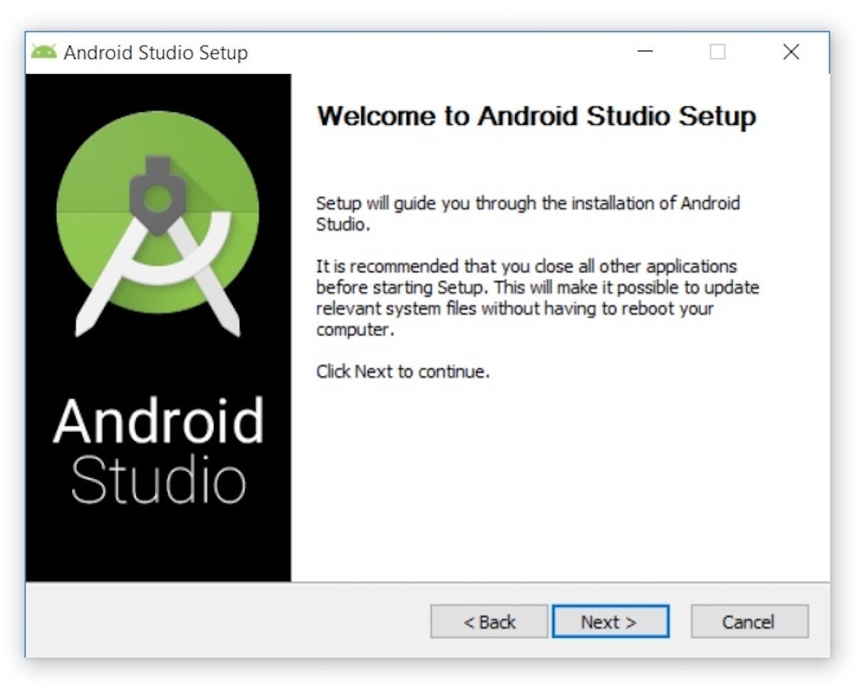

**Step 2**: Clicking Next took me to the following panel, which provides the option to decline installing an Android Virtual Device (AVD).

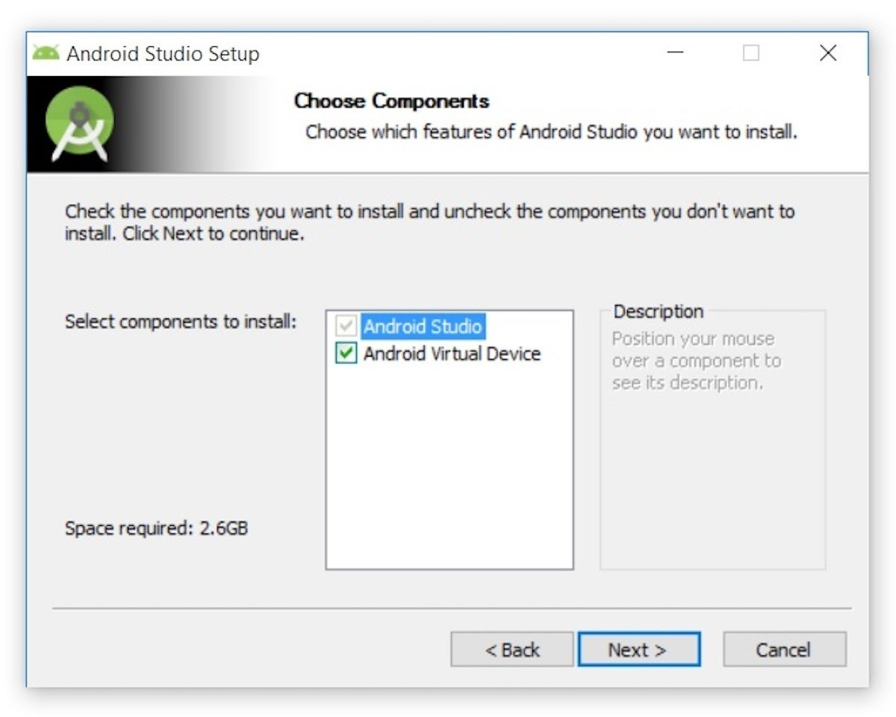

**Step 3**: I chose to keep the default settings. After clicking Next, I was taken to the Configuration Settings panel, where I was asked to choose where to install Android Studio.

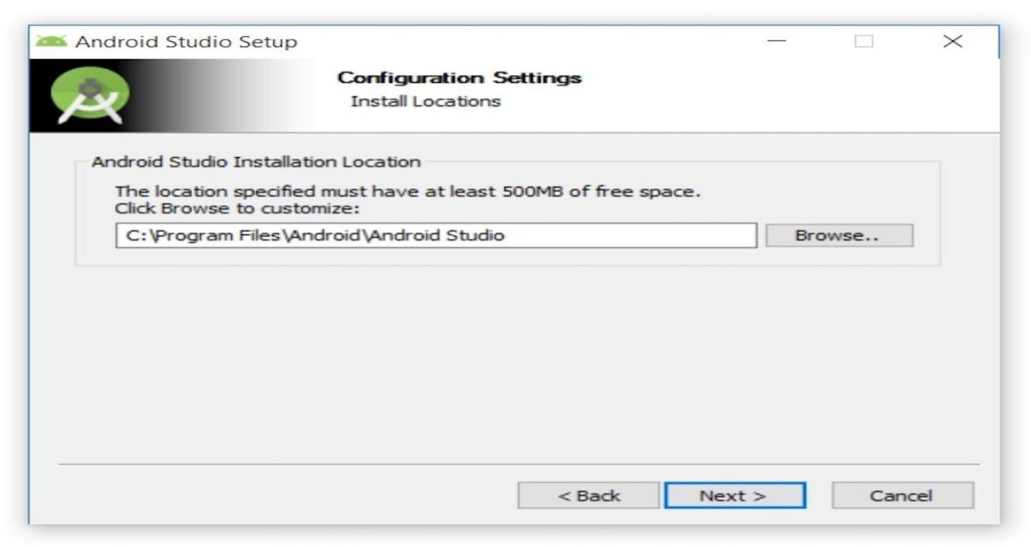

**Step 4**: I kept the default installation location and clicked Next, and was greeted with the Choose Start Menu Folder panel.

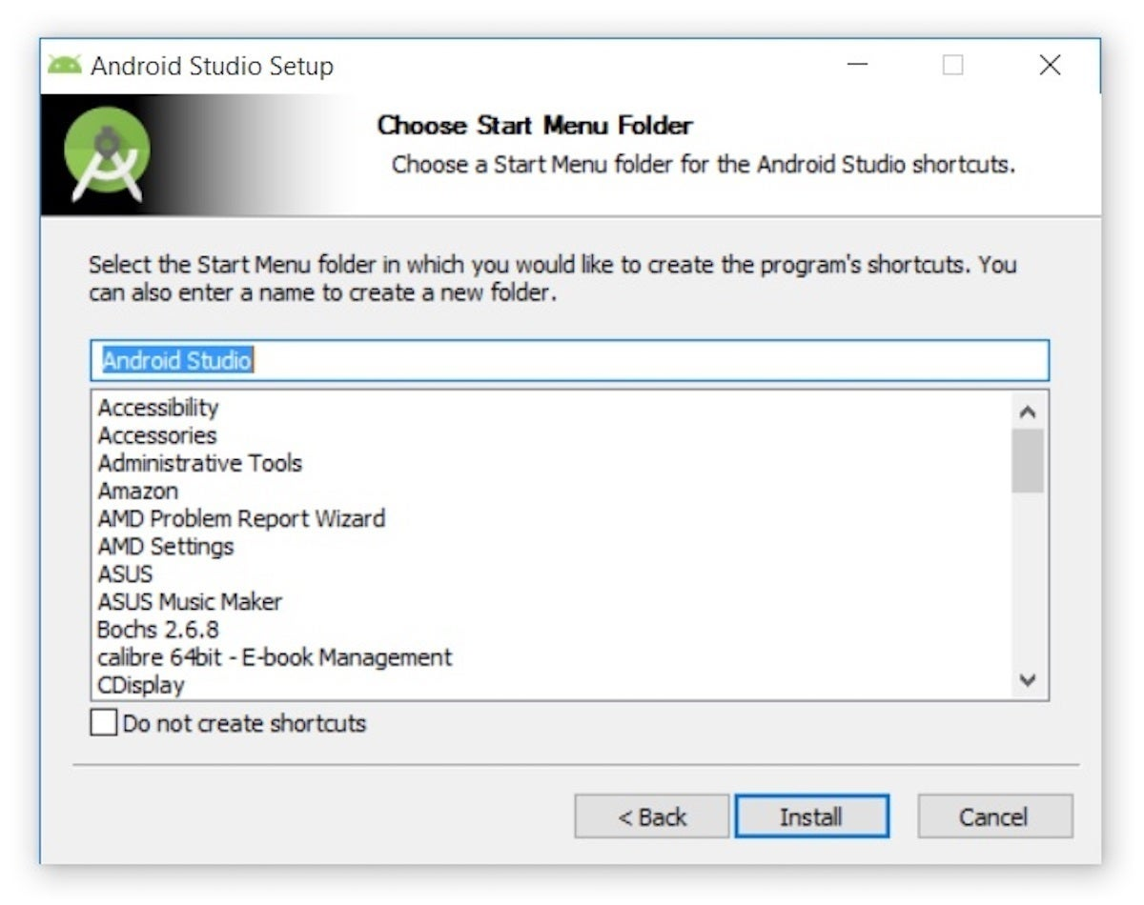

**Step 5**: I kept the default setting and clicked Install. The following Installing panel appeared:

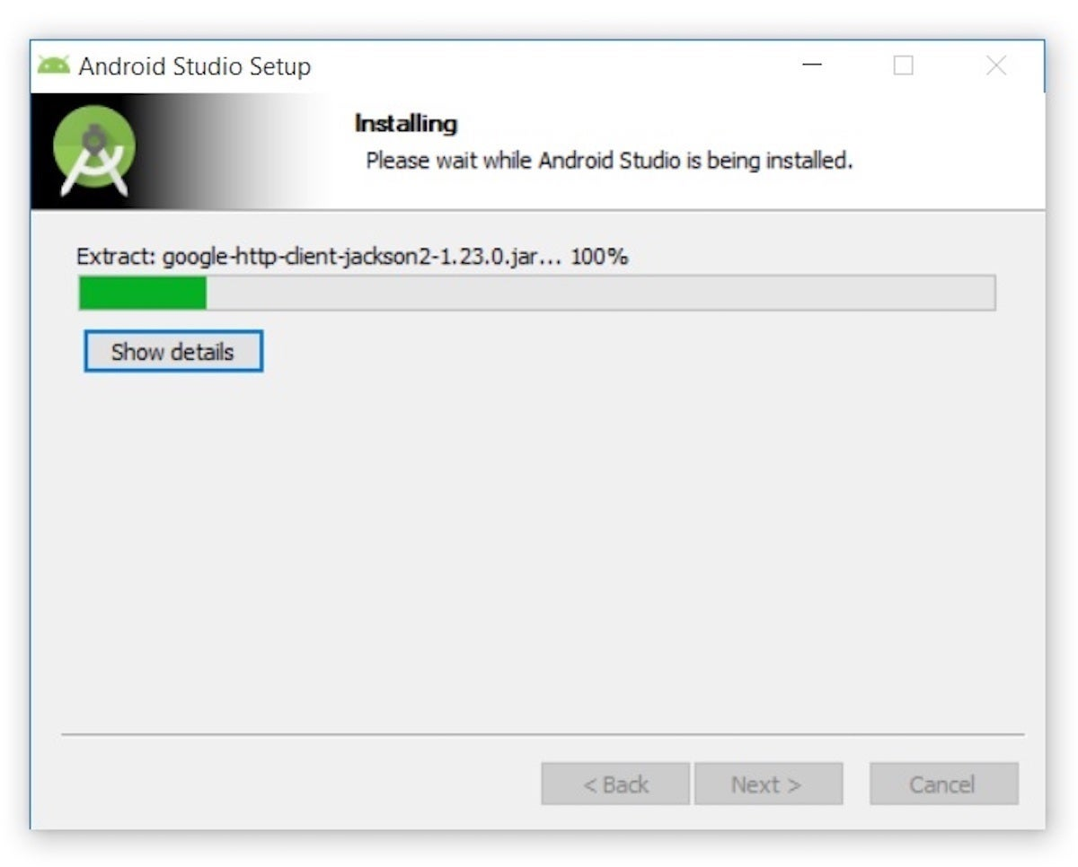

**Step 6**: Clicking Show details causes the names of files being installed and other activities to be displayed. When installation finished, the Installation Complete panel appeared.

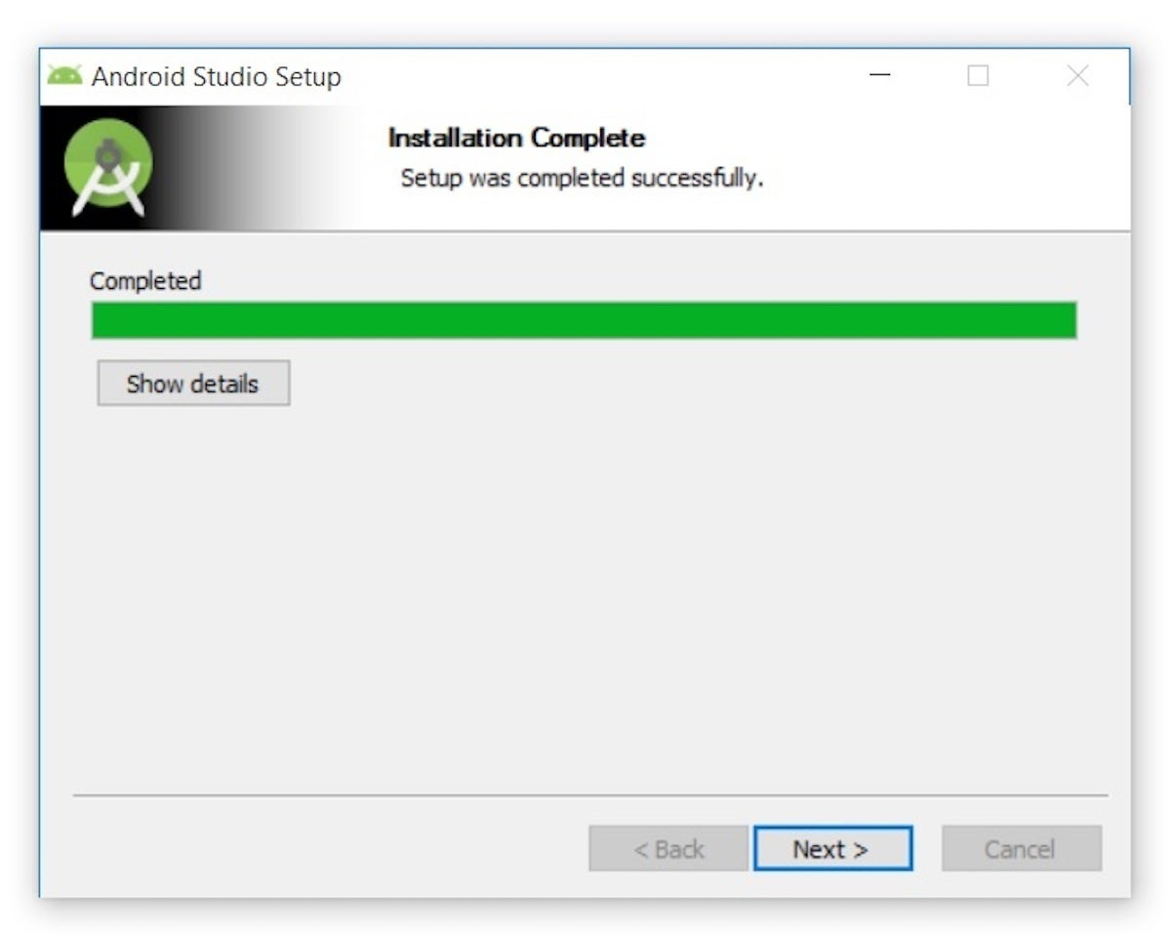

**Step 7**: After clicking Next, the installer presented the Completing Android Studio Setup panel.

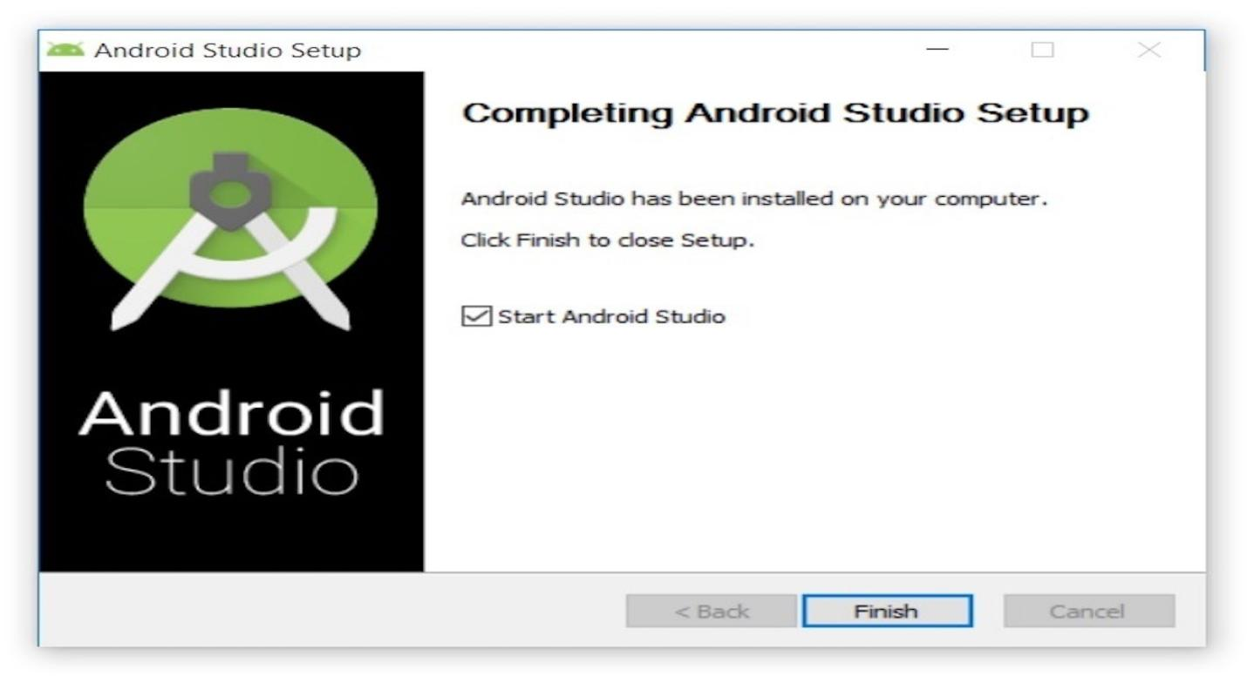

**Step 8**: To complete the installation, I left the Start Android Studio box checked and clicked Finish.

* **Running Android Studio**

**Step 1**: The first time Android Studio runs, it presents a Complete Installation dialog box that offers the option of importing settings from a previous installation.

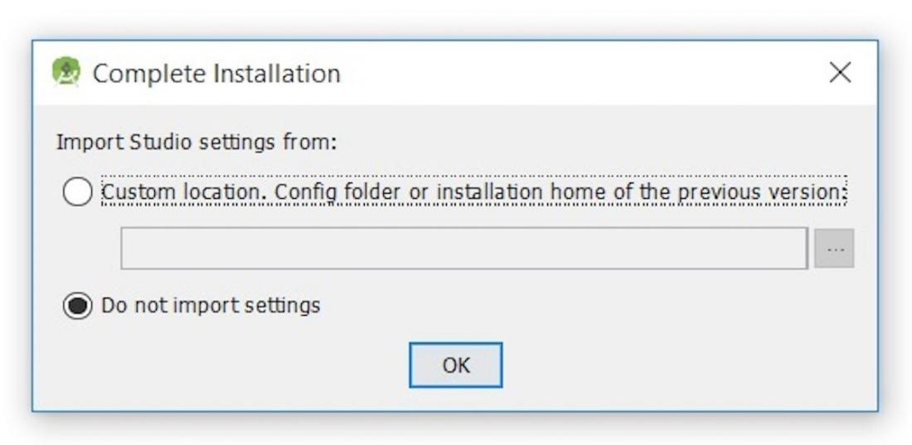

**Step 2**: I chose not to import settings (the default selection) and clicked OK, and was rewarded with the following splash screen:

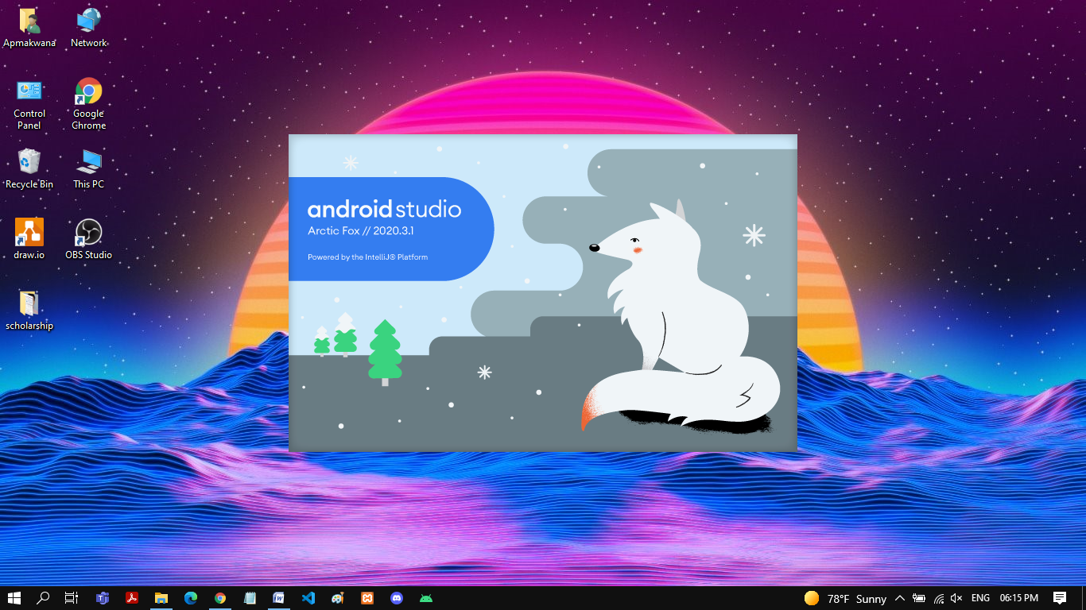

**Step 3**: I also observed the following Finding Available SDK Components message box.

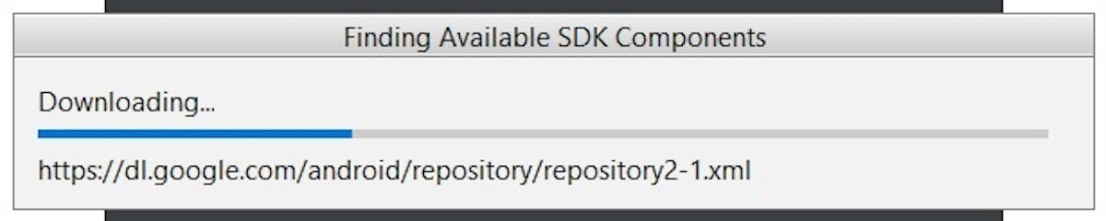

**Step 4**: At this point, Android Studio presented the following Android Studio Setup Wizard dialog box:

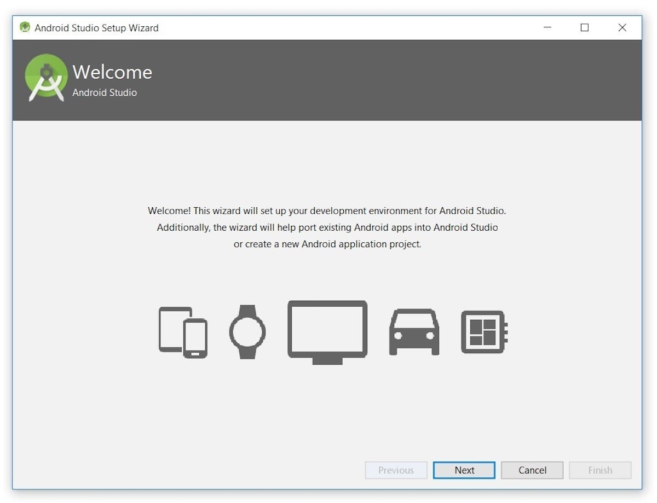

**Step 5**: I clicked Next, and the wizard invited me to select an installation type. I kept the default standard setting.

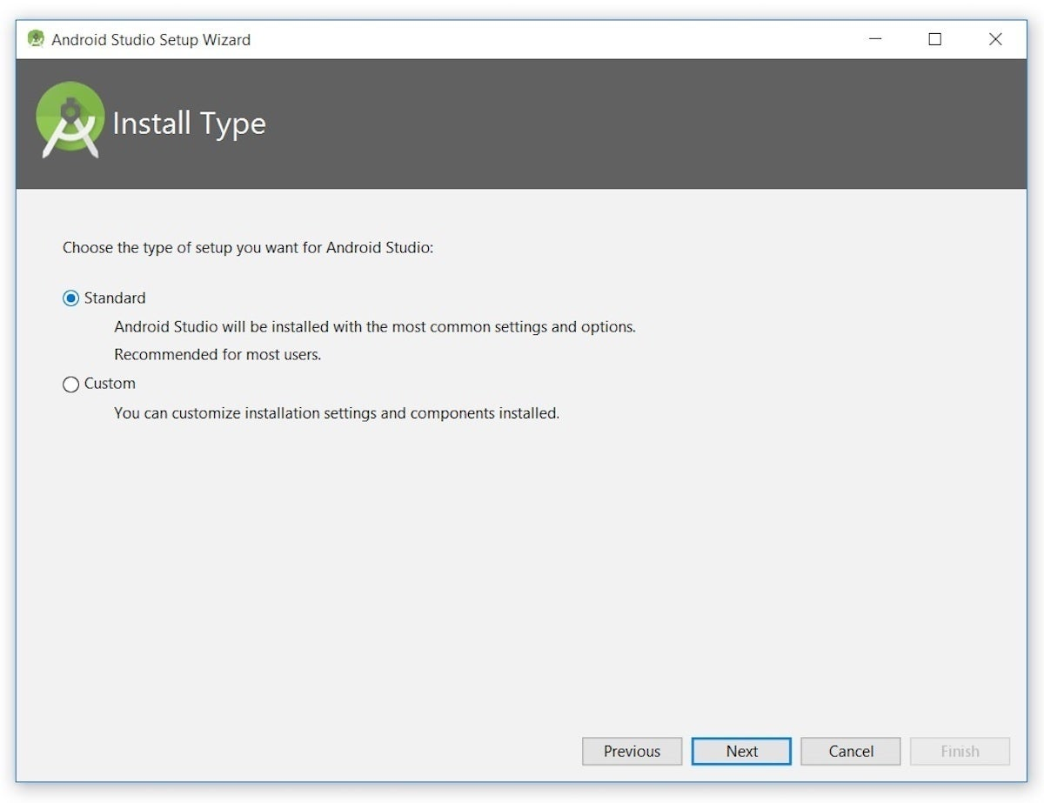

**Step 6**: I was then given the opportunity to choose a user interface theme.

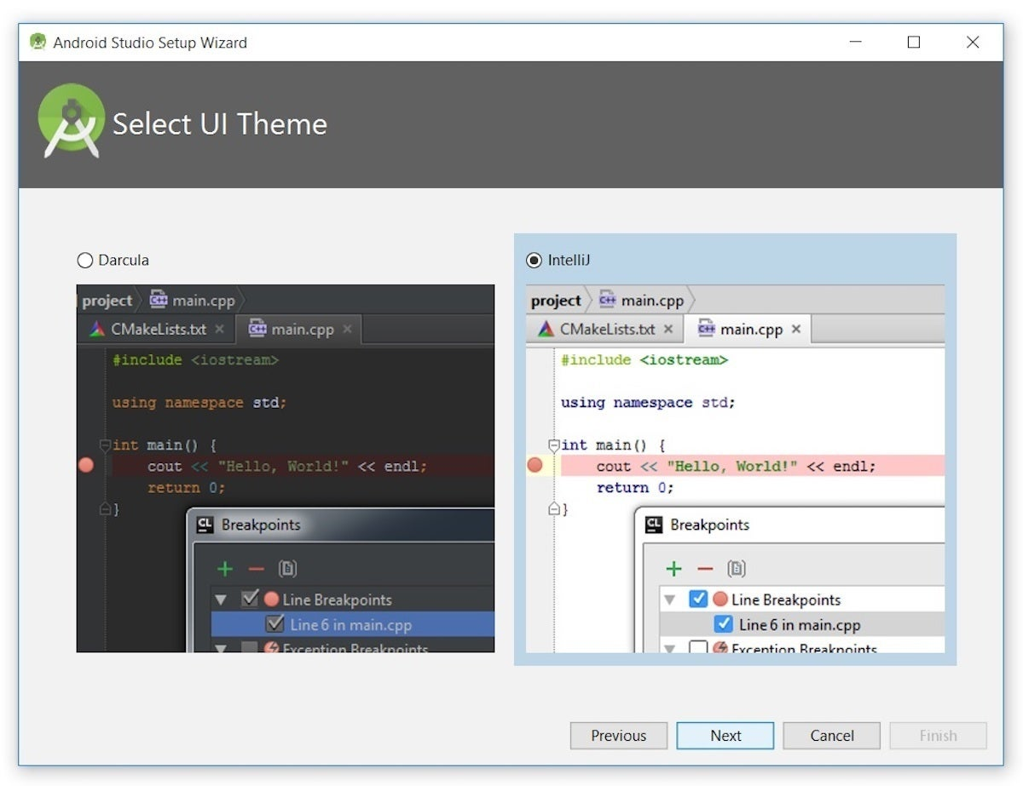

**Step 7**: I kept the default IntelliJ setting and clicked Next. Android Studio next provided the opportunity to verify settings.

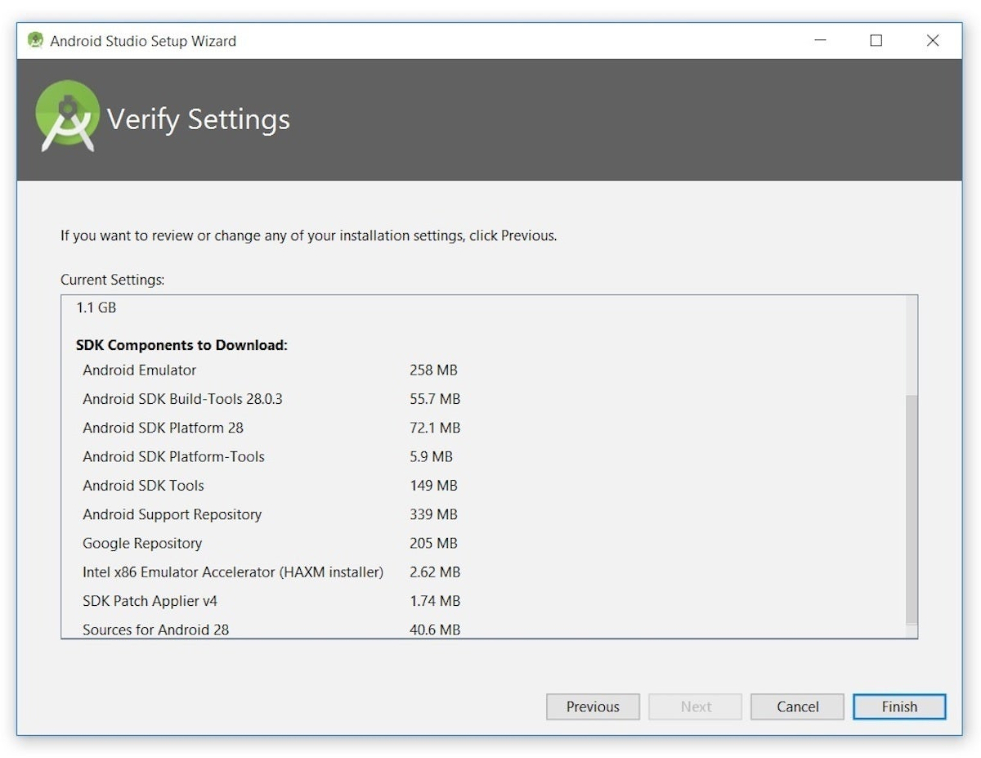

**Step** **8**: I clicked Finish and Android Studio began the process of downloading SDK components.

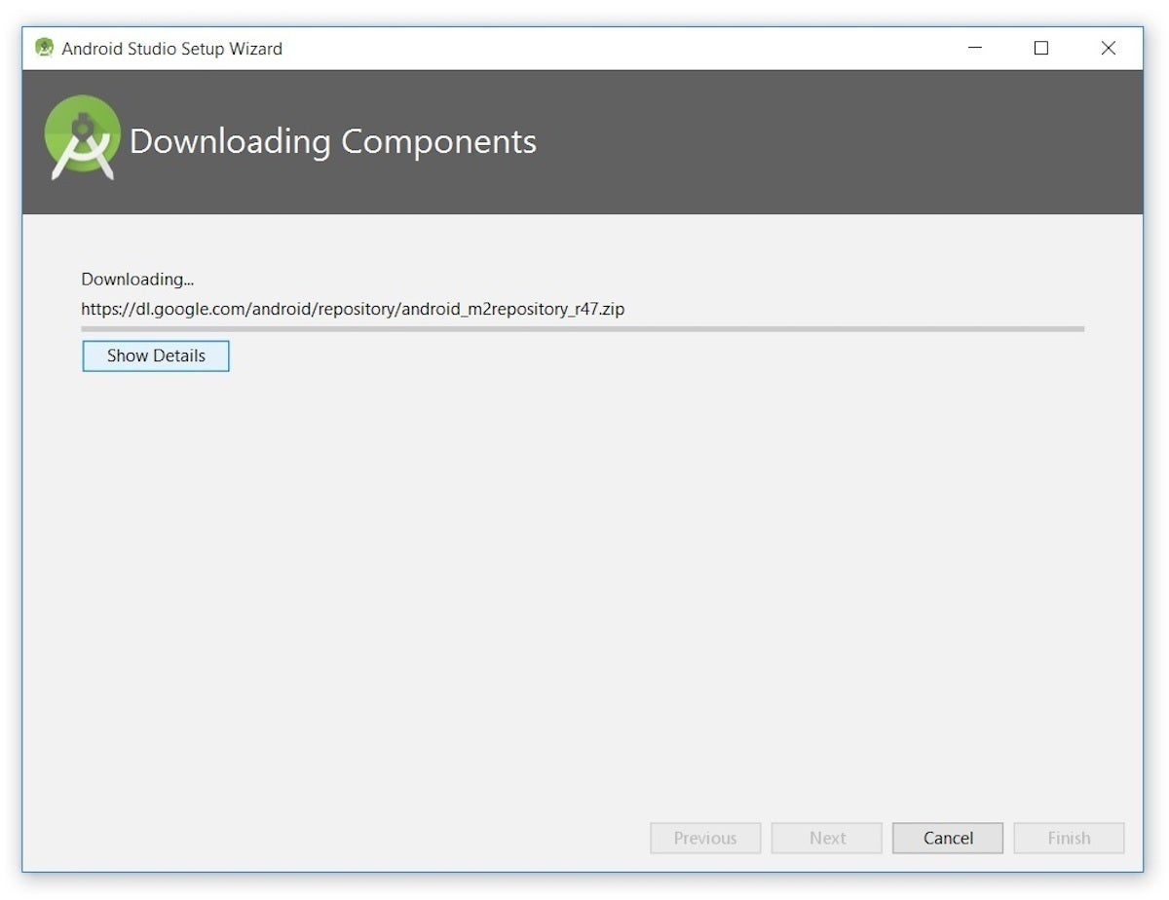

**Step 9**: It can take several minutes for this part of the setup to finish. Clicking Show Details might relieve some boredom by revealing the various files being downloaded and unzipped.

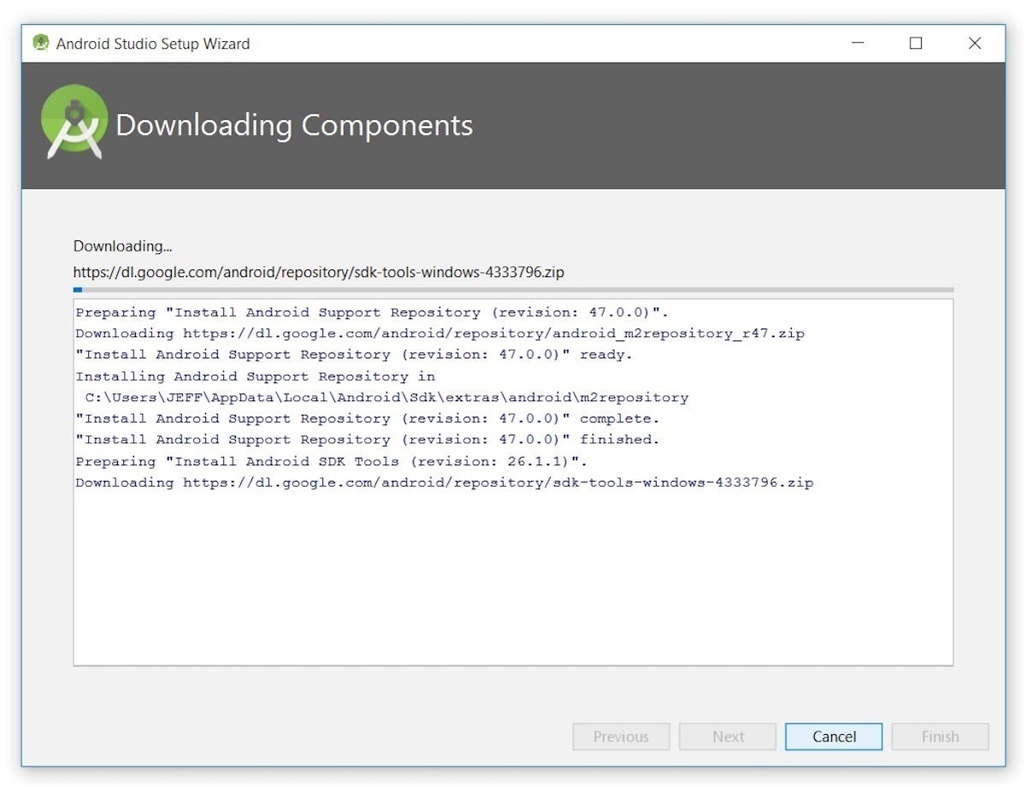

**Step 10**: For my AMD-based computer, an unpleasant surprise awaited after the components had completely downloaded and unzipped:

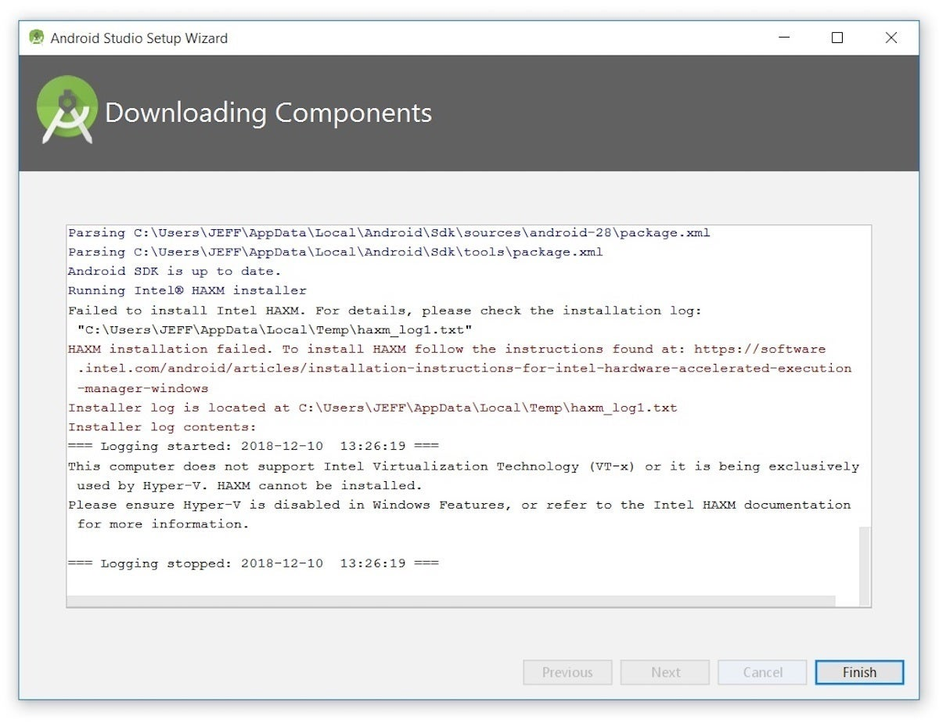

**Step 11**: My options are to either put up with the slow emulator or use an Android device to speed up development. In Part 3 I'll show you how I resolved this issue.

**Step 12**: Finally, I clicked Finish to complete the wizard. The Welcome to Android Studio dialog box appeared.

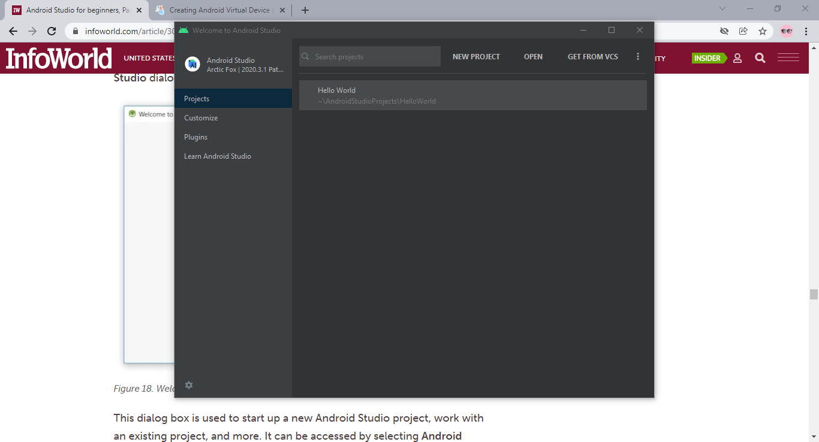

**Step 13**: This dialog box is used to start up a new Android Studio project, work with an existing project, and more. It can be accessed by selecting Android Studio from the Windows Start menu, or the equivalent on another platform.

**Practical - 2**

**Aim: Configure android development tools (ADT) plug-in and create android virtual device(AVD).**

* **Starting a new project**

**Step 1**: From our setup so far, you should still have Android Studio running with the **Welcome to Android Studio** dialog box. From here, click **Start a new Android Studio project**. Android Studio will respond with the **Create New Project** dialog box shown in Figure.

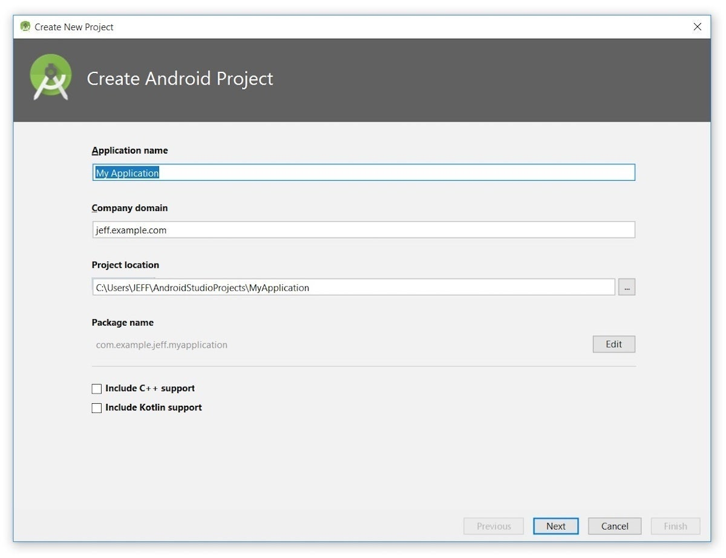

**Step 2**: Enter **W2A** (Welcome to Android) as the application name and **javajeff.ca** as the company domain name. On my desktop, I observed **C:\Users\JEFF\AndroidStudioProjects\W2A** as the project location. Click **Next** to select your target devices.

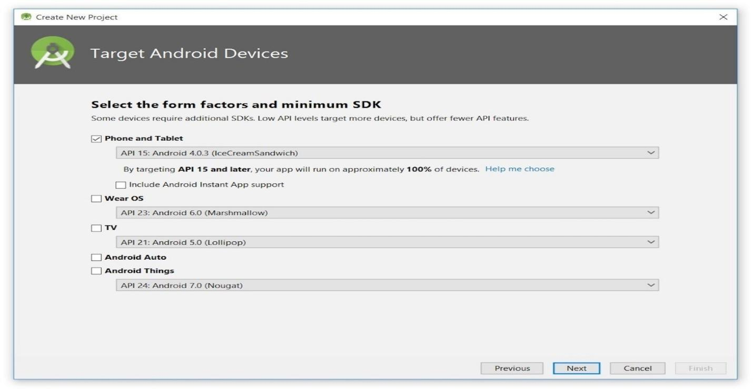

**Step 3**: Android Studio lets you select form factors, or categories of target devices, for every app you create. I kept the default setting.

**Step 4**: Click **Next**, and you will be given the opportunity to choose a template for your app’s main activity. For now we’ll stick with **Empty Activity**. Select this template (if necessary) and click **Next**.

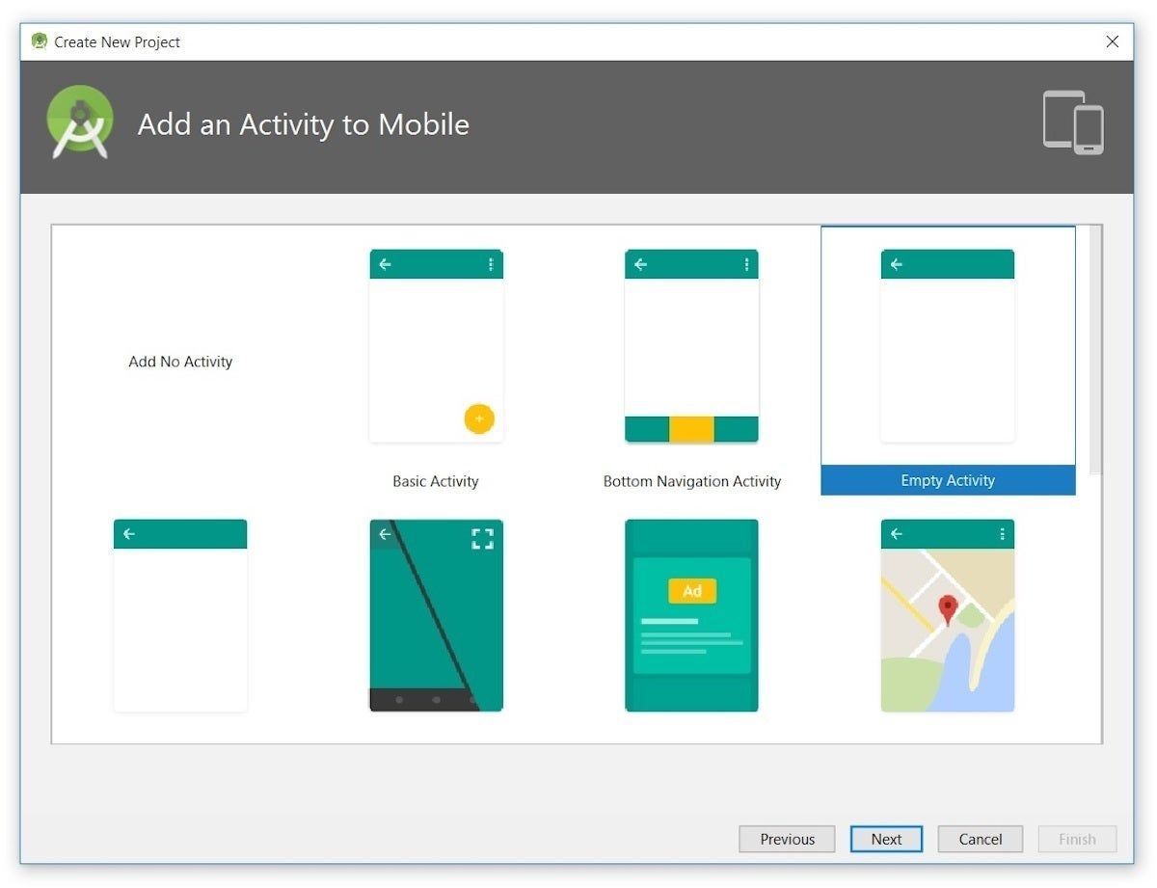

**Step 5**: Next you'll customize the activity:

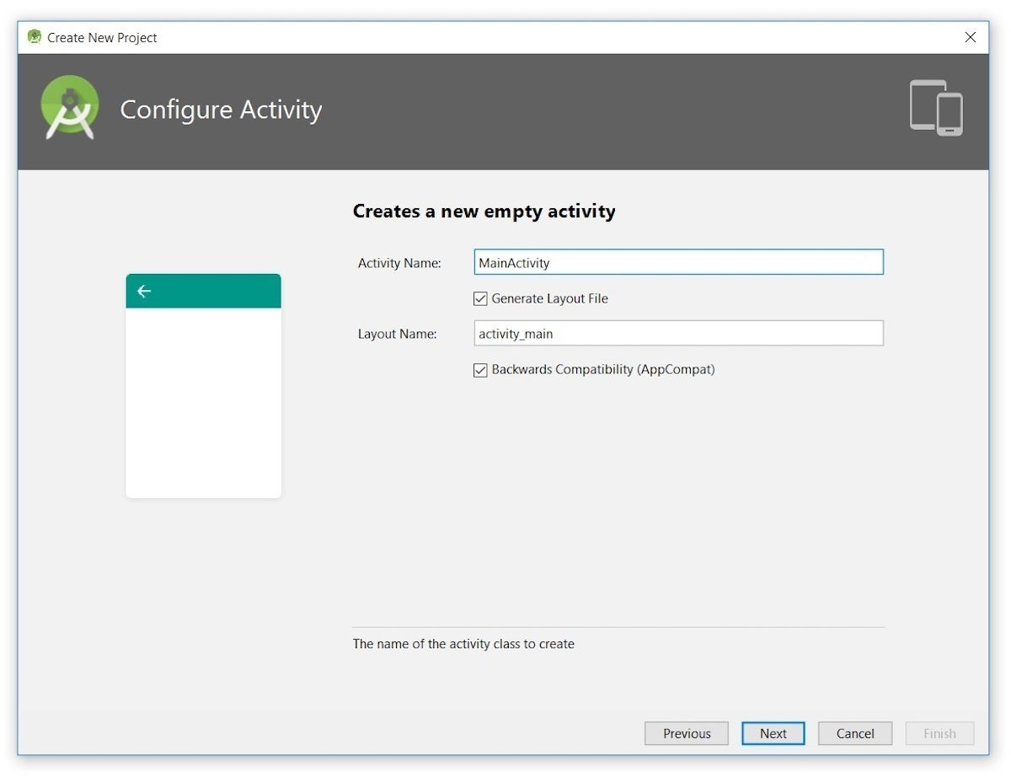

**Step 6**: Enter **W2A** as the activity name and **main** as the layout name, and click **Next** to complete this step.

**Step 7**: Android Studio enables **Finish** after downloading the constraint layout files. Click this button and Android Studio takes you to the main window.

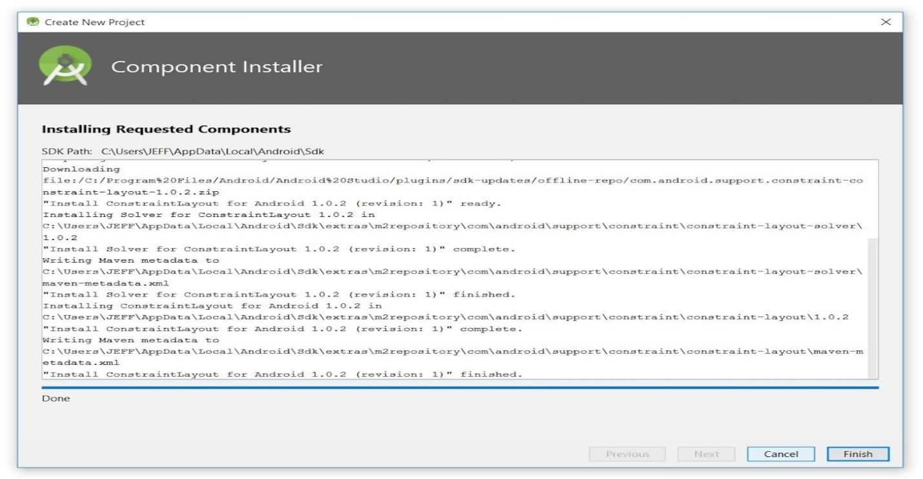

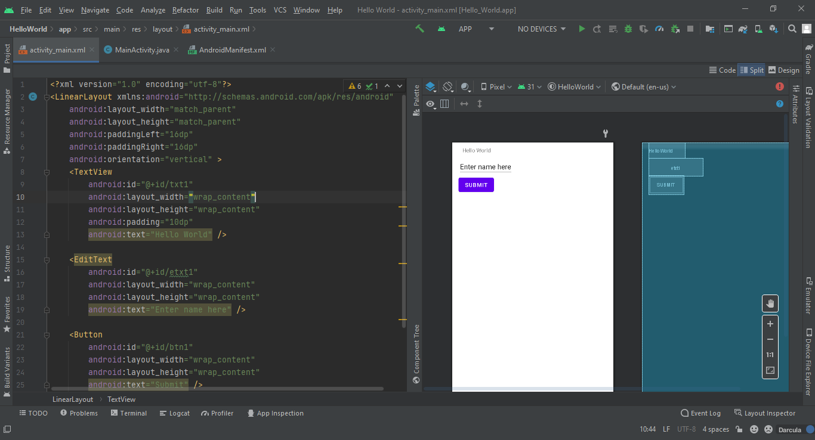

**Step 8**: The main window is divided into a menu bar and several other areas, which are identified in Figures.

* **Install Plugins**

**Step 1**: Open Android Studio and you will get following window.

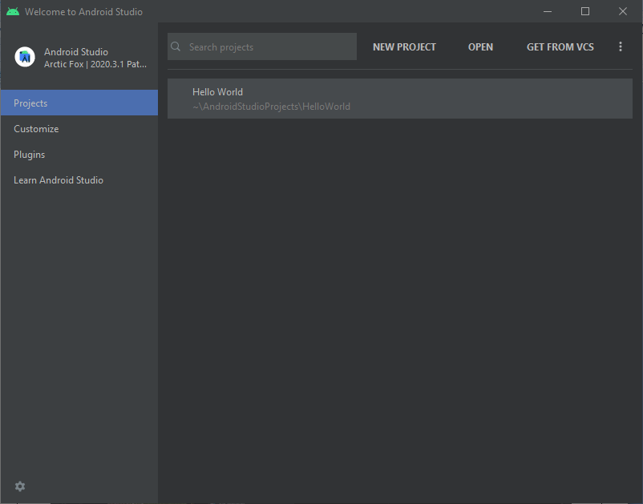

**Step 2**: Goto Plugins and Select Plugin you want to install.

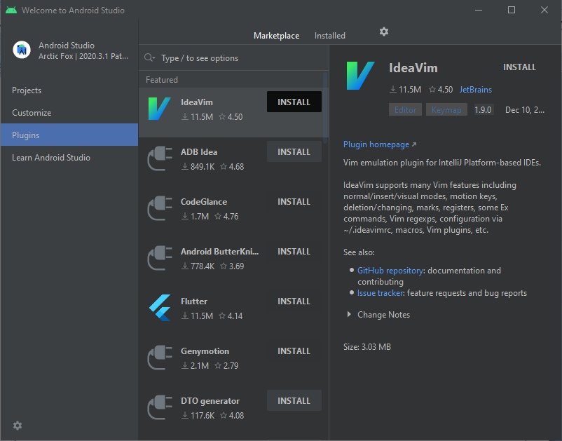

**Step 3**: Here I want to install “**IdeaVim**” Click on Install.

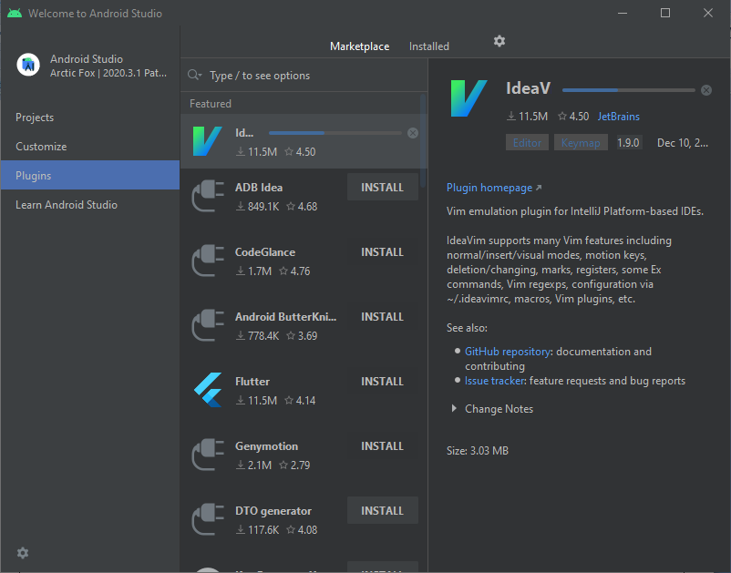

**Step 4**: Now you will get following window. Click on “**Restart IDE**”.

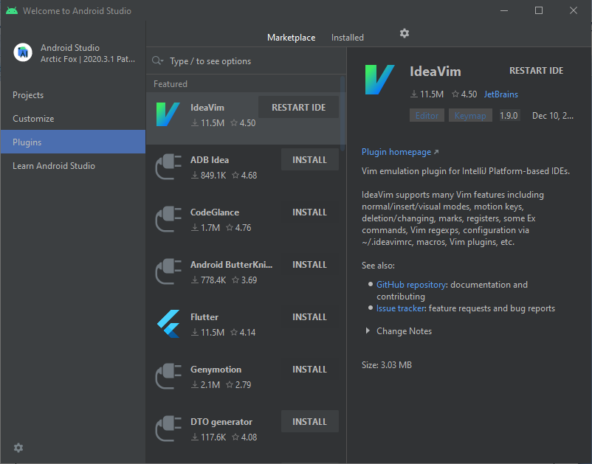

**Step 5**: Now Plugin installed successfully.

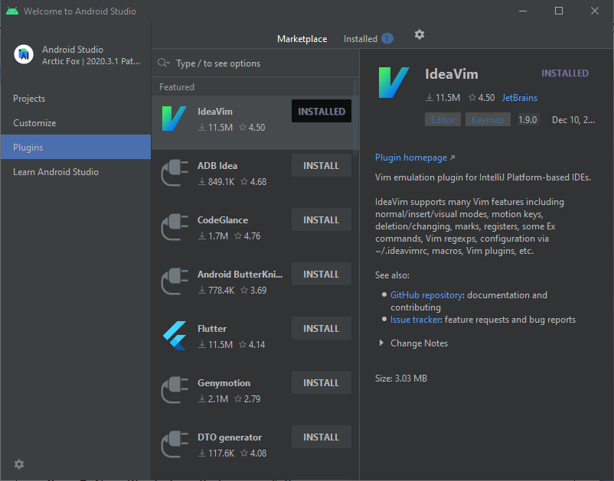

* **Create [an Android](http://www.c-sharpcorner.com/technologies/android-programming" \t "_blank) Virtual Device (AVD)**

**Step 1:** Today we are learning how to make a virtual device if an Android phone is not available for testing an app. So in this way, we will create our own virtual machine and run the app on it, but one thing is that if you want to run a virtual device it will work more slowly than the real devices. Now go to the **Tools**option, then **Android**and then select the **AVD Manager**.

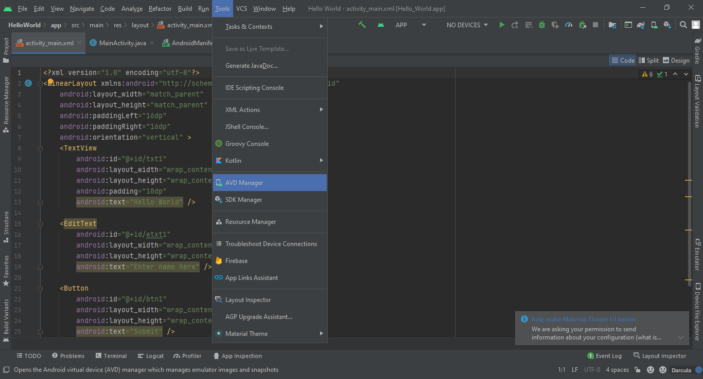

**Step 2:** After clicking the AVD Manager, if you are installing Android for the first time then this type of screen will appear and ask to create the virtual device; now click on this button.

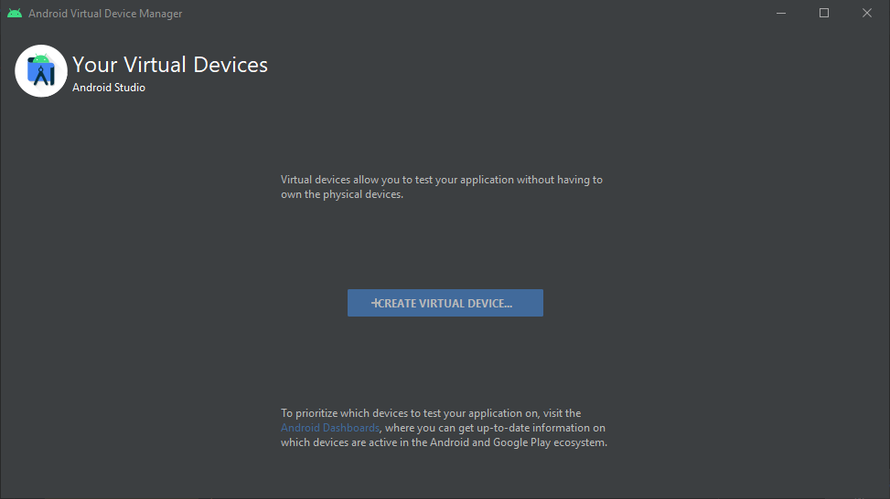

**Step 3:** Now select the device which you want to make a virtual device, but remember that you also test your app on tablet, TV and wear devices, so ad them this time. I choose the Nexus 5 device to run my app.

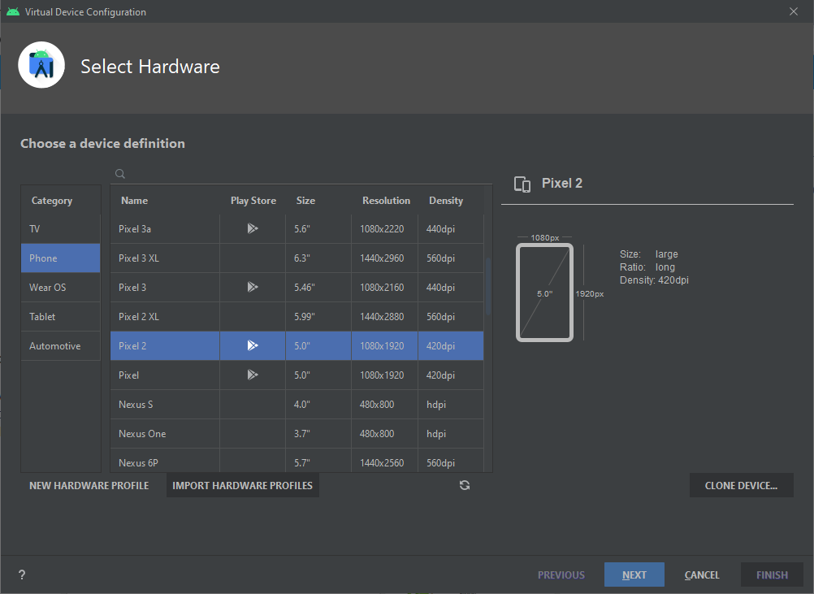

**Step 4**

Now after clicking next you can see that the API level appears; if you agree to that level, then press the next button, but in left side, you see that HAXMI is not installed in PC, so we have two options. One is to download the Intel HAXMI website, the second is to go to the SDK Manager and check HAXMI and install the package.

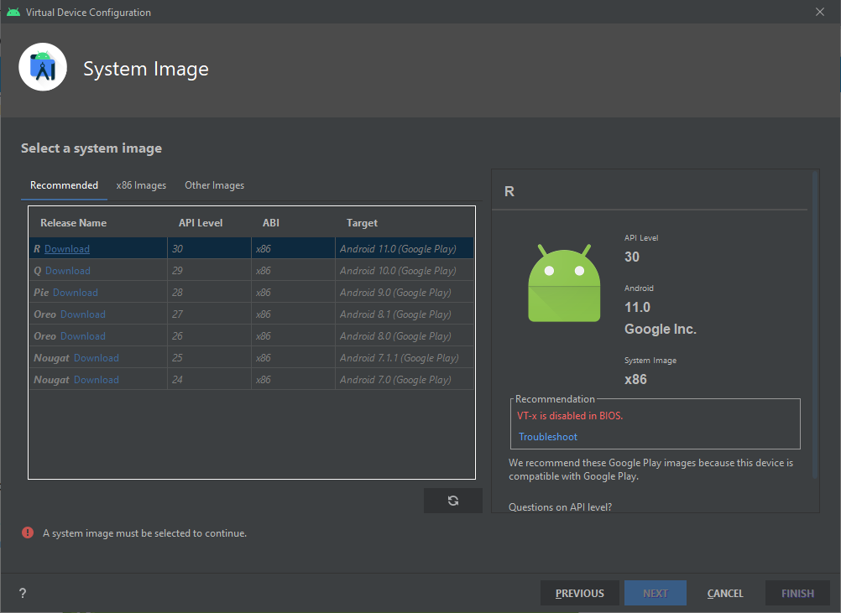

**Step 5**

After clicking next now you choose the RAM and some memory configuration of virtual devices because if you want to run three virtual devices at a time you have to share the RAM equally.

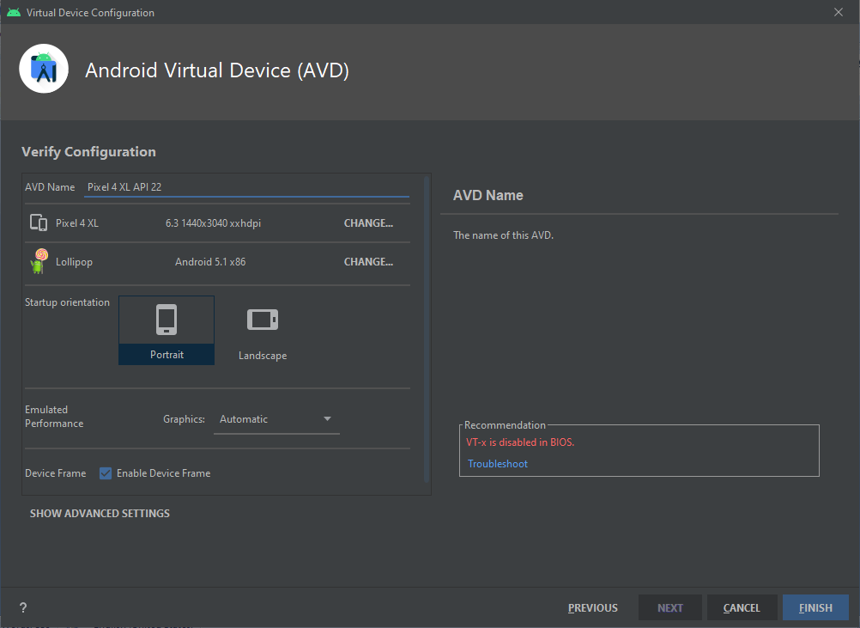

**Step 6**

Now click on the finish button which appears in the previous step, then after taking 2 to 3 minutes now the virtual device is created and now you will be able to use this device.

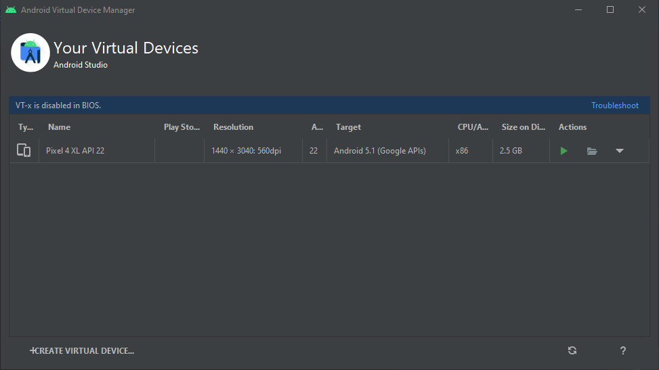

Practical 3

Create an application with Custom Font Style for use of style.xml file.

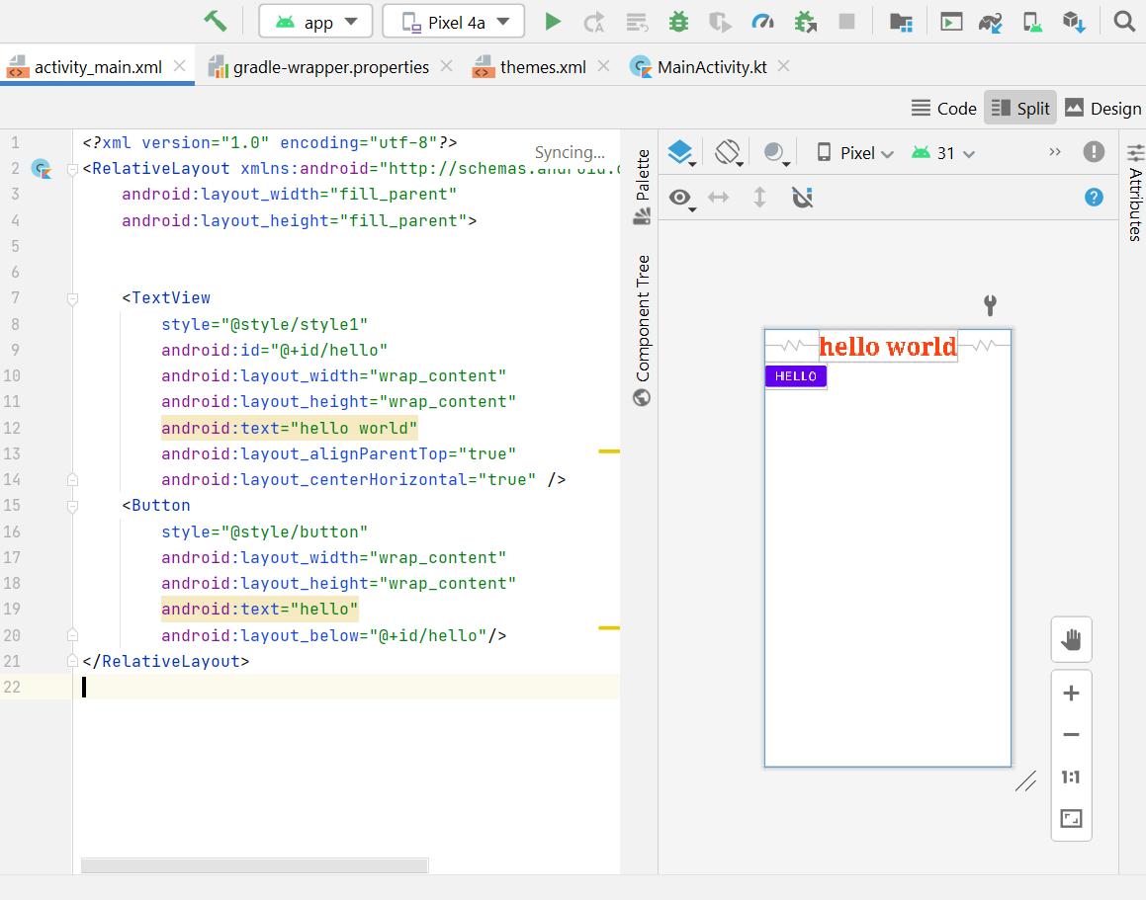

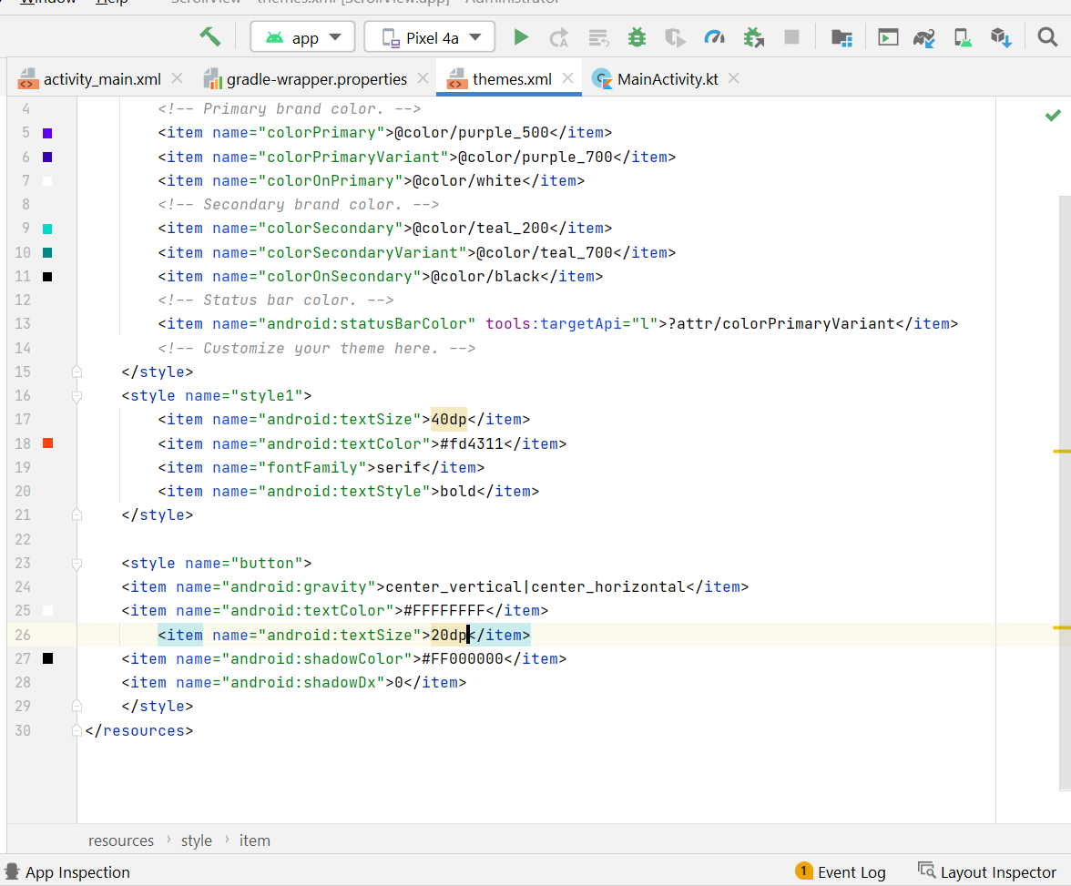

Practical 4

Develop a program to display Hello World on middle of the screen with Red colour.

*<?*xml version="1.0" encoding="utf-8"*?>*<androidx.constraintlayout.widget.ConstraintLayout xmlns:android="http://schemas.android.com/apk/res/android"  
 xmlns:app="http://schemas.android.com/apk/res-auto"  
 xmlns:tools="http://schemas.android.com/tools"  
 android:layout\_width="match\_parent"  
 android:layout\_height="match\_parent"  
 tools:context=".MainActivity">  
  
 <TextView  
 android:id="@+id/textView"  
 android:layout\_width="wrap\_content"  
 android:layout\_height="wrap\_content"  
 android:text="Hello World!"  
 android:textColor="#ff0000"  
 android:textSize="30dp"/>  
  
</androidx.constraintlayout.widget.ConstraintLayout>

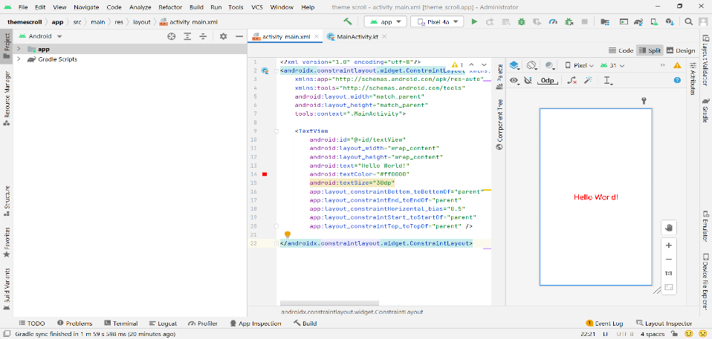

Practical 5

Create an application for demonstration of Linear, Relative, Absolute, Table and Frame Layout in android.

**Relative layout login**

*<?*xml version="1.0" encoding="utf-8"*?>*<RelativeLayout xmlns:android="http://schemas.android.com/apk/res/android"  
 xmlns:app="http://schemas.android.com/apk/res-auto"  
 xmlns:tools="http://schemas.android.com/tools"  
 android:layout\_width="match\_parent"  
 android:layout\_height="match\_parent"  
 tools:context=".MainActivity">  
 <TextView  
 android:id="@+id/title"  
 android:layout\_width="wrap\_content"  
 android:layout\_height="wrap\_content"  
 android:layout\_centerHorizontal="true"  
 android:layout\_marginTop="50dp"  
 android:shadowColor="#4E4747"  
 android:shadowRadius="@dimen/material\_emphasis\_medium"  
 android:text="LOGIN"  
 android:textColor="#4CAF50"  
 android:textSize="34sp"  
 android:textStyle="bold" />  
 <TextView  
 android:id="@+id/userTitle"  
 android:layout\_width="wrap\_content"  
 android:layout\_height="wrap\_content"  
 android:layout\_below="@+id/title"  
 android:layout\_marginStart="10dp"  
 android:layout\_marginTop="50dp"  
 android:text="Username"  
 android:textSize="20sp"  
 android:textStyle="bold" />  
 <EditText  
 android:id="@+id/userEd"  
 android:layout\_width="270dp"  
 android:layout\_height="wrap\_content"  
 android:layout\_below="@id/title"  
 android:layout\_marginLeft="20dp"  
 android:layout\_marginTop="50dp"  
 android:layout\_toRightOf="@+id/userTitle"  
 android:background="@android:drawable/editbox\_dropdown\_light\_frame"  
 android:hint="Enter Your Name"  
 android:inputType="textPersonName"  
 android:lines="1"  
 android:minHeight="48dp"  
 android:textColor="@color/black" />  
 <TextView  
 android:id="@+id/passTitle"  
 android:layout\_width="wrap\_content"  
 android:layout\_height="wrap\_content"  
 android:layout\_below="@+id/userTitle"  
 android:layout\_marginStart="10dp"  
 android:layout\_marginTop="50dp"  
 android:text="Password"  
 android:textSize="20sp"  
 android:textStyle="bold" />  
 <EditText  
 android:id="@+id/passEd"  
 android:layout\_width="270dp"  
 android:layout\_height="wrap\_content"  
 android:layout\_below="@id/userTitle"  
 android:layout\_marginLeft="20dp"  
 android:layout\_marginTop="50dp"  
 android:layout\_toRightOf="@+id/passTitle"  
 android:background="@android:drawable/editbox\_dropdown\_light\_frame"  
 android:hint="Enter Your Password"  
 android:inputType="textPassword"  
 android:lines="1"  
 android:minHeight="48dp"  
 android:textColor="@color/black" />  
 <Button  
 android:id="@+id/button"  
 android:layout\_width="wrap\_content"  
 android:layout\_height="wrap\_content"  
 android:layout\_below="@id/passEd"  
 android:layout\_centerHorizontal="true"  
 android:layout\_marginTop="100dp"  
 android:text="Submit"  
 android:textSize="20sp" />  
</RelativeLayout>

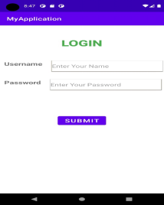

LINEAR LAYOUT

*<?*xml version="1.0" encoding="utf-8"*?>*<LinearLayout xmlns:android="http://schemas.android.com/apk/res/android"  
 xmlns:app="http://schemas.android.com/apk/res-auto"  
 xmlns:tools="http://schemas.android.com/tools"  
 android:layout\_width="match\_parent"  
 android:layout\_height="match\_parent"  
 android:orientation="vertical"  
 tools:context=".MainActivity2">  
  
 <TextView  
 android:id="@+id/title"  
 android:layout\_width="wrap\_content"  
 android:layout\_height="wrap\_content"  
 android:layout\_marginTop="50dp"  
 android:shadowColor="#4E4747"  
 android:shadowRadius="@dimen/material\_emphasis\_medium"  
 android:text="LOGIN"  
 android:layout\_gravity="center"  
 android:textColor="#4CAF50"  
 android:textSize="34sp"  
 android:textStyle="bold" />  
 <TextView  
 android:id="@+id/userTitle"  
 android:layout\_width="wrap\_content"  
 android:layout\_height="wrap\_content"  
 android:layout\_marginTop="50dp"  
 android:text="Username"  
 android:layout\_marginStart="20dp"  
 android:textSize="20sp"  
 android:textStyle="bold" />  
 <EditText  
 android:id="@+id/userEd"  
 android:layout\_width="270dp"  
 android:layout\_height="wrap\_content"  
 android:background="@android:drawable/editbox\_dropdown\_light\_frame"  
 android:hint="Enter Your Name"  
 android:inputType="textPersonName"  
 android:lines="1"  
 android:layout\_marginTop="10dp"  
 android:layout\_marginStart="10dp"  
 android:minHeight="48dp"  
 android:textColor="@color/black" />  
  
 <TextView  
 android:id="@+id/passTitle"  
 android:layout\_width="wrap\_content"  
 android:layout\_height="wrap\_content"  
 android:layout\_marginTop="50dp"  
 android:text="Password"  
 android:layout\_marginStart="20dp"  
 android:textSize="20sp"  
 android:textStyle="bold" />  
  
 <EditText  
 android:id="@+id/passEd"  
 android:layout\_width="270dp"  
 android:layout\_height="wrap\_content"  
 android:layout\_below="@id/userTitle"  
 android:background="@android:drawable/editbox\_dropdown\_light\_frame"  
 android:hint="Enter Your Password"  
 android:inputType="textPassword"  
 android:lines="1"  
 android:layout\_marginStart="10dp"  
 android:layout\_marginTop="10dp"  
 android:minHeight="48dp"  
 android:textColor="@color/black" />  
 <Button  
 android:id="@+id/button"  
 android:layout\_width="wrap\_content"  
 android:layout\_height="wrap\_content"  
 android:layout\_marginTop="50dp"  
 android:text="Submit"  
 android:layout\_gravity="center"  
 android:textSize="20sp" />  
</LinearLayout>

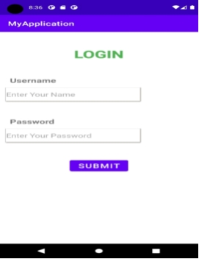

**Table Layout login**

*<?*xml version="1.0" encoding="utf-8"*?>*<TableLayout xmlns:android="http://schemas.android.com/apk/res/android"  
 android:layout\_width="wrap\_content"  
 android:layout\_height="wrap\_content"  
 android:layout\_gravity="center"  
 android:stretchColumns="\*">  
  
 <TableRow  
 android:id="@+id/row1"  
 android:layout\_width="wrap\_content"  
 android:layout\_height="wrap\_content">  
  
 <TextView  
 android:id="@+id/lblUsername"  
 android:layout\_width="wrap\_content"  
 android:layout\_height="wrap\_content"  
 android:layout\_gravity="center\_vertical"  
 android:layout\_marginLeft="10dp"  
 android:text="Username"  
 android:textSize="25dp" />  
  
 <EditText  
 android:id="@+id/txtUsername"  
 android:layout\_width="wrap\_content"  
 android:layout\_height="wrap\_content"  
 android:hint="Enter Username"  
 android:layout\_margin="10dp"  
 android:layout\_span="15"  
 android:textSize="25dp" />  
 </TableRow>  
  
 <TableRow  
 android:id="@+id/row2"  
 android:layout\_width="wrap\_content"  
 android:layout\_height="wrap\_content">  
  
 <TextView  
 android:id="@+id/lblPassword"  
 android:layout\_width="wrap\_content"  
 android:layout\_height="wrap\_content"  
 android:layout\_gravity="center\_vertical"  
 android:layout\_marginLeft="10dp"  
 android:text="Password"  
 android:textSize="25dp" />  
  
 <EditText  
 android:id="@+id/txtPassword"  
 android:layout\_width="wrap\_content"  
 android:layout\_height="wrap\_content"  
 android:hint="Enter Password"  
 android:layout\_margin="10dp"  
 android:layout\_span="15"  
 android:textSize="25dp" />  
 </TableRow>  
  
 <TableRow  
 android:id="@+id/row3"  
 android:layout\_width="wrap\_content"  
 android:layout\_height="wrap\_content">  
  
 <Button  
 android:id="@+id/btnLogin"  
 android:layout\_width="wrap\_content"  
 android:layout\_height="50dp"  
 android:gravity="center"  
 android:layout\_margin="10dp"  
 android:layout\_span="16"  
 android:text="Login"  
 android:textSize="20dp" />  
 </TableRow>  
</TableLayout>

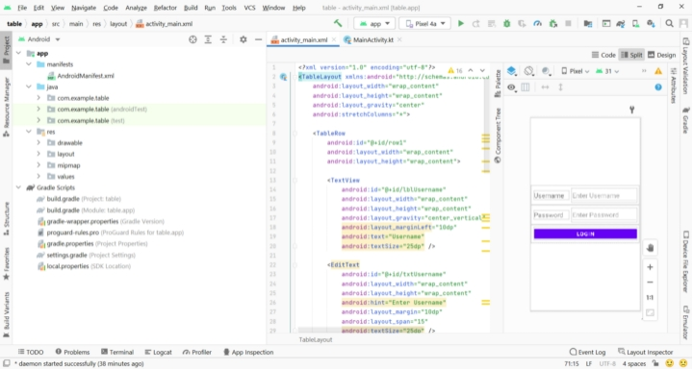

FRAME LAYOUT

*<?*xml version="1.0" encoding="utf-8"*?>*<FrameLayout xmlns:android="http://schemas.android.com/apk/res/android"  
 xmlns:app="http://schemas.android.com/apk/res-auto"  
 xmlns:tools="http://schemas.android.com/tools"  
 android:layout\_width="match\_parent"  
 android:layout\_height="match\_parent"  
 tools:context=".MainActivity">  
  
 <TextView  
 android:layout\_width="wrap\_content"  
 android:layout\_height="wrap\_content"  
 android:text="hello"  
 android:layout\_gravity="center"  
 android:textSize="30dp"/>  
 <Button  
 android:layout\_width="wrap\_content"  
 android:layout\_height="wrap\_content"  
 android:text="java"  
 android:textSize="30dp"  
 android:layout\_gravity="right|bottom"/>  
 <Button  
 android:layout\_width="wrap\_content"  
 android:layout\_height="wrap\_content"  
 android:text="c++"  
 android:textSize="30dp"  
 android:layout\_gravity="right|top"/>  
 <Button  
 android:layout\_width="wrap\_content"  
 android:layout\_height="wrap\_content"  
 android:text="world"  
 android:textSize="30dp"  
 android:layout\_gravity="center|left"/>  
   
  
  
</FrameLayout>

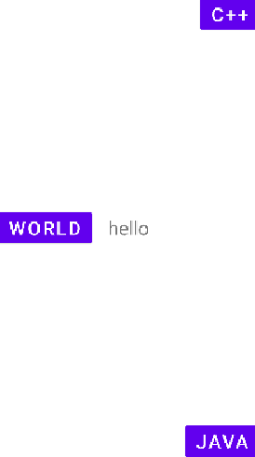

ABSOLUTE LAYOUT

<AbsoluteLayout xmlns:android="http://schemas.android.com/apk/res/android"  
 android:layout\_width="fill\_parent"  
 android:layout\_height="fill\_parent">  
  
 <TextView  
 android:layout\_width="wrap\_content"  
 android:layout\_height="wrap\_content"  
 android:text="Android"  
 android:textSize="25sp"  
 android:layout\_y="200px"/>  
 <TextView  
 android:layout\_width="wrap\_content"  
 android:layout\_height="wrap\_content"  
 android:text="Android"  
 android:textSize="25sp"  
 android:layout\_x="200px"/>  
 <Button  
 android:layout\_width="wrap\_content"  
 android:layout\_height="wrap\_content"  
 android:text="hello"  
 android:textSize="20dp"  
 android:layout\_y="500px"   
 android:layout\_x="300px"/>  
</AbsoluteLayout>

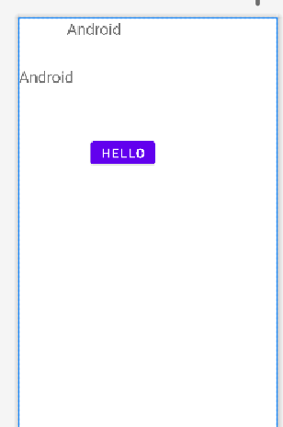

PRACTICAL 6

CREATE AN APPLLICATION TO DEMONSTRATION ANDROID ACTIVITY LIFE CYCLE

*<?*xml version="1.0" encoding="utf-8"*?>*<LinearLayout xmlns:android="http://schemas.android.com/apk/res/android"  
 android:layout\_width="match\_parent"  
 android:layout\_height="match\_parent"  
 android:paddingLeft="16dp"  
 android:paddingRight="16dp"  
 android:gravity="center\_horizontal">  
 <TextView  
 android:id="@+id/txt1"  
 android:layout\_width="wrap\_content"  
 android:layout\_height="wrap\_content"  
 android:padding="10dp"  
 android:text=""  
 android:textSize="30dp"  
 android:textColor="#ff0000" />  
</LinearLayout>

JAVA FILE

package com.example.lifecycle;  
import androidx.appcompat.app.AppCompatActivity;  
import android.widget.TextView;  
import android.os.Bundle;  
public class MainActivity extends AppCompatActivity {  
 TextView txt1;  
 @Override  
 protected void onCreate(Bundle savedInstanceState) {  
 super.onCreate(savedInstanceState);  
 setContentView(R.layout.*activity\_main*);  
 txt1=(TextView) findViewById(R.id.*txt1*);  
 txt1.setText(txt1.getText()+"onCreate() invoked\n");  
 }  
 @Override  
 public void onStart() {  
 super.onStart();  
 txt1.setText(txt1.getText()+"\nonStart() invoked\n");  
 }  
 @Override  
 public void onRestart() {  
 super.onRestart();  
 txt1.setText(txt1.getText()+"\nonRestart() invoked\n");  
 }  
 @Override  
 public void onResume() {  
 super.onResume();  
 txt1.setText(txt1.getText()+"\nonResume() invoked\n");  
 }  
 @Override  
 public void onPause() {  
 super.onPause();  
 txt1.setText(txt1.getText()+"\nonPause() invoked\n");  
 }  
 @Override  
 public void onStop() {  
 super.onStop();  
 txt1.setText(txt1.getText()+"\nonStop() invoked\n");  
 }  
 @Override  
 public void onDestroy() {  
 super.onDestroy();  
 txt1.setText(txt1.getText()+"\nonDestroy() invoked\n");  
 } }

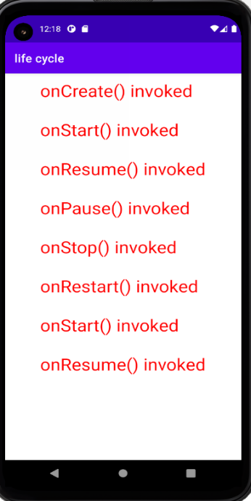

Practical 7

Create an application for demonstration of Horizontal Scroll View and Vertical Scroll View in android

VERTICAL SCROLL VIEW

*<?*xml version="1.0" encoding="utf-8"*?>*<RelativeLayout xmlns:android="http://schemas.android.com/apk/res/android"  
 xmlns:tools="http://schemas.android.com/tools"  
 android:layout\_width="match\_parent"  
 android:layout\_height="match\_parent"  
 tools:context=".MainActivity">  
  
 <HorizontalScrollView  
 android:id="@+id/horizontalScrollView"  
 android:layout\_width="match\_parent"  
 android:layout\_height="60dp">  
  
 <LinearLayout  
 android:layout\_width="wrap\_content"  
 android:layout\_height="wrap\_content"  
 android:orientation="horizontal">  
  
 <Button  
 android:id="@+id/button1"  
 android:layout\_width="wrap\_content"  
 android:layout\_height="wrap\_content"  
 android:text="New Button1" />  
  
 <Button  
 android:id="@+id/button2"  
 android:layout\_width="wrap\_content"  
 android:layout\_height="wrap\_content"  
 android:text="New Button2" />  
  
 <Button  
 android:id="@+id/button3"  
 android:layout\_width="wrap\_content"  
 android:layout\_height="wrap\_content"  
 android:text="New Button3" />  
  
 <Button  
 android:id="@+id/button4"  
 android:layout\_width="wrap\_content"  
 android:layout\_height="wrap\_content"  
 android:text="New Button4" />  
  
 <Button  
 android:id="@+id/button5"  
 android:layout\_width="wrap\_content"  
 android:layout\_height="wrap\_content"  
 android:text="New Button5" />  
 </LinearLayout>  
  
 </HorizontalScrollView>  
  
 <ScrollView  
 android:layout\_marginTop="60dp"  
 android:layout\_width="match\_parent"  
 android:layout\_height="match\_parent">  
  
 <LinearLayout  
 android:orientation="vertical"  
 android:layout\_width="match\_parent"  
 android:layout\_height="wrap\_content">  
  
 <Button  
 android:layout\_width="match\_parent"  
 android:layout\_height="200dp"  
 android:background="#4CAF50"  
 android:text="Hello World 1"  
 android:textColor="#263238" />  
  
 <ImageView  
 android:background="#2196F3"  
 android:layout\_width="match\_parent"  
 android:layout\_height="200dp"/>  
  
 <TextView  
 android:background="#FF0D59"  
 android:layout\_width="match\_parent"  
 android:layout\_height="200dp"/>  
  
 <Button  
 android:background="#673AB7"  
 android:text="Hello World 2"  
 android:layout\_width="match\_parent"  
 android:layout\_height="200dp"/>  
  
 <Button  
 android:background="#03A9F4"  
 android:text="Hello World 3"  
 android:layout\_width="match\_parent"  
 android:layout\_height="200dp"/>  
 <ImageView  
 android:background="#FF5722"  
 android:layout\_width="match\_parent"  
 android:layout\_height="200dp"/>  
  
 </LinearLayout>  
 </ScrollView>  
</RelativeLayout>

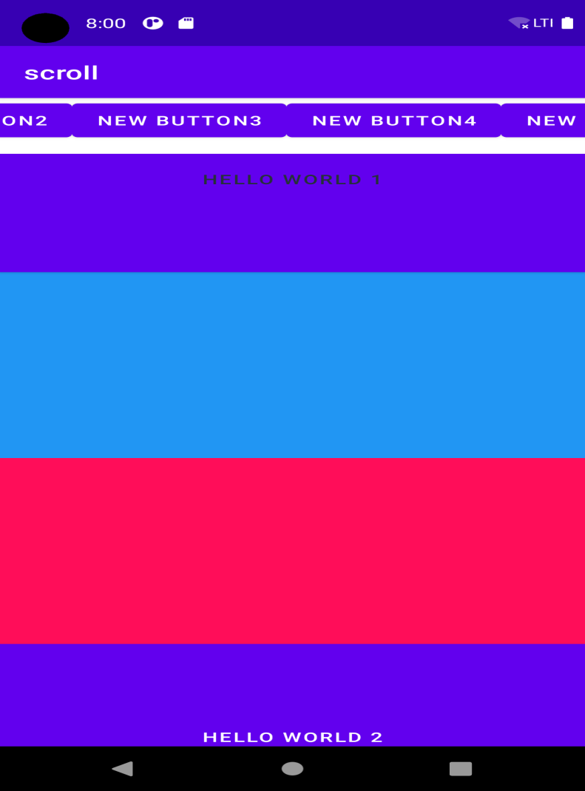

\

PRACTICAL 8

Create sample application with login module.(Check username and password) On successful login, display welcome message in next activity. And on failing login, alert user using Toast “Login fail “and Button will remain disabled.

XML FILE

*<?*xml version="1.0" encoding="utf-8"*?>*<RelativeLayout xmlns:android="http://schemas.android.com/apk/res/android"  
 xmlns:app="http://schemas.android.com/apk/res-auto"  
 xmlns:tools="http://schemas.android.com/tools"  
 android:layout\_width="match\_parent"  
 android:layout\_height="match\_parent"  
 tools:context=".MainActivity">  
  
 <TextView  
 android:id="@+id/title"  
 android:layout\_width="wrap\_content"  
 android:layout\_height="wrap\_content"  
 android:layout\_centerHorizontal="true"  
 android:layout\_marginTop="50dp"  
 android:shadowColor="#4E4747"  
 android:shadowRadius="@dimen/material\_emphasis\_medium"  
 android:text="LOGIN"  
 android:textColor="#4CAF50"  
 android:textSize="34sp"  
 android:textStyle="bold" />  
  
 <TextView  
 android:id="@+id/userTitle"  
 android:layout\_width="wrap\_content"  
 android:layout\_height="wrap\_content"  
 android:layout\_below="@+id/title"  
 android:layout\_marginStart="10dp"  
 android:layout\_marginTop="50dp"  
 android:text="Username"  
 android:textSize="20sp"  
 android:textStyle="bold" />  
  
 <EditText  
 android:id="@+id/userEd"  
 android:layout\_width="270dp"  
 android:layout\_height="wrap\_content"  
 android:layout\_below="@id/title"  
 android:layout\_marginLeft="20dp"  
 android:layout\_marginTop="50dp"  
 android:layout\_toRightOf="@+id/userTitle"  
 android:background="@android:drawable/editbox\_dropdown\_light\_frame"  
 android:hint="Enter Your Name"  
 android:inputType="textPersonName"  
 android:lines="1"  
 android:minHeight="48dp"  
 android:textColor="@color/black" />  
  
 <TextView  
 android:id="@+id/passTitle"  
 android:layout\_width="wrap\_content"  
 android:layout\_height="wrap\_content"  
 android:layout\_below="@+id/userTitle"  
 android:layout\_marginStart="10dp"  
 android:layout\_marginTop="50dp"  
 android:text="Password"  
 android:textSize="20sp"  
 android:textStyle="bold" />  
  
 <EditText  
 android:id="@+id/passEd"  
 android:layout\_width="270dp"  
 android:layout\_height="wrap\_content"  
 android:layout\_below="@id/userTitle"  
 android:layout\_marginLeft="20dp"  
 android:layout\_marginTop="50dp"  
 android:layout\_toRightOf="@+id/passTitle"  
 android:background="@android:drawable/editbox\_dropdown\_light\_frame"  
 android:hint="Enter Your Password"  
 android:inputType="textPassword"  
 android:lines="1"  
 android:minHeight="48dp"  
 android:textColor="@color/black" />  
  
  
 <Button  
 android:id="@+id/btn"  
 android:layout\_width="wrap\_content"  
 android:layout\_height="wrap\_content"  
 android:layout\_below="@id/passEd"  
 android:layout\_centerHorizontal="true"  
 android:layout\_marginTop="100dp"  
 android:text="Submit"  
 android:textSize="20sp" />  
</RelativeLayout>

**JAVA FILE ACTIVITY 1**

package com.example.lifecycle;  
import androidx.appcompat.app.AppCompatActivity;  
  
import android.content.Intent;  
import android.view.View;  
import android.widget.Button;  
import android.widget.EditText;  
import android.widget.TextView;  
import android.os.Bundle;  
import android.widget.Toast;  
  
public class MainActivity extends AppCompatActivity {  
 private Button button;  
 private EditText username, password;  
  
 @Override  
 protected void onCreate(Bundle savedInstanceState) {  
 super.onCreate(savedInstanceState);  
 setContentView(R.layout.*activity\_main*);  
  
 button = (Button) findViewById(R.id.*btn*);  
 username = (EditText) findViewById(R.id.*userEd*);  
 password = (EditText) findViewById(R.id.*passEd*);  
  
 button.setOnClickListener(new View.OnClickListener() {  
 @Override  
 public void onClick(View v) {  
  
 if(username.getText().toString().equals("admin") && password.getText().toString().equals("admin")){  
 Toast.*makeText*(getApplicationContext(),  
 "Redirecting...",Toast.*LENGTH\_LONG*).show();  
 showSecondActivity();  
 }else{  
 Toast.*makeText*(getApplicationContext(),  
 "Login Failed...",Toast.*LENGTH\_LONG*).show();  
 }  
  
  
 }  
 });  
  
 }  
 public void showSecondActivity()  
 {  
 startActivity(new Intent(this,MainActivity2.class));  
 }  
}

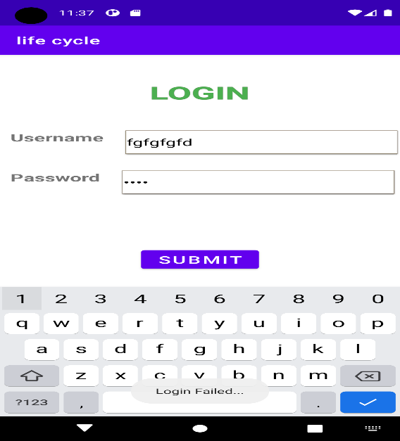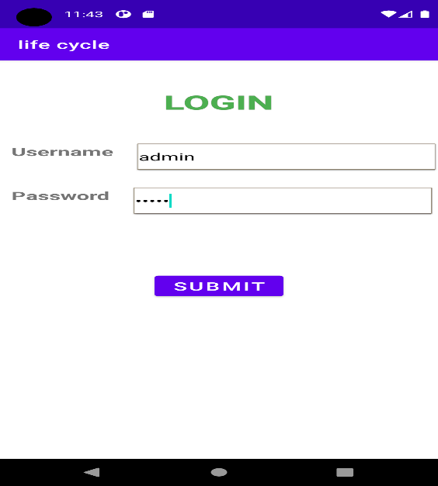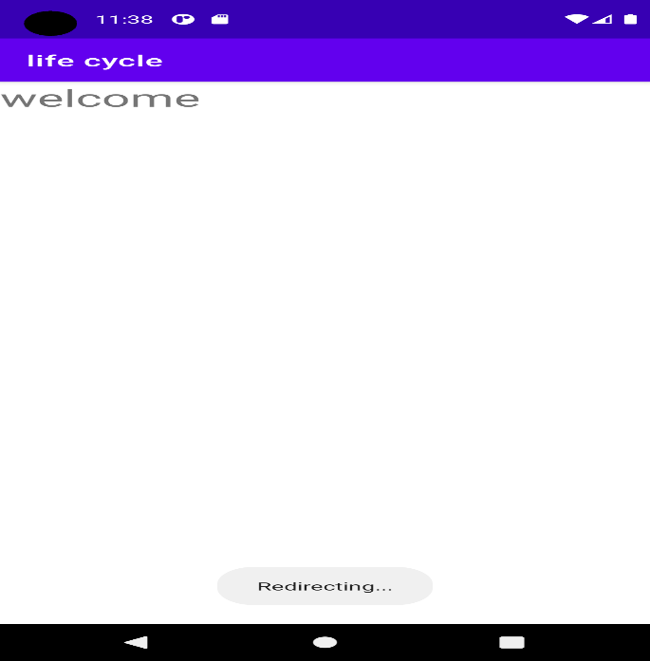

Practical 9

Create Email Registration form for demonstration of basic widgets available in android. Display all submitted data in another activity as a toast message.

*<?*xml version="1.0" encoding="utf-8"*?>*<RelativeLayout xmlns:android="http://schemas.android.com/apk/res/android"  
 xmlns:app="http://schemas.android.com/apk/res-auto"  
 xmlns:tools="http://schemas.android.com/tools"  
 android:layout\_width="match\_parent"  
 android:layout\_height="match\_parent"  
 tools:context=".MainActivity">  
 <TextView  
 android:id="@+id/t1"  
 android:layout\_width="wrap\_content"  
 android:layout\_height="wrap\_content"  
 android:text="Registration Form"  
 android:textColor="@color/blue"  
 android:textSize="30dp"  
 android:layout\_centerHorizontal="true"/>  
 <TextView  
 android:id="@+id/t2"  
 android:layout\_width="wrap\_content"  
 android:layout\_height="wrap\_content"  
 android:text="Email="  
 android:textSize="30dp"  
 android:layout\_below="@+id/t1"  
 android:layout\_marginTop="20px"/>  
  
 <EditText  
 android:id="@+id/e1"  
 android:layout\_width="150dp"  
 android:layout\_height="wrap\_content"  
 android:layout\_below="@+id/t1"  
 android:layout\_marginLeft="80dp"  
 android:layout\_toRightOf="@+id/t2"  
 android:hint="Email"  
 android:textSize="20dp" />  
 <TextView  
 android:id="@+id/t3"  
 android:layout\_width="wrap\_content"  
 android:layout\_height="wrap\_content"  
 android:text="password="  
 android:textSize="30dp"  
 android:layout\_below="@+id/t2"  
 android:layout\_marginTop="20px"/>  
  
 <EditText  
 android:id="@+id/e2"  
 android:layout\_width="150dp"  
 android:layout\_height="wrap\_content"  
 android:layout\_below="@+id/e1"  
 android:layout\_marginLeft="30dp"  
 android:layout\_toRightOf="@+id/t3"  
 android:hint="password"  
 android:textSize="20dp" />  
 <TextView  
 android:id="@+id/t4"  
 android:layout\_width="wrap\_content"  
 android:layout\_height="wrap\_content"  
 android:text="age="  
 android:textSize="30dp"  
 android:layout\_below="@+id/t3"  
 android:layout\_marginTop="20px"/>  
  
 <EditText  
 android:id="@+id/e3"  
 android:layout\_width="150dp"  
 android:layout\_height="wrap\_content"  
 android:layout\_below="@+id/e2"  
 android:layout\_marginLeft="110dp"  
 android:layout\_toRightOf="@+id/t4"  
 android:hint="age"  
 android:textSize="20dp" />  
 <RadioGroup  
 android:id="@+id/r1"  
 android:layout\_marginLeft="40dp"  
 android:layout\_width="wrap\_content"  
 android:layout\_height="wrap\_content"  
 android:text="gender"  
 android:layout\_below="@+id/t4">  
 <RadioButton  
 android:id="@+id/r2"  
 android:layout\_width="wrap\_content"  
 android:layout\_height="wrap\_content"  
 android:layout\_below="@+id/t4"  
 android:text="male"  
 android:textSize="30dp" />  
 <RadioButton  
 android:layout\_width="wrap\_content"  
 android:layout\_height="wrap\_content"  
 android:text="female"  
 android:layout\_toRightOf="@+id/r2"  
 android:textSize="30dp"/>  
 </RadioGroup>  
<TextView  
 android:id="@+id/t5"  
 android:layout\_width="wrap\_content"  
 android:layout\_height="wrap\_content"  
 android:text="address="  
 android:layout\_below="@+id/r1"  
 android:textSize="30dp"/>  
 <EditText  
 android:id="@+id/e4"  
 android:layout\_width="150dp"  
 android:layout\_height="wrap\_content"  
 android:hint="address"  
 android:textSize="20dp"  
 android:layout\_marginLeft="50dp"  
 android:layout\_toRightOf="@+id/t5"  
 android:layout\_below="@+id/r1"/>  
 <Button  
 android:id="@+id/b1"  
 android:layout\_width="wrap\_content"  
 android:layout\_height="wrap\_content"  
 android:text="submit"  
 android:layout\_below="@id/t5"  
 android:layout\_marginTop="50dp"  
 android:textSize="30dp"  
 android:layout\_centerHorizontal="true"/>  
  
</RelativeLayout>

**Java file**

package com.example.radiodemo;  
import androidx.appcompat.app.AppCompatActivity;  
import android.os.Bundle;  
import android.view.View;  
import android.widget.Button;  
import android.widget.EditText;  
import android.widget.RadioButton;  
import android.widget.RadioGroup;  
import android.widget.Toast;  
  
public class MainActivity extends AppCompatActivity {  
  
 @Override  
 protected void onCreate(Bundle savedInstanceState) {  
 super.onCreate(savedInstanceState);  
 setContentView(R.layout.*activity\_main*);  
 RadioGroup r1;  
 EditText e1,e2,e3,e4;  
 Button b1;  
 e1 = findViewById(R.id.*e1*);  
 e2 = findViewById(R.id.*e2*);  
 e3 = findViewById(R.id.*e3*);  
 e4 = findViewById(R.id.*e4*);  
 r1 = findViewById(R.id.*r1*);  
 b1 = findViewById(R.id.*b1*);  
  
 b1.setOnClickListener(new View.OnClickListener() {  
 @Override  
 public void onClick(View view) {  
 RadioButton rb;  
  
 int selectedId = r1.getCheckedRadioButtonId();  
 rb = (RadioButton) findViewById(selectedId);  
 String s = rb.getText().toString();  
 String concatedText = e1.getText().toString() + "\n" + e2.getText().toString() + "\n" + e3.getText().toString() + "\n" + s + "\n" + e4.getText().toString();  
  
  
 Toast.*makeText*(getApplicationContext(),  
 concatedText ,Toast.*LENGTH\_LONG*).show();  
  
  
 }  
 });  
 }  
}

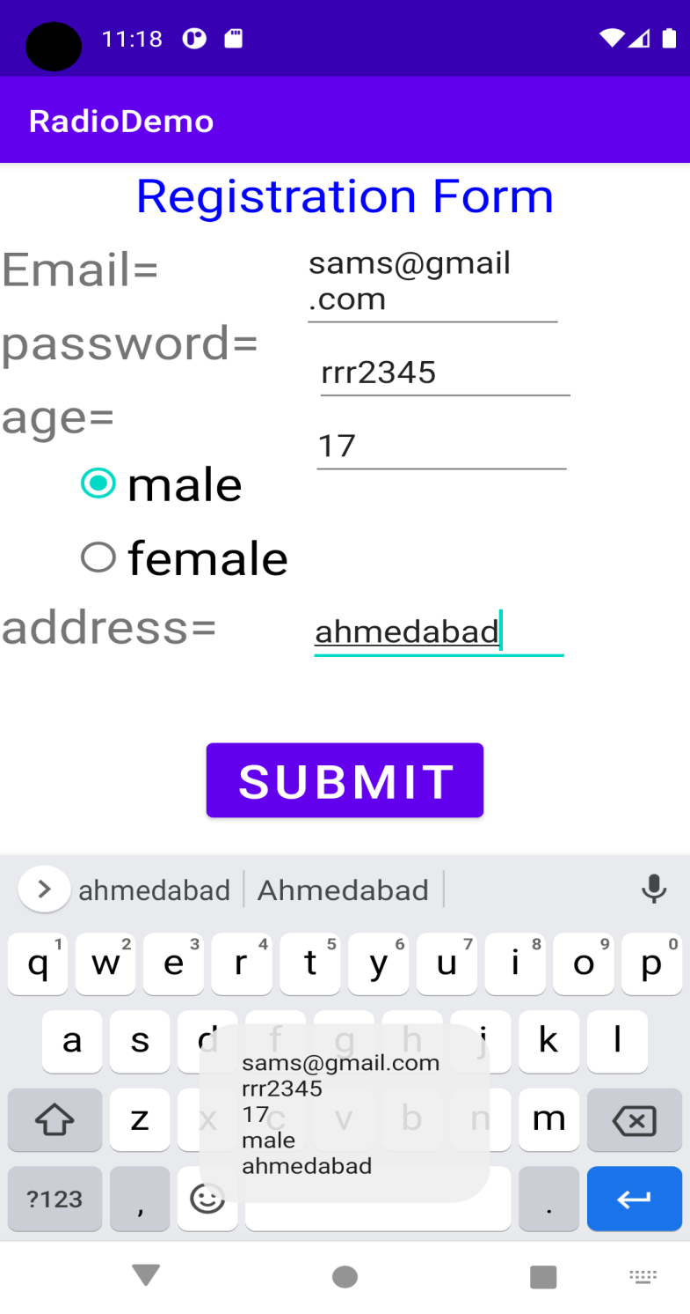

Practical -10

Aim: Create application with three different Radio button and by clicking them change background of activity.

*<?*xml version="1.0" encoding="utf-8"*?>*<LinearLayout xmlns:android="http://schemas.android.com/apk/res/android"  
 xmlns:app="http://schemas.android.com/apk/res-auto"  
 xmlns:tools="http://schemas.android.com/tools"  
 android:layout\_width="match\_parent"  
 android:layout\_height="match\_parent"  
 android:orientation="vertical"  
 android:id="@+id/linearLayout"  
 tools:context=".MainActivity">  
 <RadioButton  
 android:id="@+id/redb"  
 android:layout\_width="wrap\_content"  
 android:layout\_height="wrap\_content"  
 android:text=" Red"  
 android:layout\_marginLeft="15dp"  
 android:textColor="@color/red"  
 android:layout\_marginTop="150dp"  
 android:textSize="50dp"/>.  
 <RadioButton  
 android:id="@+id/greenb"  
 android:layout\_width="wrap\_content"  
 android:layout\_height="wrap\_content"  
 android:layout\_marginLeft="15dp"  
 android:textColor="@color/green"  
 android:layout\_marginTop="50dp"  
 android:textSize="50dp"  
 android:text=" Green"  
 />  
 <RadioButton  
 android:id="@+id/blueb"  
 android:layout\_width="wrap\_content"  
 android:layout\_height="wrap\_content"  
 android:text=" Blue"  
 android:textColor="@color/blue"  
 android:layout\_marginLeft="15dp"  
 android:layout\_marginTop="50dp"  
 android:textSize="50dp"  
 />  
  
</LinearLayout>

Java file

package com.example.radiodemo;  
  
import androidx.appcompat.app.AppCompatActivity;  
import android.graphics.Color;  
import android.os.Bundle;  
import android.view.View;  
import android.widget.LinearLayout;  
import android.widget.RadioButton;  
  
public class MainActivity extends AppCompatActivity {  
 @Override  
 protected void onCreate(Bundle savedInstanceState) {  
 super.onCreate(savedInstanceState);  
 setContentView(R.layout.*activity\_main*)  
 RadioButton rdb1, rdb2, rdb3;  
 LinearLayout layout;  
  
 rdb1 = findViewById(R.id.*redb*);  
 rdb2 = findViewById(R.id.*greenb*);  
 rdb3 = findViewById(R.id.*blueb*);  
 layout = findViewById(R.id.*linearLayout*);  
  
 rdb1.setOnClickListener(new View.OnClickListener() {  
 @Override  
 public void onClick(View view) {  
 layout.setBackgroundResource(R.color.*red*);  
 rdb1.setTextColor(Color.*BLACK*);  
 }  
 });  
  
 rdb2.setOnClickListener(new View.OnClickListener() {  
 @Override  
 public void onClick(View view) {  
 layout.setBackgroundResource(R.color.*green*);  
 rdb2.setTextColor(Color.*BLACK*);  
 }  
 });  
  
 rdb3.setOnClickListener(new View.OnClickListener() {  
 @Override  
 public void onClick(View view) {  
 layout.setBackgroundResource(R.color.*blue*);  
 rdb3.setTextColor(Color.*BLACK*);  
 }

});

}  
}

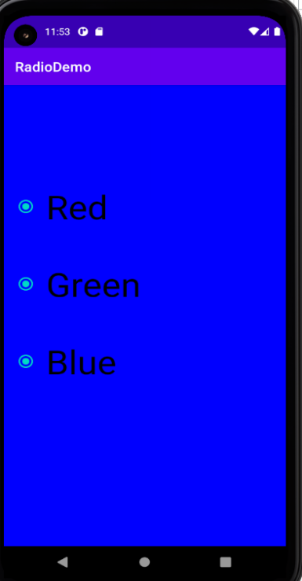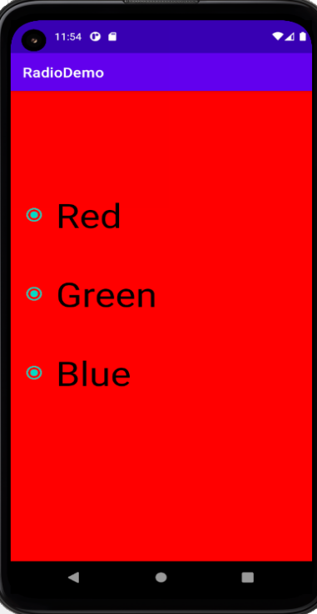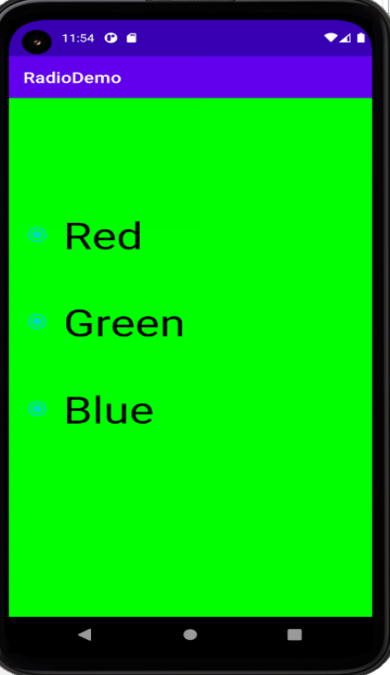

Practical 11

Create an application in which when user clicks button, user will navigate to next screen which display welcome message (using Explicit Intent).

*<?*xml version="1.0" encoding="utf-8"*?>*<RelativeLayout xmlns:android="http://schemas.android.com/apk/res/android"  
 android:layout\_width="fill\_parent"  
 android:layout\_height="fill\_parent">  
  
  
 <TextView  
 android:layout\_width="wrap\_content"  
 android:layout\_height="wrap\_content"  
 android:textAppearance="?android:attr/textAppearanceSmall"  
 android:text="FIRST ACTIVITY"  
 android:id="@+id/textView"  
 android:layout\_alignParentTop="true"  
 android:textSize="40dp"  
 android:layout\_centerHorizontal="true" />  
  
 <Button  
 android:id="@+id/btn"  
 android:layout\_width="wrap\_content"  
 android:layout\_height="wrap\_content"  
 android:layout\_below="@+id/textView"  
 android:layout\_marginLeft="90dp"  
 android:layout\_marginTop="49dp"  
 android:text="next activity"  
 android:textSize="20dp"  
 />  
  
</RelativeLayout>

Java file activity 1

package com.example.lifecycle;  
import androidx.appcompat.app.AppCompatActivity;  
  
import android.content.Intent;  
import android.view.View;  
import android.widget.Button;  
import android.widget.TextView;  
import android.os.Bundle;  
public class MainActivity extends AppCompatActivity {  
 private Button button;  
  
  
 @Override  
 protected void onCreate(Bundle savedInstanceState) {  
 super.onCreate(savedInstanceState);  
 setContentView(R.layout.*activity\_main*);  
  
 button = (Button) findViewById(R.id.*btn*);  
 button.setOnClickListener(new View.OnClickListener() {  
 @Override  
 public void onClick(View v) {  
 showSecondActivity();  
  
 }  
 });  
  
 }  
 public void showSecondActivity()  
 {  
 startActivity(new Intent(this,MainActivity2.class));  
 }  
}

Second activity

*<?*xml version="1.0" encoding="utf-8"*?>*<LinearLayout xmlns:android="http://schemas.android.com/apk/res/android"  
 xmlns:app="http://schemas.android.com/apk/res-auto"  
 xmlns:tools="http://schemas.android.com/tools"  
 android:layout\_width="match\_parent"  
 android:layout\_height="match\_parent"  
 tools:context=".MainActivity2">  
  
 <TextView  
 android:layout\_width="match\_parent"  
 android:layout\_height="match\_parent"  
 android:text="welcome"  
 android:textSize="30dp" />  
  
</LinearLayout>

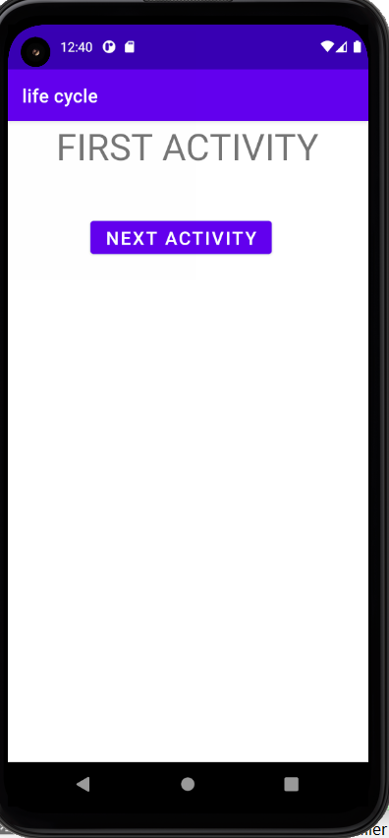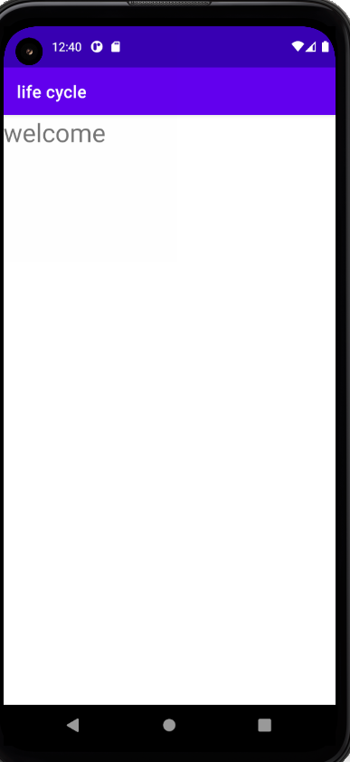

Practical 12

Create an appliccation using button,Image button ,Togglebutton

Xml file

*<?*xml version="1.0" encoding="utf-8"*?>*<RelativeLayout xmlns:android="http://schemas.android.com/apk/res/android"  
 xmlns:app="http://schemas.android.com/apk/res-auto"  
 xmlns:tools="http://schemas.android.com/tools"  
 android:layout\_width="match\_parent"  
 android:layout\_height="match\_parent"  
 tools:context=".MainActivity">  
 <Button  
 android:id="@+id/b1"  
 android:layout\_width="wrap\_content"  
 android:layout\_height="wrap\_content"  
 android:text="hello"  
 android:textSize="30dp"  
 android:layout\_centerHorizontal="true"/>  
  
 <ToggleButton  
 android:layout\_width="wrap\_content"  
 android:layout\_height="wrap\_content"  
 android:layout\_below="@+id/b1"  
 android:layout\_centerHorizontal="true"  
 android:textSize="20dp" />  
  
 <ImageButton  
 android:id="@+id/i1"  
 android:layout\_width="wrap\_content"  
 android:layout\_height="wrap\_content"  
 android:layout\_centerInParent="true"  
 android:background="#000"  
 android:src="@drawable/emptyflower" />  
  
</RelativeLayout>

Java file

package com.example.imagebutton;  
  
import androidx.appcompat.app.AppCompatActivity;  
import android.os.Bundle;  
import android.view.View;  
import android.widget.Button;  
import android.widget.ImageButton;  
import android.widget.Toast;  
  
public class MainActivity extends AppCompatActivity {  
  
 @Override  
 public void onCreate(Bundle savedInstanceState) {  
 super.onCreate(savedInstanceState);  
 setContentView(R.layout.*activity\_main*);  
 Button b1=(Button) this.findViewById(R.id.*b1*);  
 ImageButton ib = (ImageButton) this.findViewById(R.id.*i1*);  
 ib.setOnLongClickListener(new View.OnLongClickListener() {  
 @Override  
 public boolean onLongClick(View view) {  
 ib.setImageResource(R.drawable.*flower*);  
 return false;  
 }  
 });  
 b1.setOnClickListener(new View.OnClickListener() {  
 @Override  
 public void onClick(View view) {  
 Toast.*makeText*(MainActivity.this, "hello", Toast.*LENGTH\_SHORT*).show();  
 }  
 });  
 }  
}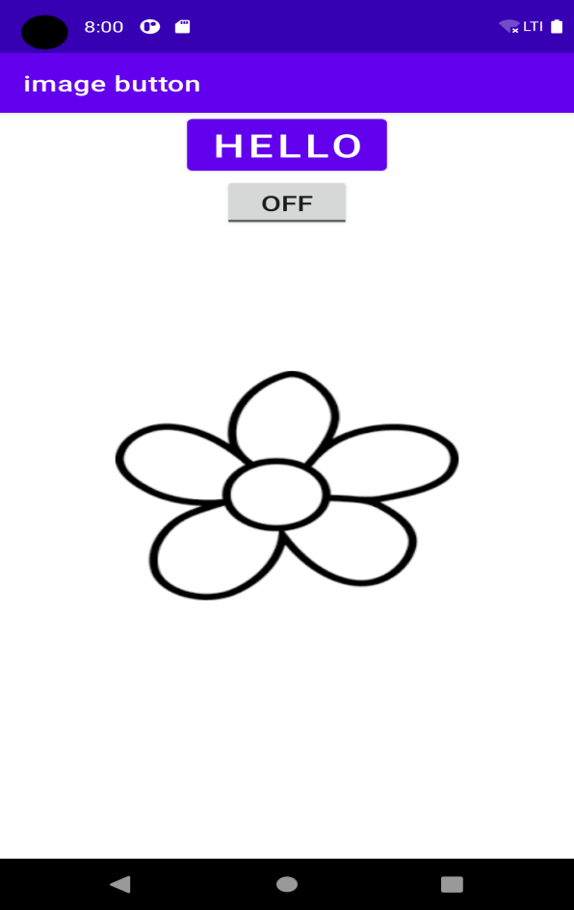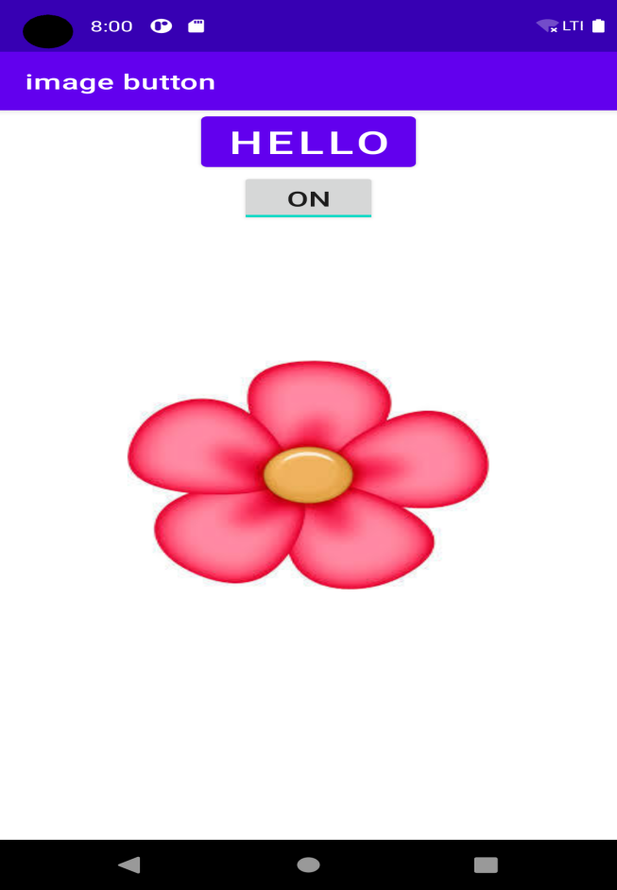

PRACTICAL 13

Create an application that will pass two number using Edit Text to the next screen and on the next screen display sum of that number

*<?*xml version="1.0" encoding="utf-8"*?>*<RelativeLayout xmlns:android="http://schemas.android.com/apk/res/android"  
 xmlns:app="http://schemas.android.com/apk/res-auto"  
 xmlns:tools="http://schemas.android.com/tools"  
 android:layout\_width="match\_parent"  
 android:layout\_height="match\_parent"  
 tools:context=".MainActivity"  
 tools:layout\_editor\_absoluteY="81dp">  
  
 <TextView  
 android:id="@+id/textView\_answer"  
 android:layout\_width="100dp"  
 android:layout\_height="25dp"  
 android:layout\_marginLeft="130dp"  
 android:layout\_marginTop="300dp"  
 android:text="0"  
 android:textSize="20dp"  
 android:textStyle="bold" />  
  
 <EditText  
 android:id="@+id/editText\_first\_no"  
 android:layout\_width="150dp"  
 android:layout\_height="40dp"  
 android:layout\_marginLeft="200dp"  
 android:layout\_marginTop="40dp"  
 android:inputType="number" />  
  
 <TextView  
 android:id="@+id/textView\_first\_no"  
 android:layout\_width="150dp"  
 android:layout\_height="25dp"  
 android:layout\_marginLeft="10dp"  
 android:layout\_marginTop="50dp"  
 android:text="First number"  
 android:textSize="20dp" />  
  
 <TextView  
 android:id="@+id/textView\_second\_no"  
 android:layout\_width="150dp"  
 android:layout\_height="25dp"  
 android:layout\_marginLeft="10dp"  
 android:layout\_marginTop="100dp"  
 android:text="Second number"  
 android:textSize="20dp" />  
  
 <EditText  
 android:id="@+id/editText\_second\_no"  
 android:layout\_width="150dp"  
 android:layout\_height="40dp"  
 android:layout\_marginLeft="200dp"  
 android:layout\_marginTop="90dp"  
 android:inputType="number"  
 tools:ignore="MissingConstraints" />  
  
 <Button  
 android:id="@+id/add\_button"  
 android:layout\_width="100dp"  
 android:layout\_height="50dp"  
 android:layout\_marginLeft="110dp"  
 android:layout\_marginTop="200dp"  
 android:text="ADD" />  
  
</RelativeLayout>

JAVA FILE

package com.example.registrationtost;  
  
import androidx.appcompat.app.AppCompatActivity;  
  
import android.graphics.Color;  
import android.os.Bundle;  
import android.view.View;  
import android.widget.Button;  
import android.widget.EditText;  
import android.widget.TextView;  
  
public class MainActivity extends AppCompatActivity {  
 EditText number1;  
 EditText number2;  
 Button Add\_button;  
 TextView result;  
 int ans=0;  
  
 @Override  
 protected void onCreate(Bundle savedInstanceState) {  
 super.onCreate(savedInstanceState);  
 setContentView(R.layout.*activity\_main*);  
  
 number1=(EditText) findViewById(R.id.*editText\_first\_no*);  
 number2=(EditText) findViewById(R.id.*editText\_second\_no*);  
 Add\_button=(Button) findViewById(R.id.*add\_button*);  
 result = (TextView) findViewById(R.id.*textView\_answer*);  
  
 Add\_button.setOnClickListener(new View.OnClickListener() {  
  
 public void onClick(View v) {  
  
 double num1 = Double.*parseDouble*(number1.getText().toString());  
 double num2 = Double.*parseDouble*(number2.getText().toString());  
  
 double sum = num1 + num2;  
  
 result.setText(Double.*toString*(sum));  
 }  
 });  
 }  
}

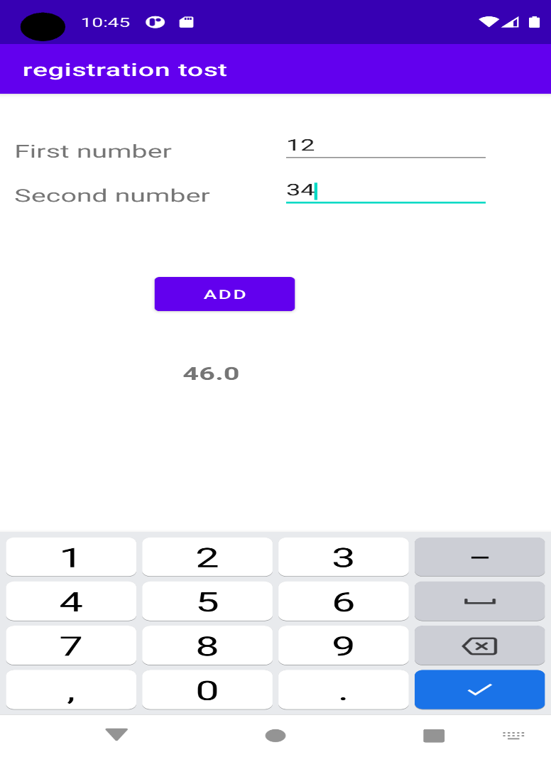

Practical 14

Create an application that will get the Text Entered in Edit Text and display that Text using toast (Message).

*<?*xml version="1.0" encoding="utf-8"*?>*<RelativeLayout xmlns:android="http://schemas.android.com/apk/res/android"  
 xmlns:app="http://schemas.android.com/apk/res-auto"  
 xmlns:tools="http://schemas.android.com/tools"  
 android:layout\_width="match\_parent"  
 android:layout\_height="match\_parent"  
 tools:context=".MainActivity"  
 tools:layout\_editor\_absoluteY="81dp">  
  
 <EditText  
 android:id="@+id/e1"  
 android:layout\_width="wrap\_content"  
 android:layout\_height="wrap\_content"  
 android:text=""  
 android:textSize="30dp"  
 android:layout\_marginTop="50dp"  
 android:layout\_marginLeft="160dp"/>  
  
 <Button  
 android:id="@+id/b2"  
 android:layout\_width="wrap\_content"  
 android:layout\_height="wrap\_content"  
 android:text="submit"  
 android:layout\_marginTop="300dp"  
 android:layout\_marginLeft="150dp"/>  
  
  
</RelativeLayout>

**Java file**

package com.example.registrationtost;  
  
import androidx.appcompat.app.AppCompatActivity;  
import android.os.Bundle;  
import android.view.View;  
import android.widget.Button;  
import android.widget.EditText;  
import android.widget.Toast;  
  
public class MainActivity extends AppCompatActivity {  
 EditText e1;  
 Button b2;  
   
 @Override  
 protected void onCreate(Bundle savedInstanceState) {  
 super.onCreate(savedInstanceState);  
 setContentView(R.layout.*activity\_main*);  
  
 e1=(EditText) findViewById(R.id.*e1*);  
 b2=(Button) findViewById(R.id.*b2*);  
   
 b2.setOnClickListener(new View.OnClickListener() {  
 public void onClick(View v) {  
  
 Toast.*makeText*(getApplicationContext(),  
 e1.getText(),Toast.*LENGTH\_LONG*).show();  
  
 }  
 });  
 }  
}

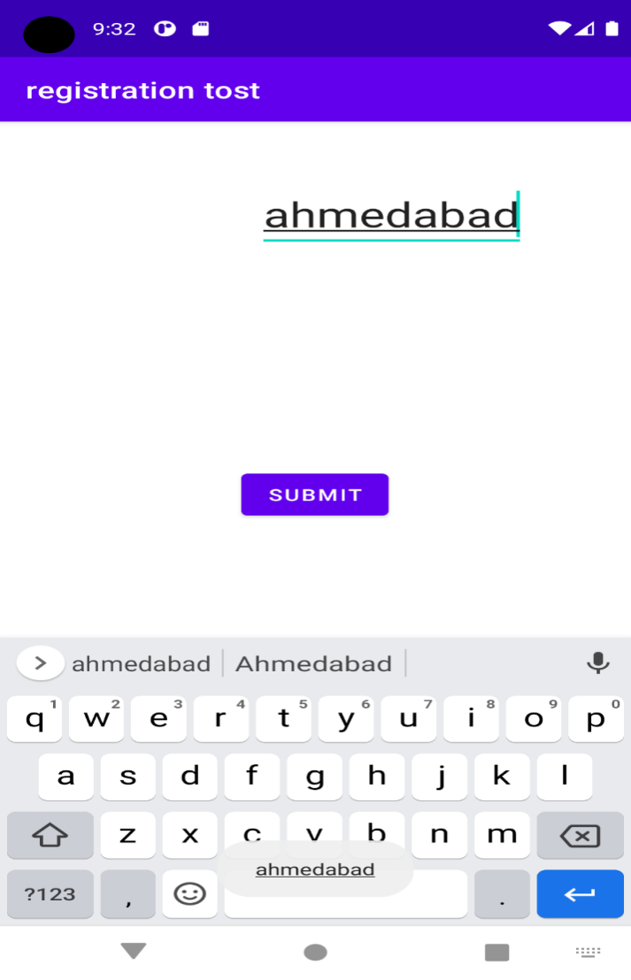

**PRACTICAL 15**

Create an android application to convert temperature from centigrade to Fahrenheit

*<?*xml version="1.0" encoding="utf-8"*?>*<RelativeLayout xmlns:android="http://schemas.android.com/apk/res/android"  
 xmlns:app="http://schemas.android.com/apk/res-auto"  
 xmlns:tools="http://schemas.android.com/tools"  
 android:layout\_width="match\_parent"  
 android:layout\_height="match\_parent"  
 tools:context=".MainActivity"  
 tools:layout\_editor\_absoluteY="81dp">  
  
 <EditText  
 android:id="@+id/e1"  
 android:layout\_width="wrap\_content"  
 android:layout\_height="wrap\_content"  
 android:text=""  
 android:textSize="30dp"  
 android:layout\_marginTop="50dp"  
 android:layout\_marginLeft="160dp"/>  
  
 <Button  
 android:id="@+id/b2"  
 android:layout\_width="wrap\_content"  
 android:layout\_height="wrap\_content"  
 android:text="submit"  
 android:layout\_marginTop="300dp"  
 android:layout\_marginLeft="150dp"/>  
  
  
</RelativeLayout>

**JAVA FILE**

package com.example.registrationtost;  
  
import androidx.appcompat.app.AppCompatActivity;  
import android.os.Bundle;  
import android.view.View;  
import android.widget.Button;  
import android.widget.EditText;  
import android.widget.Toast;  
public class MainActivity extends AppCompatActivity {  
 EditText e1;  
 Button b2;  
 Double a;  
   
 @Override  
 protected void onCreate(Bundle savedInstanceState) {  
 super.onCreate(savedInstanceState);  
 setContentView(R.layout.*activity\_main*);  
  
 e1=(EditText) findViewById(R.id.*e1*);  
 b2=(Button) findViewById(R.id.*b2*);  
   
 b2.setOnClickListener(new View.OnClickListener() {  
 public void onClick(View v) {  
 a=Double.*parseDouble*(String.*valueOf*(e1.getText()));  
 Double b=a\*9/5+32;  
 String r=String.*valueOf*(b);  
 Toast.*makeText*(MainActivity.this,r+"°F",Toast.*LENGTH\_SHORT*).show();  
  
 }  
 });  
 }  
}

**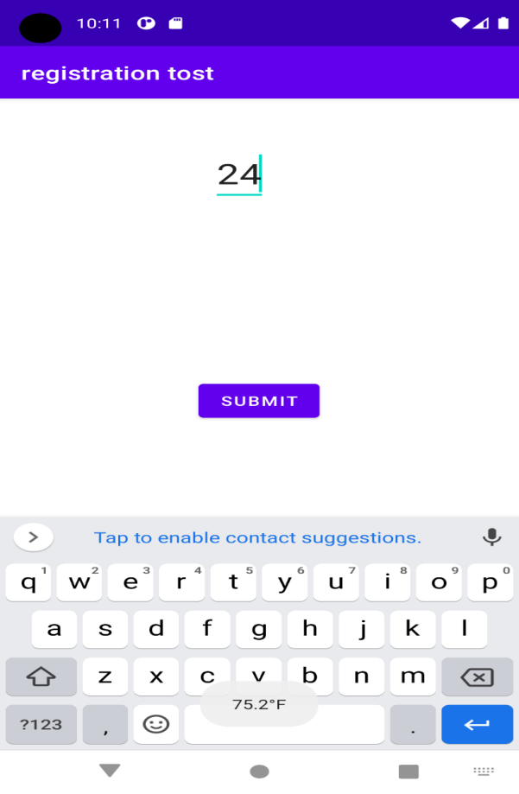**

PRACTICAL 16

Create an android application to perform addition, subtraction, multiplication, division operations of two numbers and also find maximum from them. Display toast message for all result.

<?xml version="1.0" encoding="utf-8"?>  
<RelativeLayout xmlns:android="http://schemas.android.com/apk/res/android"  
 xmlns:app="http://schemas.android.com/apk/res-auto"  
 xmlns:tools="http://schemas.android.com/tools"  
 android:layout\_width="match\_parent"  
 android:layout\_height="match\_parent"  
 tools:context=".MainActivity"  
 tools:layout\_editor\_absoluteY="81dp">  
<TextView  
 android:id="@+id/t1"  
 android:layout\_width="wrap\_content"  
 android:layout\_height="wrap\_content"  
 android:text="no 1"  
 android:textSize="30dp"/>  
 <EditText  
 android:id="@+id/e1"  
 android:layout\_width="match\_parent"  
 android:layout\_height="wrap\_content"  
 android:text=""  
 android:textSize="20dp"  
 android:layout\_toRightOf="@+id/t1"  
 android:hint="no 1" />  
 <TextView  
 android:id="@+id/t2"  
 android:layout\_width="wrap\_content"  
 android:layout\_height="wrap\_content"  
 android:text="no 2"  
 android:layout\_marginTop="20dp"  
 android:layout\_below="@+id/t1"  
 android:textSize="30dp"/>  
 <EditText  
 android:id="@+id/e2"  
 android:layout\_width="match\_parent"  
 android:layout\_height="wrap\_content"  
 android:text=""  
 android:layout\_marginTop="10dp"  
 android:textSize="20dp"  
 android:layout\_toRightOf="@+id/t2"  
 android:layout\_below="@+id/e1"  
 android:hint="no 2"/>  
 <Button  
 android:id="@+id/b1"  
 android:layout\_width="wrap\_content"  
 android:layout\_height="wrap\_content"  
 android:text="sum"  
 android:layout\_marginTop="200dp"  
 android:layout\_marginLeft="150dp"/>  
 <Button  
 android:id="@+id/b2"  
 android:layout\_width="wrap\_content"  
 android:layout\_height="wrap\_content"  
 android:text="subtract"  
 android:layout\_marginTop="250dp"  
 android:layout\_marginLeft="150dp"/>  
 <Button  
 android:id="@+id/b3"  
 android:layout\_width="wrap\_content"  
 android:layout\_height="wrap\_content"  
 android:text="div"  
 android:layout\_marginTop="300dp"  
 android:layout\_marginLeft="150dp"/>  
 <Button  
 android:id="@+id/b4"  
 android:layout\_width="wrap\_content"  
 android:layout\_height="wrap\_content"  
 android:text="mul"  
 android:layout\_marginTop="350dp"  
 android:layout\_marginLeft="150dp"/>  
 <Button  
 android:id="@+id/b5"  
 android:layout\_width="wrap\_content"  
 android:layout\_height="wrap\_content"  
 android:text="greater then"  
 android:layout\_marginTop="400dp"  
 android:layout\_marginLeft="150dp"/>  
  
</RelativeLayout>

**JAVA FILE**

package com.example.registrationtost;  
  
import androidx.appcompat.app.AppCompatActivity;  
import android.os.Bundle;  
import android.view.View;  
import android.widget.Button;  
import android.widget.EditText;  
import android.widget.Toast;  
public class MainActivity extends AppCompatActivity {  
 EditText e1;  
 EditText e2;  
 Button b1;  
 Button b2;  
 Button b3;  
 Button b4;  
 Button b5;  
 Double a;  
 Double b;  
 double c;  
  
 @Override  
 protected void onCreate(Bundle savedInstanceState) {  
 super.onCreate(savedInstanceState);  
 setContentView(R.layout.*activity\_main*);  
  
 e1 = (EditText) findViewById(R.id.*e1*);  
 e2 = (EditText) findViewById(R.id.*e2*);  
 b2 = (Button) findViewById(R.id.*b2*);  
 b1 = (Button) findViewById(R.id.*b1*);  
 b3 = (Button) findViewById(R.id.*b3*);  
 b4 = (Button) findViewById(R.id.*b4*);  
 b5 = (Button) findViewById(R.id.*b5*);  
  
  
 b1.setOnClickListener(new View.OnClickListener() {  
 public void onClick(View v) {  
 a = Double.*parseDouble*(String.*valueOf*(e1.getText()));  
 b = Double.*parseDouble*(String.*valueOf*(e2.getText()));  
 Double c = a + b;  
 String r = String.*valueOf*(c);  
 Toast.*makeText*(MainActivity.this, r, Toast.*LENGTH\_SHORT*).show();  
  
 }  
 });  
 b2.setOnClickListener(new View.OnClickListener() {  
 public void onClick(View v) {  
 a = Double.*parseDouble*(String.*valueOf*(e1.getText()));  
 b = Double.*parseDouble*(String.*valueOf*(e2.getText()));  
 Double c = a - b;  
 String r = String.*valueOf*(c);  
 Toast.*makeText*(MainActivity.this, r, Toast.*LENGTH\_SHORT*).show();  
  
 }  
 });  
 b3.setOnClickListener(new View.OnClickListener() {  
 public void onClick(View v) {  
 a = Double.*parseDouble*(String.*valueOf*(e1.getText()));  
 b = Double.*parseDouble*(String.*valueOf*(e2.getText()));  
 Double c = a / b;  
 String r = String.*valueOf*(c);  
 Toast.*makeText*(MainActivity.this, r, Toast.*LENGTH\_SHORT*).show();  
  
 }  
 });  
 b4.setOnClickListener(new View.OnClickListener() {  
 public void onClick(View v) {  
 a = Double.*parseDouble*(String.*valueOf*(e1.getText()));  
 b = Double.*parseDouble*(String.*valueOf*(e2.getText()));  
 Double c = a \* b;  
 String r = String.*valueOf*(c);  
 Toast.*makeText*(MainActivity.this, r, Toast.*LENGTH\_SHORT*).show();  
  
 }  
 });

b5.setOnClickListener(new View.OnClickListener() {  
 @Override  
 public void onClick(View view) {  
 a = Double.*parseDouble*(String.*valueOf*(e1.getText()));  
 b = Double.*parseDouble*(String.*valueOf*(e2.getText()));  
 if(a>b){  
 String r=String.*valueOf*(a);  
 Toast.*makeText*(MainActivity.this, r, Toast.*LENGTH\_SHORT*).show();  
 }  
 else{  
 String r=String.*valueOf*(b);  
 Toast.*makeText*(MainActivity.this, r, Toast.*LENGTH\_SHORT*).show();  
  
 }  
 }  
});

}

}  
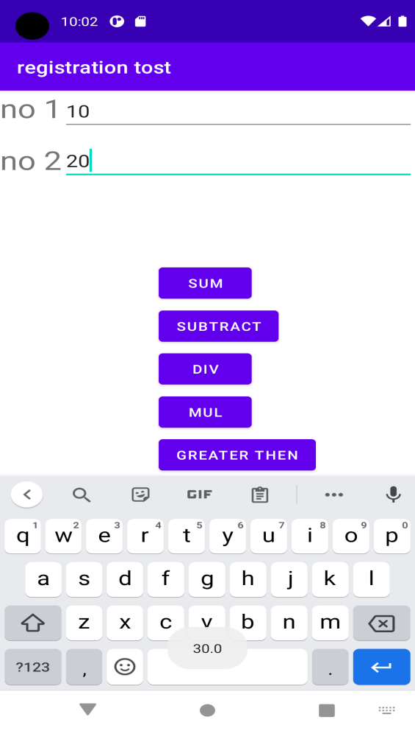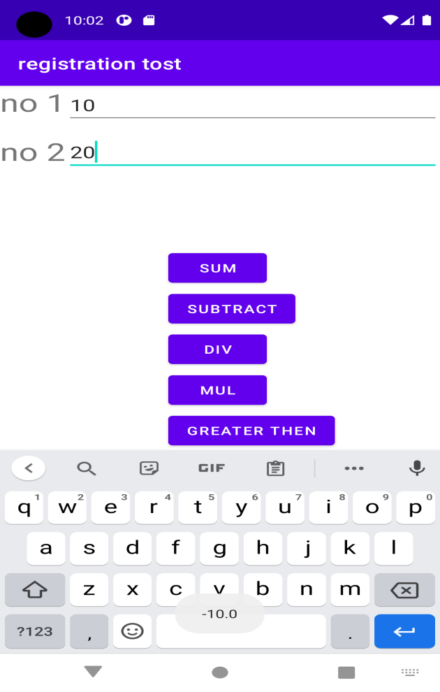

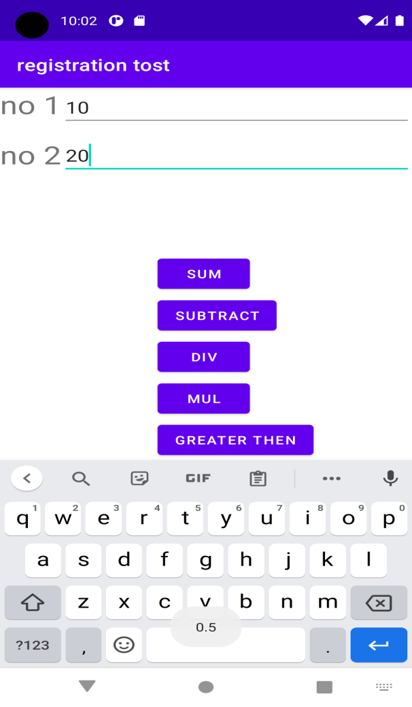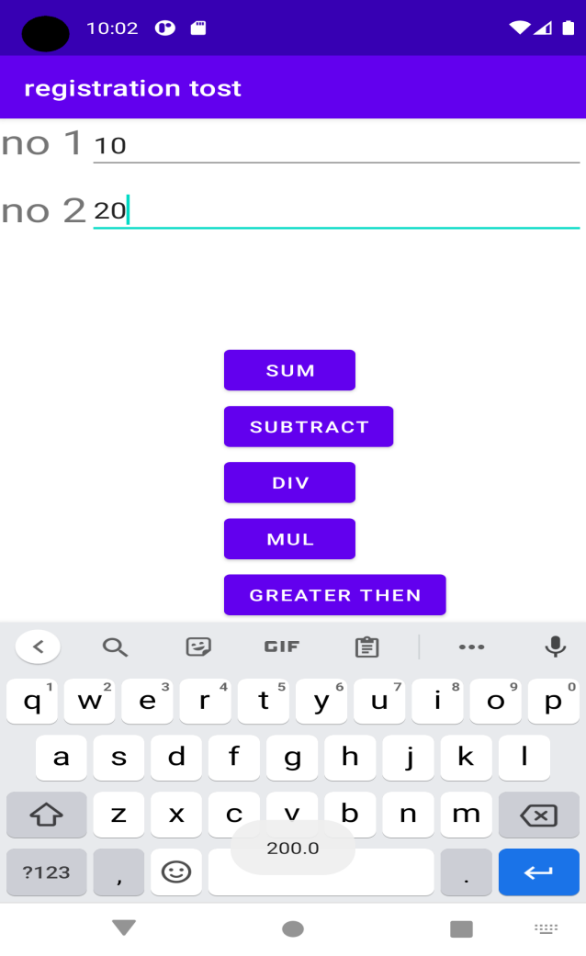

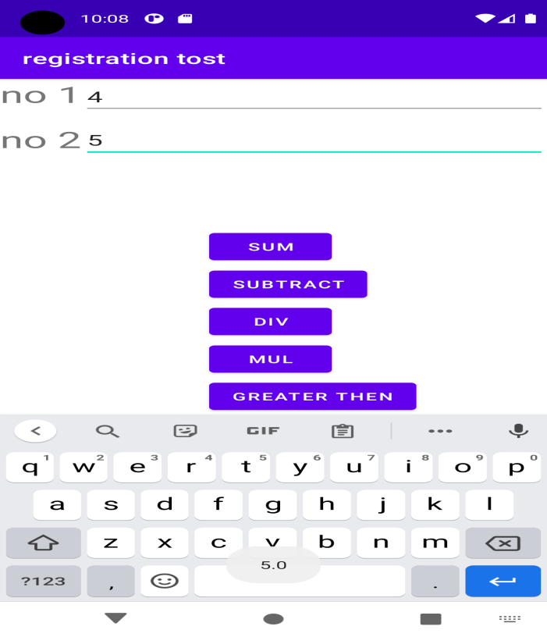

Practical 17

Create an application that will pass some number to the next screen and on the next screen that number of items should be display in the list

**Activity1.xml**

*<?*xml version="1.0" encoding="utf-8"*?>*<RelativeLayout xmlns:android="http://schemas.android.com/apk/res/android"  
 xmlns:app="http://schemas.android.com/apk/res-auto"  
 xmlns:tools="http://schemas.android.com/tools"  
 android:layout\_width="match\_parent"  
 android:layout\_height="match\_parent"  
 tools:context=".MainActivity">  
 <EditText  
 android:id="@+id/e1"  
 android:layout\_width="100dp"  
 android:layout\_height="wrap\_content"  
 android:layout\_centerVertical="true"  
 android:layout\_centerHorizontal="true"  
 android:hint="enter no"/>  
  
 <Button  
 android:id="@+id/b1"  
 android:layout\_width="wrap\_content"  
 android:layout\_height="wrap\_content"  
 android:text="submit"  
 android:layout\_below="@+id/e1"  
 android:layout\_centerHorizontal="true"/>  
  
</RelativeLayout>

**Activity1.java**

package com.example.listno;  
  
import android.app.Activity;  
import android.content.Intent;  
import android.os.Bundle;  
import android.view.View;  
import android.view.View.OnClickListener;  
import android.widget.Button;  
import android.widget.EditText;  
  
public class MainActivity extends Activity implements OnClickListener {  
  
 EditText editnum;  
 Button btshow;  
 @Override  
 public void onCreate(Bundle savedInstanceState) {  
 super.onCreate(savedInstanceState);  
 setContentView(R.layout.*activity\_main*);  
  
 editnum=(EditText) findViewById(R.id.*e1*);  
 btshow=(Button) findViewById(R.id.*b1*);  
  
 btshow.setOnClickListener(this);  
  
 }  
 @Override  
 public void onClick(View v) {  
 *// TODO Auto-generated method stub* if(v.getId()==btshow.getId())  
 {  
 Intent myintent=new Intent(this,MainActivity2.class);  
 myintent.putExtra("num", Integer.*parseInt*(editnum.getText().toString()));  
 this.startActivity(myintent);  
 }  
 }  
**}**

**Activity2.xml**

*<?*xml version="1.0" encoding="utf-8"*?>*<RelativeLayout xmlns:android="http://schemas.android.com/apk/res/android"  
 xmlns:app="http://schemas.android.com/apk/res-auto"  
 xmlns:tools="http://schemas.android.com/tools"  
 android:layout\_width="match\_parent"  
 android:layout\_height="match\_parent">  
  
 <ListView  
 android:id="@+id/l1"  
 android:layout\_width="wrap\_content"  
 android:layout\_height="wrap\_content" />  
  
</RelativeLayout>

**Activity2.java**

package com.example.listno;  
  
import android.app.Activity;  
import android.os.Bundle;  
import android.view.View;  
import android.widget.AdapterView;  
import android.widget.AdapterView.OnItemClickListener;  
import android.widget.ArrayAdapter;  
import android.widget.ListView;  
import android.widget.Toast;  
  
public class MainActivity2 extends Activity implements OnItemClickListener {  
  
 ListView lv;  
 String items[];  
 @Override  
 public void onCreate(Bundle savedInstanceState) {  
 super.onCreate(savedInstanceState);  
 setContentView(R.layout.*activity\_main2*);  
  
 lv=(ListView) findViewById(R.id.*l1*);  
 int num=getIntent().getIntExtra("num", 0);  
 items=new String[num];  
 for(int i=0;i<num;i++)  
 {  
 items[i]="item "+(i+1);  
 }  
 ArrayAdapter<String> arr=new ArrayAdapter<String>(this, android.R.layout.*simple\_list\_item\_1*,items);  
 lv.setAdapter(arr);  
  
 lv.setOnItemClickListener(this);  
 }  
 @Override  
 public void onItemClick(AdapterView<?> arg0, View arg1, int pos, long arg3) {  
 *// TODO Auto-generated method stub* Toast.*makeText*(this,items[pos] + " selected", Toast.*LENGTH\_SHORT*).show();  
 }  
}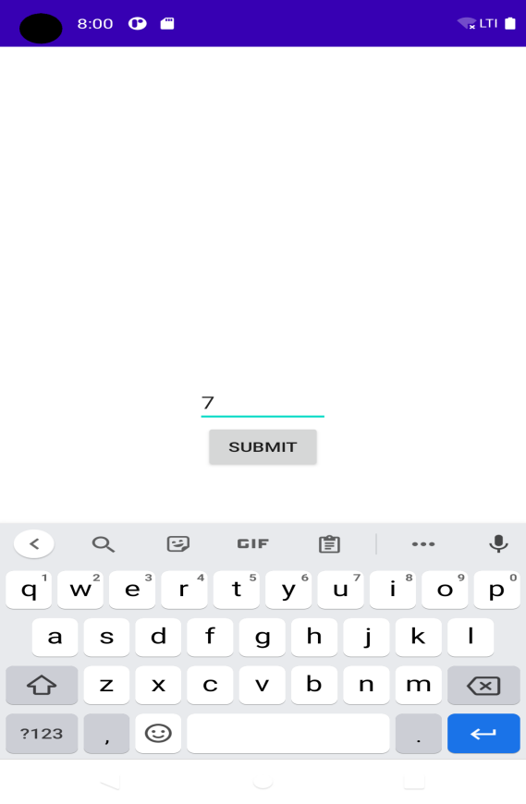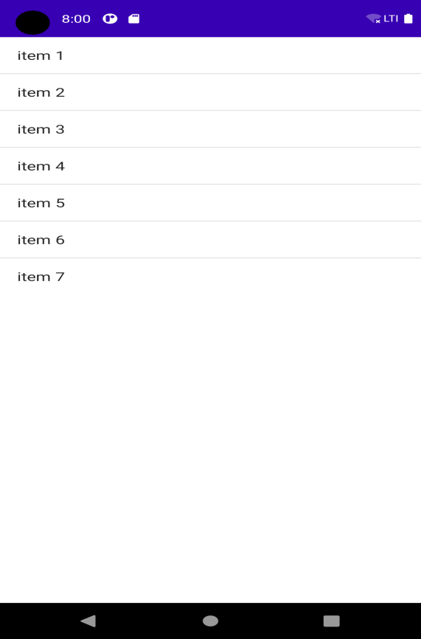

Practical 18

Create an application that accepts URL from user and when user click submit button open that URL in browser

*<?*xml version="1.0" encoding="utf-8"*?>*<RelativeLayout xmlns:android="http://schemas.android.com/apk/res/android"  
 xmlns:tools="http://schemas.android.com/tools"  
 android:layout\_width="match\_parent"  
 android:layout\_height="match\_parent"  
 tools:context=".MainActivity">  
  
  
 <EditText  
 android:id="@+id/editText1"  
 android:layout\_width="match\_parent"  
 android:layout\_height="wrap\_content"  
 android:layout\_alignParentTop="true"  
 android:layout\_centerHorizontal="true"  
 android:layout\_marginTop="136dp"  
 android:hint="enter link"  
 android:ems="10" />  
   
 <Button  
 android:id="@+id/button1"  
 android:layout\_width="wrap\_content"  
 android:layout\_height="wrap\_content"  
 android:layout\_below="@+id/editText1"  
 android:layout\_centerHorizontal="true"  
 android:layout\_marginTop="49dp"  
 android:layout\_marginEnd="132dp"  
 android:text="Click" />  
  
</RelativeLayout>

**JAVA FILE**

package com.example.registrationtost;  
  
import androidx.appcompat.app.AppCompatActivity;  
  
import android.app.Activity;  
import android.content.Intent;  
import android.net.Uri;  
import android.os.Bundle;  
import android.view.View;  
import android.widget.Button;  
import android.widget.EditText;  
  
public class MainActivity extends Activity {  
  
 @Override  
 protected void onCreate(Bundle savedInstanceState) {  
 super.onCreate(savedInstanceState);  
 setContentView(R.layout.*activity\_main*);  
  
  
 final EditText editText1 = (EditText) findViewById(R.id.*editText1*);  
 Button button = (Button) findViewById(R.id.*button1*);  
  
  
 button.setOnClickListener(new View.OnClickListener() {  
 @Override  
 public void onClick(View v) {  
  
 String url = editText1.getText().toString();  
 Intent intent = new Intent(Intent.*ACTION\_VIEW*, Uri.*parse*(url));  
 startActivity(intent);  
 }  
 });  
 }  
}

**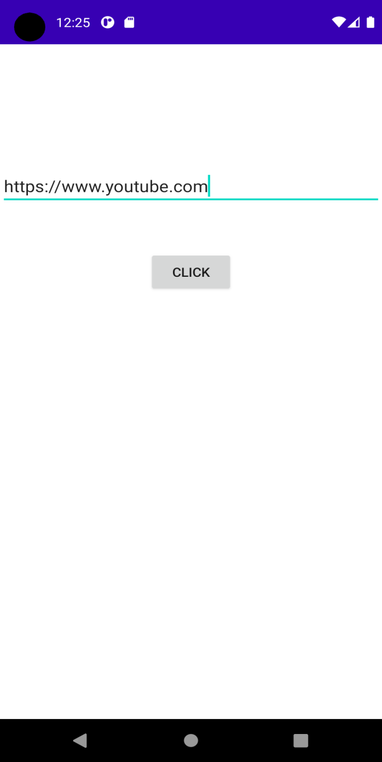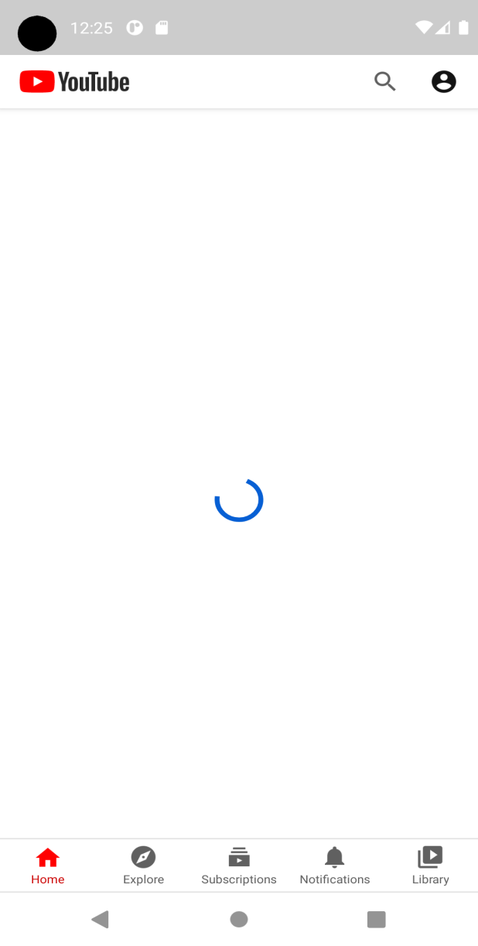**

PRACTICAL 19

Create an UI such that, one screen have list of all the types of cars. On selecting of any car name, next screen should show Car details like: name, launched date, company name

**Activiy1.xml**

*<?*xml version="1.0" encoding="utf-8"*?>*<LinearLayout xmlns:android="http://schemas.android.com/apk/res/android"  
 xmlns:tools="http://schemas.android.com/tools"  
 android:layout\_width="match\_parent"  
 android:layout\_height="match\_parent"  
 android:orientation="vertical"  
 tools:context=".MainActivity">  
  
 <ListView  
 android:id="@+id/simpleListView"  
 android:layout\_width="fill\_parent"  
 android:layout\_height="wrap\_content"/>  
  
  
</LinearLayout>

**List.xml**

*<?*xml version="1.0" encoding="utf-8"*?>*<LinearLayout xmlns:android="http://schemas.android.com/apk/res/android"  
 android:layout\_width="match\_parent"  
 android:layout\_height="match\_parent"  
 android:orientation="vertical">  
  
 <TextView  
 android:id="@+id/textView"  
 android:layout\_width="fill\_parent"  
 android:layout\_height="wrap\_content"  
 android:layout\_gravity="center"  
 android:text="ABCDESDKC"  
 android:textSize="36sp"  
 android:textColor="@color/black" />  
  
</LinearLayout>

**Activity 1 .java**

package com.example.myapplicationasdasd;  
  
import androidx.appcompat.app.AppCompatActivity;  
  
import android.content.Intent;  
import android.os.Bundle;  
import android.view.View;  
import android.widget.AdapterView;  
import android.widget.ArrayAdapter;  
import android.widget.ListView;  
import android.widget.Toast;  
  
public class MainActivity extends AppCompatActivity {  
  
 @Override  
 protected void onCreate(Bundle savedInstanceState) {  
 super.onCreate(savedInstanceState);  
 setContentView(R.layout.*activity\_main*);  
  
 ListView simpleList;  
 String gameList[] = {"Harrier", "i10", "DEZIRE", "Ciaz", "Nexon", "BMW"};  
  
 simpleList = (ListView) findViewById(R.id.*simpleListView*);  
 ArrayAdapter<String> arrayAdapter = new ArrayAdapter<String>(this, R.layout.*list\_item*, R.id.*textView*, gameList);  
 simpleList.setAdapter(arrayAdapter);  
  
 simpleList.setOnItemClickListener(new AdapterView.OnItemClickListener()  
 {  
 @Override  
 public void onItemClick(AdapterView<?> parent, View view,  
 int position, long id) {  
 String val =(String) arrayAdapter.getItem(position).toString();  
 Intent i =new Intent(getApplicationContext(),MainActivity2.class);  
 i.putExtra("company",val);  
 startActivity(i);  
 Toast.*makeText*(MainActivity.this, gameList[position], Toast.*LENGTH\_SHORT*).show();  
 }  
  
 });  
  
 }  
  
}

**Activity2.xml**

*<?*xml version="1.0" encoding="utf-8"*?>*<RelativeLayout xmlns:android="http://schemas.android.com/apk/res/android"  
 android:layout\_width="match\_parent"  
 android:layout\_height="match\_parent">  
  
 <TextView  
 android:layout\_marginTop="30dp"  
 android:id="@+id/t1"  
 android:layout\_width="wrap\_content"  
 android:layout\_height="wrap\_content"  
 android:text="launch date:"  
 android:textSize="20dp" />  
 <TextView  
 android:layout\_marginTop="30dp"  
 android:id="@+id/a1"  
 android:layout\_width="wrap\_content"  
 android:layout\_height="wrap\_content"  
 android:layout\_toRightOf="@+id/t1"  
 android:layout\_marginLeft="30dp"  
 android:text=""  
 android:textSize="20dp" />  
 <TextView  
 android:layout\_marginTop="30dp"  
 android:id="@+id/t2"  
 android:layout\_width="wrap\_content"  
 android:layout\_height="wrap\_content"  
 android:text="price"  
 android:layout\_below="@+id/t1"  
 android:textSize="20dp" />  
 <TextView  
 android:layout\_marginTop="30dp"  
 android:layout\_marginLeft="30dp"  
 android:id="@+id/a2"  
 android:layout\_width="wrap\_content"  
 android:layout\_height="wrap\_content"  
 android:layout\_toRightOf="@+id/t2"  
 android:layout\_below="@id/a1"  
 android:text=""  
 android:textSize="20dp" />  
 <TextView  
 android:layout\_marginTop="30dp"  
 android:id="@+id/t3"  
 android:layout\_width="wrap\_content"  
 android:layout\_height="wrap\_content"  
 android:layout\_below="@+id/t2"  
 android:text="company name:"  
 android:textSize="20dp" />  
 <TextView  
 android:layout\_marginTop="30dp"  
 android:id="@+id/a3"  
 android:layout\_width="wrap\_content"  
 android:layout\_height="wrap\_content"  
 android:layout\_toRightOf="@+id/t3"  
 android:layout\_marginLeft="30dp"  
 android:text=""  
 android:layout\_below="@+id/a2"  
 android:textSize="20dp" />  
  
  
</RelativeLayout>

**ACTIVITY2.JAVA**

package com.example.myapplicationasdasd;  
  
import androidx.appcompat.app.AppCompatActivity;  
  
import android.os.Bundle;  
import android.widget.TextView;  
  
public class MainActivity2 extends AppCompatActivity {  
 TextView price, launch, company;  
  
 @Override  
 protected void onCreate(Bundle savedInstanceState) {  
 super.onCreate(savedInstanceState);  
 setContentView(R.layout.*activity\_main2*);  
  
 launch = findViewById(R.id.*a1*);  
 company = findViewById(R.id.*a3*);  
 price = findViewById(R.id.*a2*);  
 company.setText(getIntent().getExtras().getString("company"));  
 if (getIntent().getExtras().getString("company").equals("Harrier")) {  
 launch.setText("feb 2022");  
 company.setText("tata");  
 price.setText("10lac");  
 }  
 else if (getIntent().getExtras().getString("company").equals("i10")){  
 launch.setText("feb 2014");  
 company.setText("hyundai");  
 price.setText("10lac");  
 }  
 else if (getIntent().getExtras().getString("company").equals("DEZIRE")){  
 launch.setText("MAY 2010");  
 company.setText("Suzuki");  
 price.setText("10lac");  
 }  
 else if (getIntent().getExtras().getString("company").equals("Ciaz")){  
 launch.setText("feb 2014");  
 company.setText("suzuki");  
 price.setText("10lac");  
 }  
 else if (getIntent().getExtras().getString("company").equals("Nexon")){  
 launch.setText("feb 2018");  
 company.setText("tata");  
 price.setText("10lac");  
 }  
 else if (getIntent().getExtras().getString("company").equals("BMW")){  
 launch.setText("feb 2000");  
 company.setText("BMW");  
 price.setText("60lac");  
 }  
  
 }  
}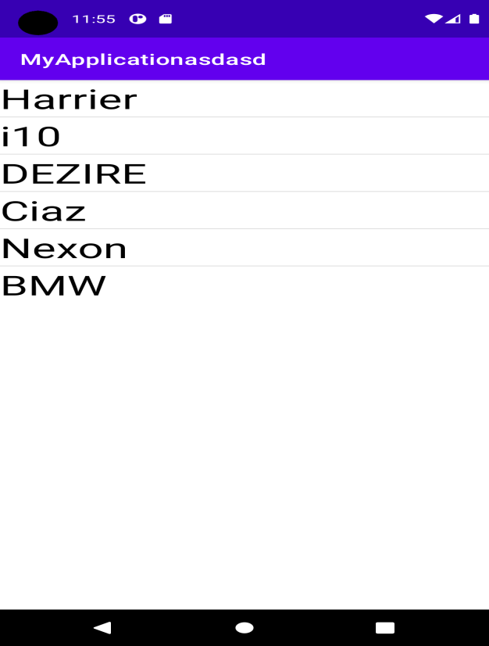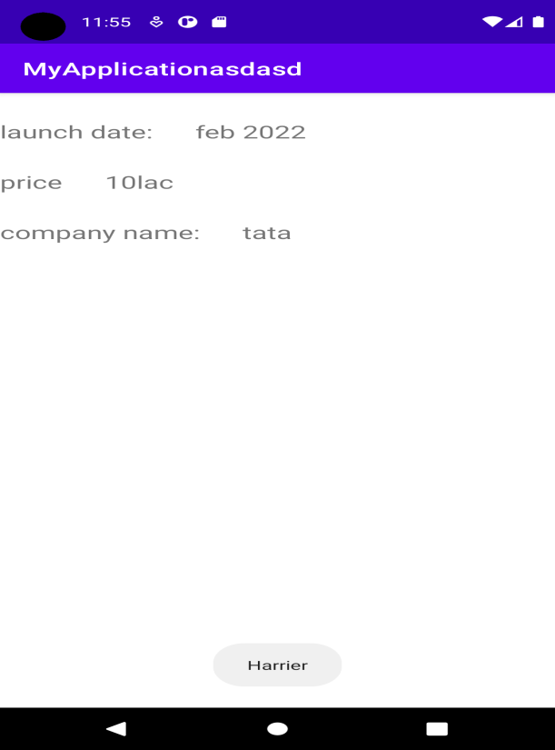

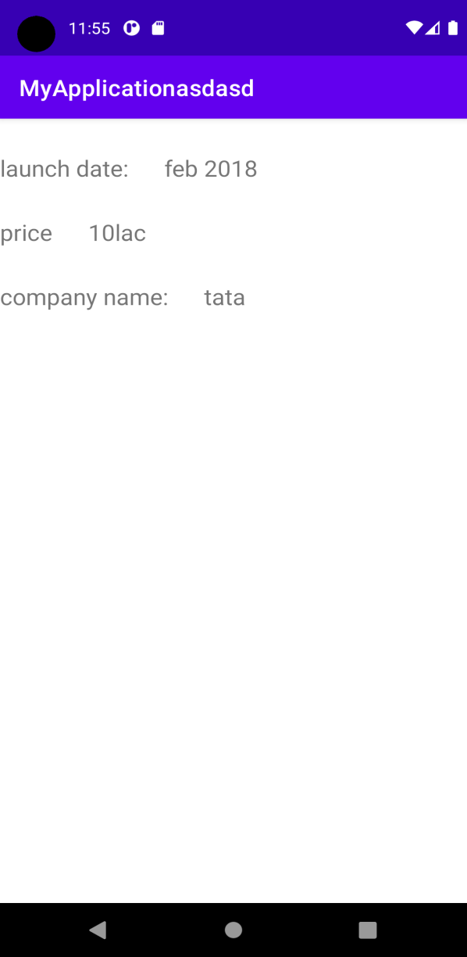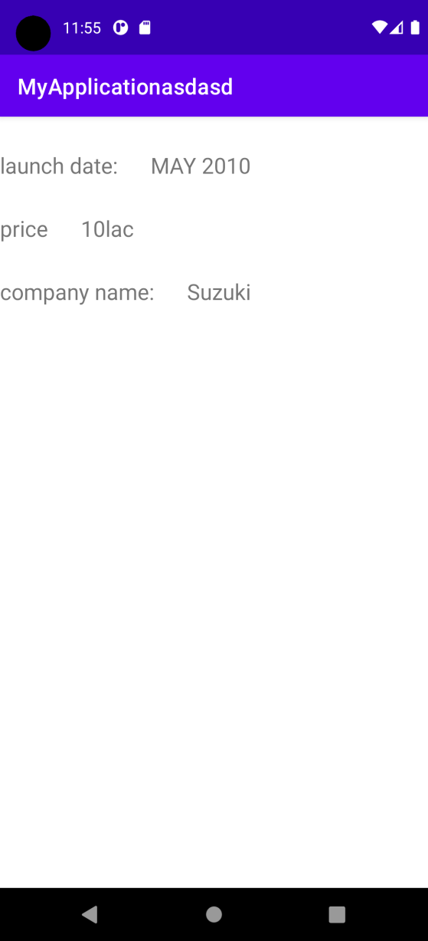

*PRACTICAL 20*

Create an application that use image button and clicking this button change the image of it and also handle onLongClick event.

XML FILE

*<?*xml version="1.0" encoding="utf-8"*?>*<RelativeLayout xmlns:android="http://schemas.android.com/apk/res/android"  
 xmlns:app="http://schemas.android.com/apk/res-auto"  
 xmlns:tools="http://schemas.android.com/tools"  
 android:layout\_width="match\_parent"  
 android:layout\_height="match\_parent"  
 tools:context=".MainActivity">  
  
 <ImageButton  
 android:id="@+id/i1"  
 android:layout\_width="wrap\_content"  
 android:layout\_height="wrap\_content"  
 android:layout\_centerInParent="true"  
 android:background="#000"  
 android:src="@drawable/emptyflower" />  
  
  
  
</RelativeLayout>

JAVA FILE

package com.example.imagebutton;  
  
import androidx.appcompat.app.AppCompatActivity;  
  
import android.os.Bundle;  
import android.view.View;  
import android.widget.ImageButton;  
  
public class MainActivity extends AppCompatActivity {  
  
 @Override  
 public void onCreate(Bundle savedInstanceState) {  
 super.onCreate(savedInstanceState);  
 setContentView(R.layout.*activity\_main*);  
  
 ImageButton ib = (ImageButton) this.findViewById(R.id.*i1*);  
 ib.setOnLongClickListener(new View.OnLongClickListener() {  
 @Override  
 public boolean onLongClick(View view) {  
 ib.setImageResource(R.drawable.*flower*);  
 return false;  
 }  
});

}  
}

*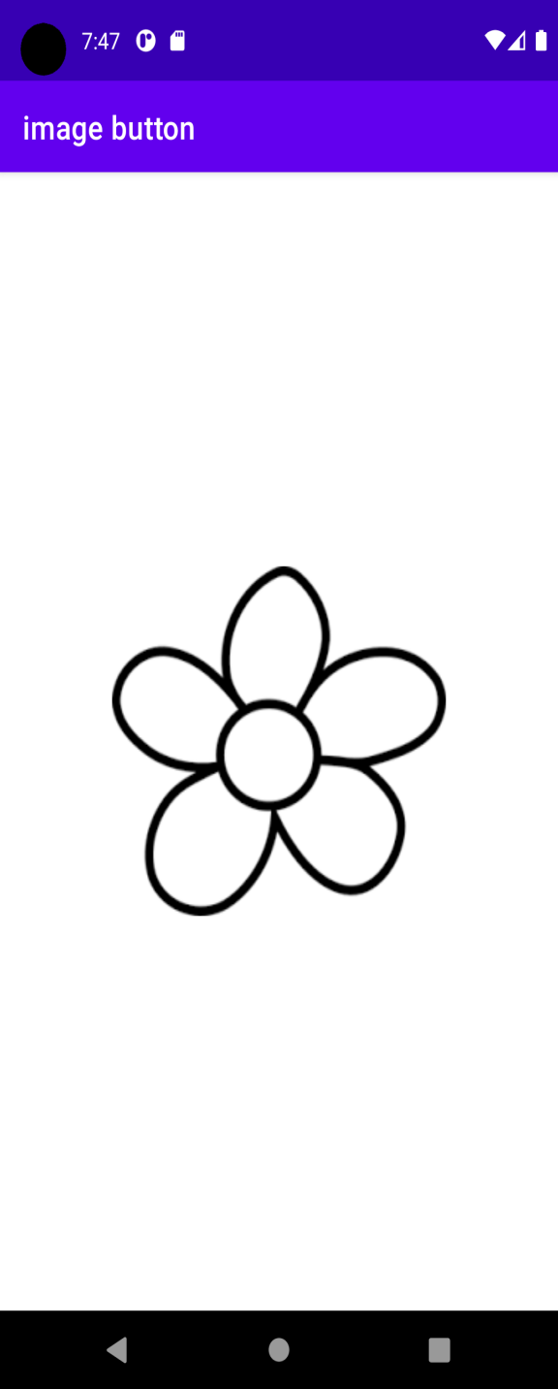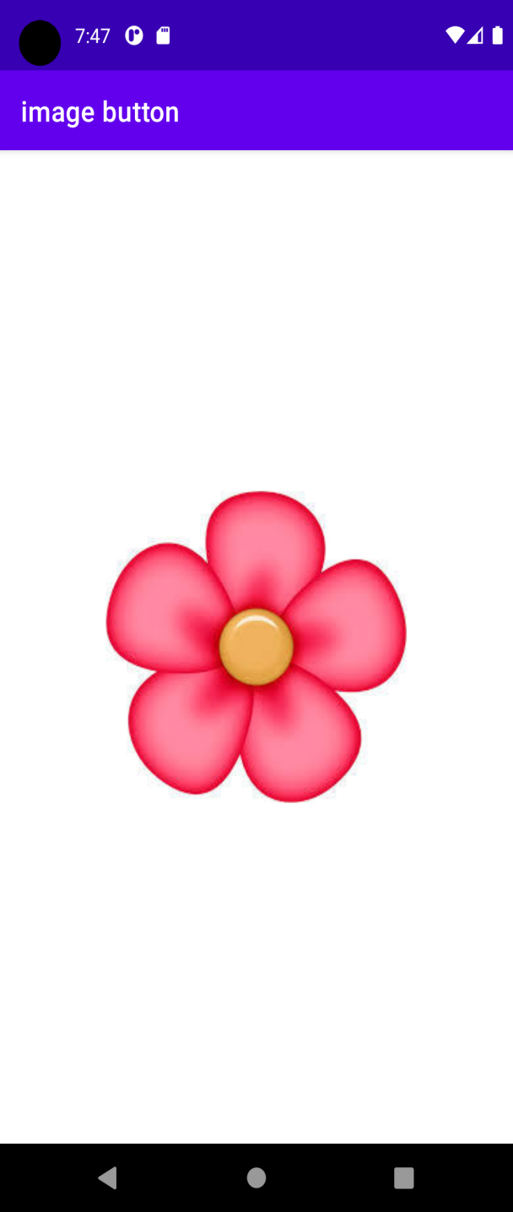*

*PRACTICAL 21*

Create an application that create list of games and on selection of any list option, display it in toast.

*<?*xml version="1.0" encoding="utf-8"*?>*<LinearLayout xmlns:android="http://schemas.android.com/apk/res/android"  
 xmlns:tools="http://schemas.android.com/tools"  
 android:layout\_width="match\_parent"  
 android:layout\_height="match\_parent"  
 android:orientation="vertical"  
 tools:context=".MainActivity">  
  
 <ListView  
 android:id="@+id/simpleListView"  
 android:layout\_width="fill\_parent"  
 android:layout\_height="wrap\_content"/>  
  
</LinearLayout>

**LIST.XML**

*<?*xml version="1.0" encoding="utf-8"*?>*<LinearLayout xmlns:android="http://schemas.android.com/apk/res/android"  
 android:layout\_width="match\_parent"  
 android:layout\_height="match\_parent"  
 android:orientation="vertical">  
  
 <TextView  
 android:id="@+id/textView"  
 android:layout\_width="fill\_parent"  
 android:layout\_height="wrap\_content"  
 android:layout\_gravity="center"  
 android:text="ABCDESDKC"  
 android:textSize="36sp"  
 android:textColor="@color/black" />  
  
</LinearLayout>

**JAVA FILE**

package com.example.myapplicationasdasd;  
  
import androidx.appcompat.app.AppCompatActivity;  
import android.os.Bundle;  
import android.view.View;  
import android.widget.AdapterView;  
import android.widget.ArrayAdapter;  
import android.widget.ListView;  
import android.widget.Toast;  
  
public class MainActivity extends AppCompatActivity {  
  
 @Override  
 protected void onCreate(Bundle savedInstanceState) {  
 super.onCreate(savedInstanceState);  
 setContentView(R.layout.*activity\_main*);  
  
 *// Array of strings...* ListView simpleList;  
 String gameList[] = {"GTA5", "VALORANT", "FORTNITE", "FORZA", "AMONGUS", "COC"};  
  
 simpleList = (ListView) findViewById(R.id.*simpleListView*);  
 ArrayAdapter<String> arrayAdapter = new ArrayAdapter<String>(this, R.layout.*list\_item*, R.id.*textView*, gameList);  
 simpleList.setAdapter(arrayAdapter);  
  
 simpleList.setOnItemClickListener(new AdapterView.OnItemClickListener()  
 {  
 @Override  
 public void onItemClick(AdapterView<?> parent, View view,  
 int position, long id) {  
 *// TODO Auto-generated method stub* Toast.*makeText*(MainActivity.this, gameList[position], Toast.*LENGTH\_SHORT*).show();  
 }  
 });  
 }  
  
}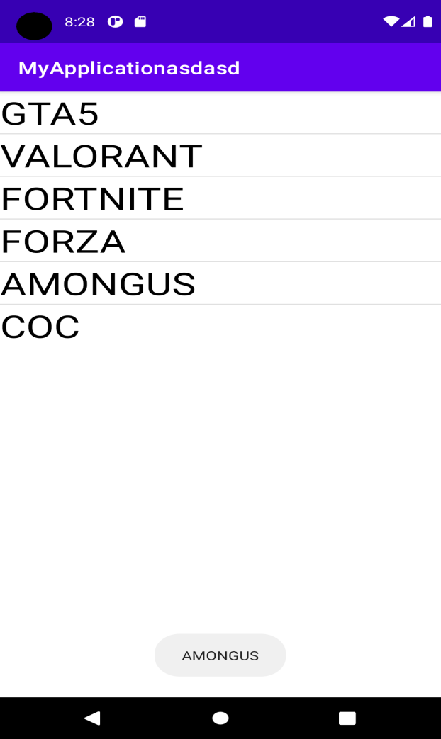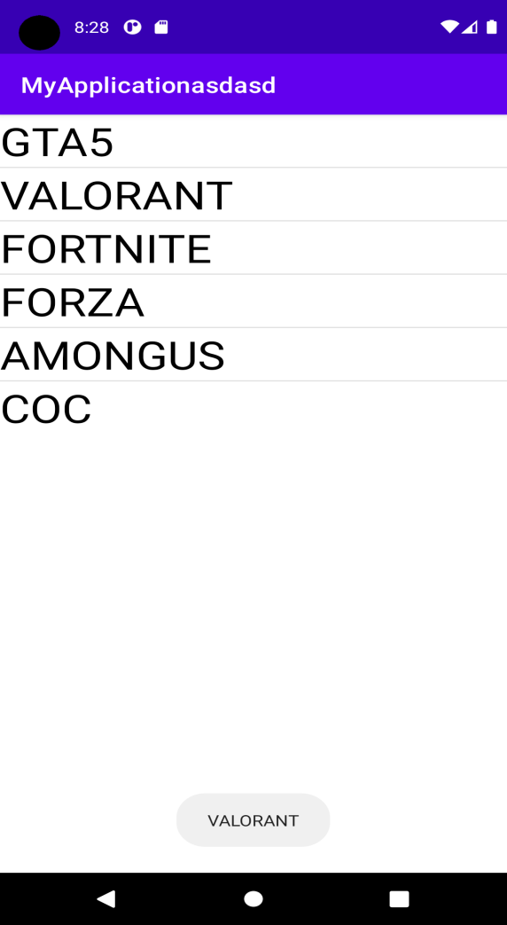

Practical 22

Create an Option Menu in Android Application.

Main.Xml file

<RelativeLayout xmlns:android="http://schemas.android.com/apk/res/android"  
 android:layout\_width="fill\_parent"  
 android:layout\_height="fill\_parent">  
  
 <TextView  
 android:id="@+id/t1"  
 android:layout\_width="wrap\_content"  
 android:layout\_height="wrap\_content"  
 android:text="you selected"  
 android:textSize="30dp"  
 android:layout\_centerHorizontal="true"  
 android:layout\_marginTop="400px"/>  
  
  
</RelativeLayout>

Menu.xml

*<?*xml version="1.0" encoding="utf-8"*?>*<menu xmlns:android="http://schemas.android.com/apk/res/android">  
 <item  
 android:id="@+id/m1"  
 android:title="about" />  
 <item  
 android:id="@+id/m2"  
 android:title="help" />  
 <item  
 android:id="@+id/m3"  
 android:title="close">  
 <menu>  
<item  
 android:id="@+id/s1"  
 android:title="hello"/>  
 </menu></item>  
</menu>

JAVA FILE

package com.example.ruman;  
  
import androidx.annotation.NonNull;  
import androidx.appcompat.app.AppCompatActivity;  
import android.content.Intent;  
import android.net.Uri;  
import android.os.Bundle;  
import android.view.Menu;  
import android.view.MenuInflater;  
import android.view.MenuItem;  
import android.view.View;  
import android.widget.TextView;  
  
public class MainActivity extends AppCompatActivity {  
 TextView t1;  
   
 @Override  
 protected void onCreate(Bundle savedInstanceState) {  
 super.onCreate(savedInstanceState);  
 setContentView(R.layout.*activity\_main*);  
 t1 = (TextView) findViewById(R.id.*t1*);  
 }  
 @Override  
 public boolean onCreateOptionsMenu(Menu menu) {  
 MenuInflater inflater = getMenuInflater();  
 inflater.inflate(R.menu.*menu*, menu);  
 return super.onCreateOptionsMenu(menu);  
 }  
  
 @Override  
 public boolean onOptionsItemSelected(@NonNull MenuItem item) {  
 switch (item.getItemId()) {  
 case R.id.*m1*:  
 t1.setText("you selected" + item.getTitle());  
 break;  
 case R.id.*m2*:  
 t1.setText("you selected" + item.getTitle());  
 break;  
 case R.id.*m3*:  
 t1.setText("you selected" + item.getTitle());  
 break;  
 case R.id.*s1*:  
 t1.setText("you selected" + item.getTitle());  
 break;  
 }  
 return super.onOptionsItemSelected(item);  
 }  
}

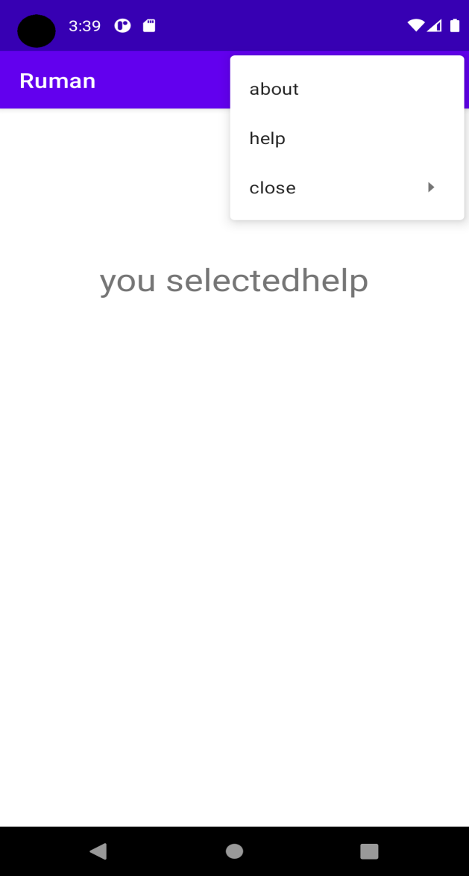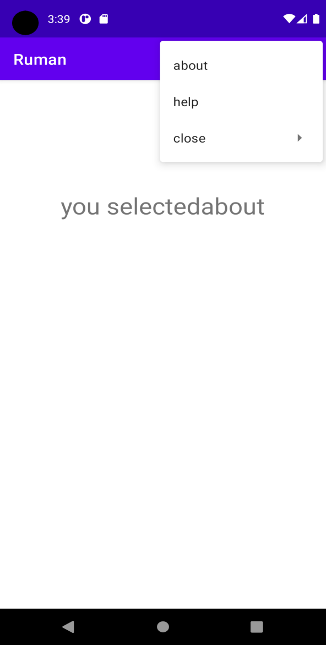

PRACTICAL 23

Create an application that display custom menu Bookmark, File, search, share in which file menu also has submenu within it. By selecting or clicking any menu option display appropriate message.

XML FILE

<RelativeLayout xmlns:android="http://schemas.android.com/apk/res/android"  
 android:layout\_width="fill\_parent"  
 android:layout\_height="fill\_parent"  
 android:id="@+id/relativelayout">  
  
 <TextView  
 android:id="@+id/t1"  
 android:layout\_width="wrap\_content"  
 android:layout\_height="wrap\_content"  
 android:text="you selected"  
 android:textSize="30dp"  
 android:layout\_centerHorizontal="true"  
 android:layout\_marginTop="400px"/>  
 <Button  
 android:layout\_width="wrap\_content"  
 android:layout\_height="wrap\_content"  
 android:id="@+id/b1"  
 android:text="menu"  
 android:textSize="30dp"  
 android:layout\_centerHorizontal="true"  
 android:layout\_centerVertical="true"  
 />  
  
  
</RelativeLayout>

MENU FILE

*<?*xml version="1.0" encoding="utf-8"*?>*<menu xmlns:android="http://schemas.android.com/apk/res/android">  
 <item  
 android:id="@+id/m1"  
 android:title="Bookmark" />  
 <item  
 android:id="@+id/m2"  
 android:title="search" />  
 <item  
 android:id="@+id/m3"  
 android:title="Search"/>  
 <item  
 android:id="@+id/m4"  
 android:title="File">  
 <menu>  
<item  
 android:id="@+id/s1"  
 android:title="open"/>  
 <item  
 android:id="@+id/s2"  
 android:title="saveas"/>  
 <item  
 android:id="@+id/s3"  
 android:title="save"/>  
 </menu></item>  
  
  
  
</menu>

JAVA FILE

package com.example.ruman;  
  
import androidx.annotation.NonNull;  
import androidx.appcompat.app.AppCompatActivity;  
import android.os.Bundle;  
import android.view.ContextMenu;  
import android.view.Menu;  
import android.view.MenuInflater;  
import android.view.MenuItem;  
import android.view.View;  
import android.widget.Button;  
import android.widget.TextView;  
import android.widget.Toast;  
  
public class MainActivity extends AppCompatActivity {  
 TextView t1;  
 Button b;  
 RelativeLayout layout;  
  
 @Override  
 protected void onCreate(Bundle savedInstanceState) {  
 super.onCreate(savedInstanceState);  
 setContentView(R.layout.*activity\_main*);  
 b=findViewById(R.id.*b1*);  
 t1=findViewById(R.id.*t1*);  
 layout=findViewById(R.id.*relativelayout*);  
 registerForContextMenu(b);  
 }  
 @Override  
 public boolean onCreateOptionsMenu(Menu menu) {  
 MenuInflater inflater = getMenuInflater();  
 inflater.inflate(R.menu.*menu*, menu);  
 return super.onCreateOptionsMenu(menu);  
 }  
  
 @Override  
 public boolean onOptionsItemSelected(@NonNull MenuItem item) {  
 switch (item.getItemId()) {  
 case R.id.*m1*:  
 t1.setText("you selected" + item.getTitle());  
 break;  
 case R.id.*m2*:  
 t1.setText("you selected" + item.getTitle());  
 break;  
 case R.id.*m3*:  
 t1.setText("you selected" + item.getTitle());  
 break;  
 case R.id.*s1*:  
 t1.setText("you selected" + item.getTitle());  
 break;  
 case R.id.*s2*:  
 t1.setText("you selected" + item.getTitle());  
 break;  
 case R.id.*s3*:  
 t1.setText("you selected" + item.getTitle());  
 break;  
 case R.id.*m4*:  
 t1.setText("you selected" + item.getTitle());  
 break;  
 }  
 return super.onOptionsItemSelected(item);  
 }  
 @Override  
 public void onCreateContextMenu(ContextMenu menu, View v, ContextMenu.ContextMenuInfo menuInfo) {  
 MenuInflater inflater=getMenuInflater();  
 inflater.inflate(R.menu.*menu*,menu);  
 super.onCreateContextMenu(menu, v, menuInfo);  
 }  
  
 @Override  
 public boolean onContextItemSelected(@NonNull MenuItem item) {  
 switch (item.getItemId()){  
 case R.id.*m1*:Toast.*makeText*(this,"you selected"+item.getTitle(),Toast.*LENGTH\_LONG*).show();  
 break;  
 case R.id.*m2*:Toast.*makeText*(this,"you selected"+item.getTitle(),Toast.*LENGTH\_LONG*).show();  
 break;  
 case R.id.*m3*:Toast.*makeText*(this,"you selected"+item.getTitle(),Toast.*LENGTH\_LONG*).show();  
 break;  
 case R.id.*m4*:Toast.*makeText*(this,"you selected"+item.getTitle(),Toast.*LENGTH\_LONG*).show();  
 break;  
 case R.id.*s2*:Toast.*makeText*(this,"you selected"+item.getTitle(),Toast.*LENGTH\_LONG*).show();  
 break;  
 case R.id.*s1*:Toast.*makeText*(this,"you selected"+item.getTitle(),Toast.*LENGTH\_LONG*).show();  
 break;  
 case R.id.*s3*:Toast.*makeText*(this,"you selected"+item.getTitle(),Toast.*LENGTH\_LONG*).show();  
 break;  
 }  
 return super.onContextItemSelected(item);  
 }  
}

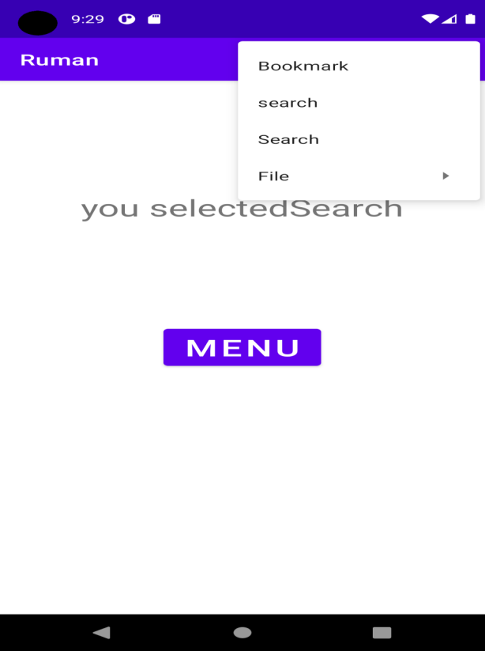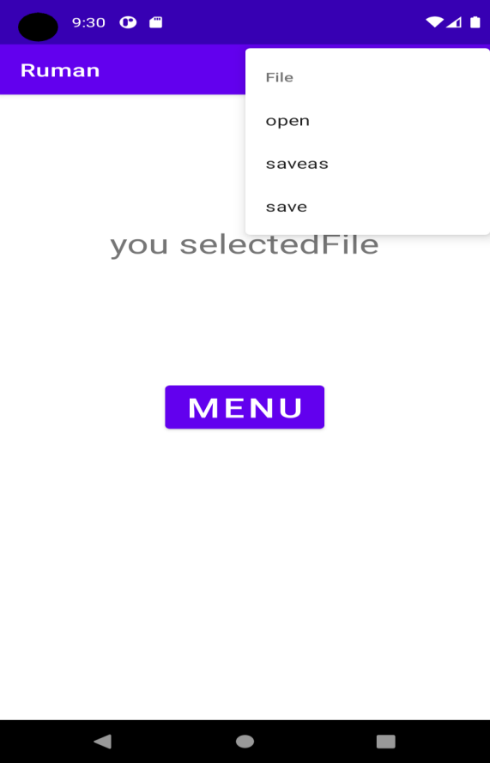

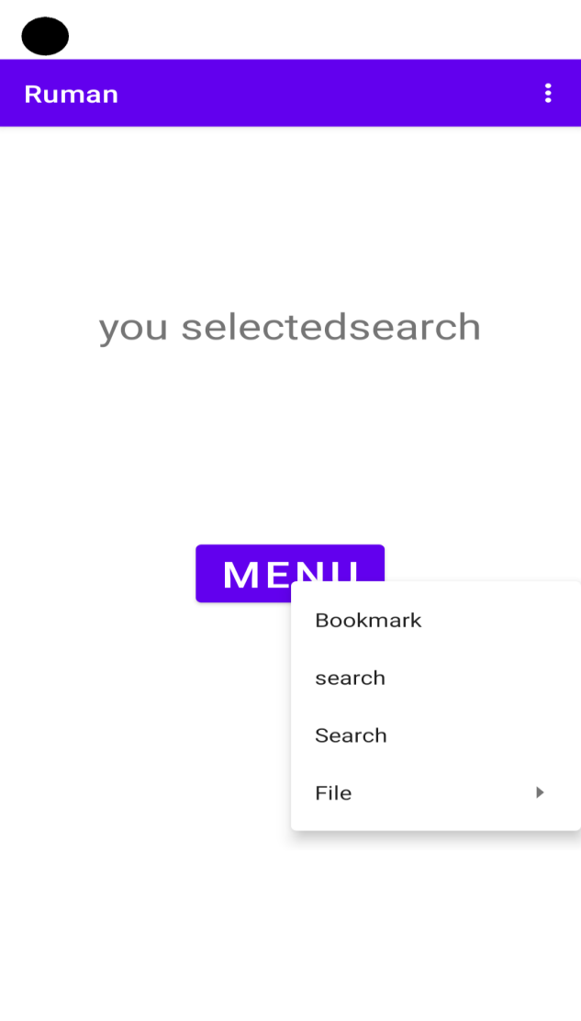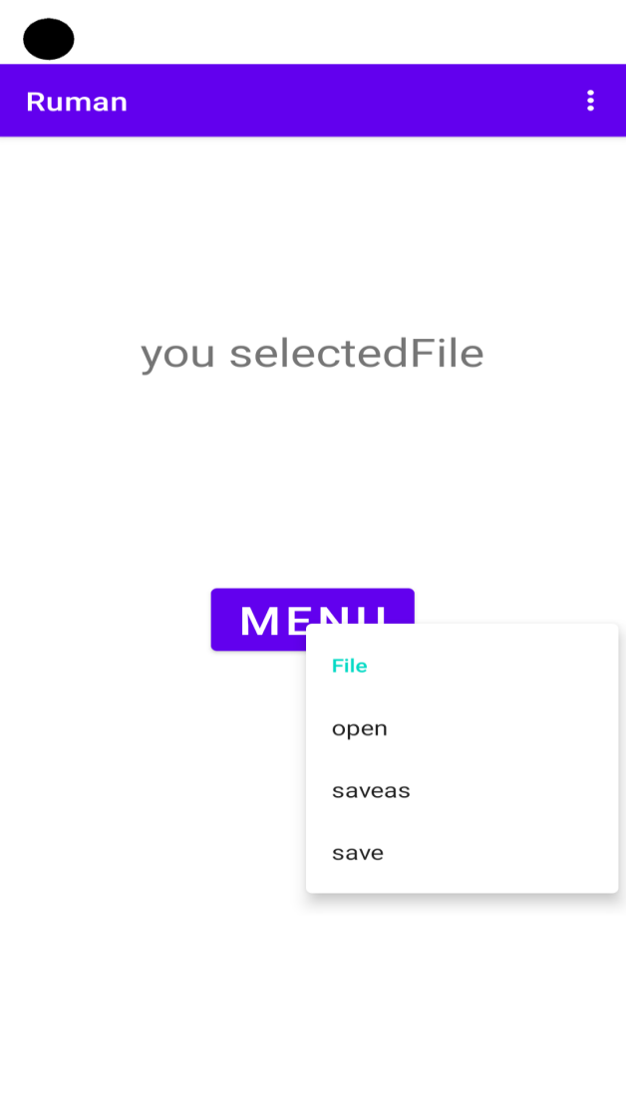

PRACTICAL 24

Create and application that will change colour of the screen based on selected options from the menu

XML FILE

<RelativeLayout xmlns:android="http://schemas.android.com/apk/res/android"  
 android:layout\_width="fill\_parent"  
 android:layout\_height="fill\_parent"  
 android:id="@+id/relativelayout">  
  
 <TextView  
 android:id="@+id/t1"  
 android:layout\_width="wrap\_content"  
 android:layout\_height="wrap\_content"  
 android:text="you selected"  
 android:textSize="30dp"  
 android:layout\_centerHorizontal="true"  
 android:layout\_marginTop="400px"/>  
  
</RelativeLayout>

JAVA FILE

package com.example.ruman;  
  
import androidx.annotation.NonNull;  
import androidx.appcompat.app.AppCompatActivity;  
import android.os.Bundle;  
import android.view.Menu;  
import android.view.MenuInflater;  
import android.view.MenuItem;  
import android.widget.RelativeLayout;  
import android.widget.TextView;  
  
  
public class MainActivity extends AppCompatActivity {  
 TextView t1;  
 RelativeLayout layout;  
  
 @Override  
 protected void onCreate(Bundle savedInstanceState) {  
 super.onCreate(savedInstanceState);  
 setContentView(R.layout.*activity\_main*);  
 t1=findViewById(R.id.*t1*);  
 layout=findViewById(R.id.*relativelayout*);  
  
 }  
 @Override  
 public boolean onCreateOptionsMenu(Menu menu) {  
 MenuInflater inflater = getMenuInflater();  
 inflater.inflate(R.menu.*menu*, menu);  
 return super.onCreateOptionsMenu(menu);  
 }  
  
 @Override  
 public boolean onOptionsItemSelected(@NonNull MenuItem item) {  
 switch (item.getItemId()) {  
 case R.id.*m1*:  
 layout.setBackgroundResource(R.color.*red*);  
 t1.setText("you selected" + item.getTitle());  
 break;  
 case R.id.*m2*:  
 layout.setBackgroundResource(R.color.*green*);  
 t1.setText("you selected" + item.getTitle());  
 break;  
 case R.id.*m3*:  
 layout.setBackgroundResource(R.color.*teal\_200*);  
 t1.setText("you selected" + item.getTitle());  
 break;  
 case R.id.*s1*:  
 layout.setBackgroundResource(R.color.*teal\_700*);  
 t1.setText("you selected" + item.getTitle());  
 break;  
 }  
 return super.onOptionsItemSelected(item);  
 }

}  
  
  
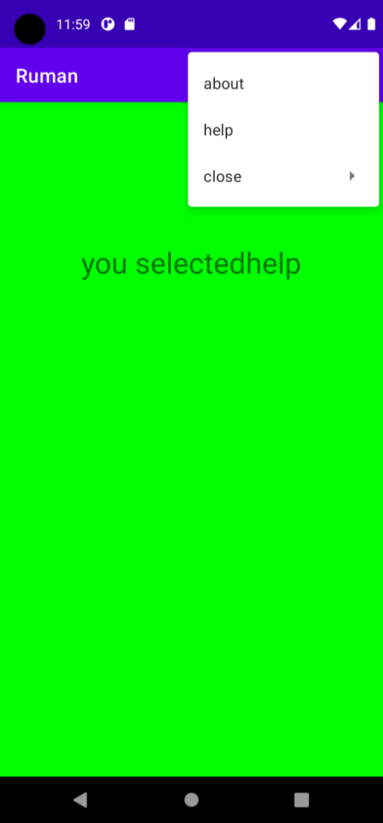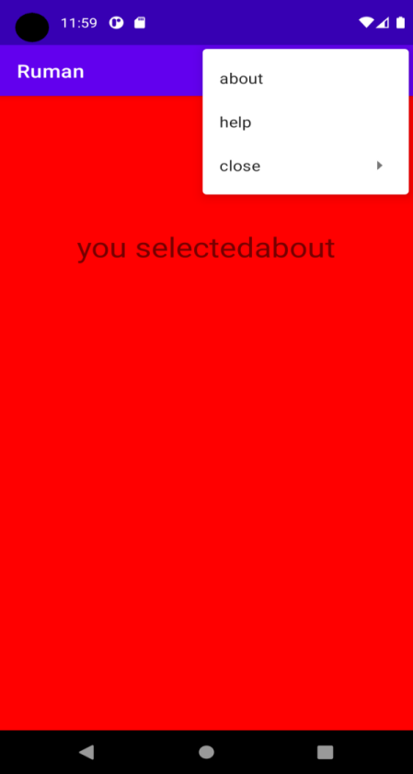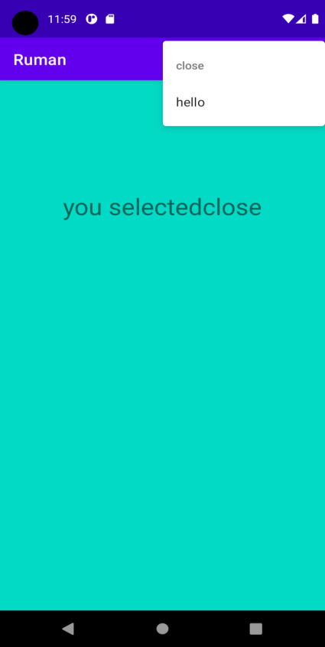

Practical 25

Create an application the create and display use of alert dialog box.

**Xml file**

*<?*xml version="1.0" encoding="utf-8"*?>*<RelativeLayout  
 xmlns:android="http://schemas.android.com/apk/res/android"  
 xmlns:tools="http://schemas.android.com/tools"  
 android:layout\_width="match\_parent"  
 android:layout\_height="match\_parent"  
 tools:context=".MainActivity">  
  
 <TextView  
 android:layout\_width="wrap\_content"  
 android:layout\_height="wrap\_content"  
 android:layout\_marginTop="180dp"  
 android:gravity="center\_horizontal"  
 android:text="Press The Back Button of Your Phone."  
 android:textSize="30dp"  
 android:textStyle="bold" />  
  
</RelativeLayout>

**Java file**

package com.example.alertbox;  
  
import android.content.DialogInterface;  
import android.os.Bundle;  
import androidx.appcompat.app.AlertDialog;  
import androidx.appcompat.app.AppCompatActivity;  
  
public class MainActivity extends AppCompatActivity {  
  
 @Override  
 protected void onCreate(Bundle savedInstanceState)  
 {  
 super.onCreate(savedInstanceState);  
 setContentView(R.layout.*activity\_main*);  
 }  
 @Override  
 public void onBackPressed()  
 {  
 AlertDialog.Builder builder = new AlertDialog.Builder(MainActivity.this);  
 builder.setMessage("Do you want to exit ?");  
 builder.setTitle("Alert !");  
 builder.setCancelable(false);  
 builder.setPositiveButton("Yes", new DialogInterface.OnClickListener() {  
 @Override  
 public void onClick(DialogInterface dialog, int which)  
 {  
 finish();  
 }  
 });  
 builder.setNegativeButton("No", new DialogInterface.OnClickListener() {  
 @Override  
 public void onClick(DialogInterface dialog, int which)  
 {  
 dialog.cancel();  
 }  
 });  
 AlertDialog alertDialog = builder.create();  
 alertDialog.show();  
 }  
}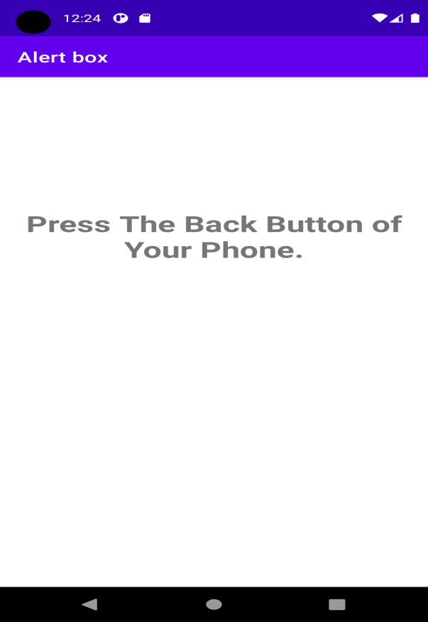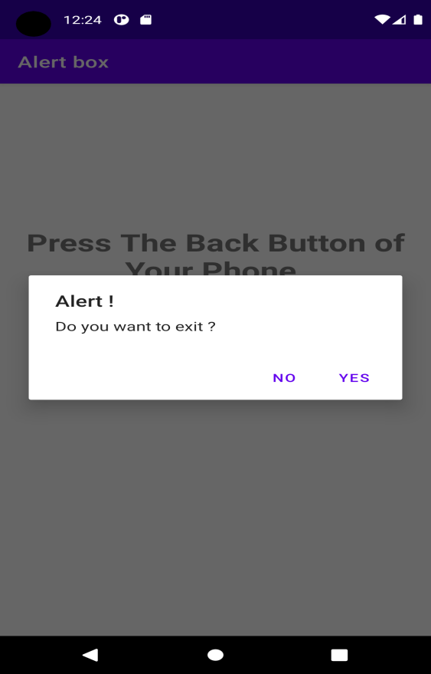

Practical 26

Create an application the create and display use of Rating Bar and Progress Bar.

Xml file

*<?*xml version="1.0" encoding="utf-8"*?>*<RelativeLayout xmlns:android="http://schemas.android.com/apk/res/android"  
 android:layout\_width="match\_parent" android:layout\_height="match\_parent">  
 <ProgressBar  
 android:id="@+id/pBar"  
 style="?android:attr/progressBarStyleHorizontal"  
 android:layout\_width="wrap\_content"  
 android:layout\_height="wrap\_content"  
 android:layout\_marginLeft="100dp"  
 android:layout\_marginTop="200dp"  
 android:minHeight="50dp"  
 android:minWidth="200dp"  
 android:max="100"  
 android:indeterminate="false"  
 android:progress="0" />  
 <TextView  
 android:id="@+id/tView"  
 android:layout\_width="wrap\_content"  
 android:layout\_height="wrap\_content"  
 android:layout\_alignLeft="@+id/pBar"  
 android:layout\_below="@+id/pBar" />  
 <Button  
 android:id="@+id/btnShow"  
 android:layout\_width="wrap\_content"  
 android:layout\_height="wrap\_content"  
 android:layout\_marginLeft="130dp"  
 android:layout\_marginTop="20dp"  
 android:text="Start Progress"  
 android:layout\_below="@+id/tView"/>  
 <RatingBar  
 android:layout\_below="@id/btnShow"  
 android:id="@+id/ratingBar1"  
 android:layout\_width="wrap\_content"  
 android:layout\_height="wrap\_content"  
 android:layout\_marginLeft="80dp"  
 android:layout\_marginTop="200dp"  
 android:numStars="5"  
 android:rating="2"/>  
 <TextView  
 android:id="@+id/textview1"  
 android:layout\_width="wrap\_content"  
 android:layout\_height="wrap\_content"  
 android:layout\_below="@+id/ratingBar1"  
 android:layout\_alignLeft="@+id/ratingBar1"  
 android:layout\_marginTop="20dp"  
 android:textSize="20dp"  
 android:textStyle="bold"/>  
</RelativeLayout>

Java file

package com.example.alertbox;  
  
import android.os.Handler;  
  
import android.os.Bundle;  
import android.view.View;  
import android.widget.Button;  
import android.widget.ProgressBar;  
import android.widget.RatingBar;  
import android.widget.TextView;  
  
import androidx.appcompat.app.AppCompatActivity;  
  
public class MainActivity extends AppCompatActivity {  
 private ProgressBar pgsBar;  
 private int i = 0;  
 private TextView txtView;  
 private RatingBar rBar;  
 private TextView tView;  
 private Handler hdlr = new Handler();  
 @Override  
 protected void onCreate(Bundle savedInstanceState) {  
 super.onCreate(savedInstanceState);  
 setContentView(R.layout.*activity\_main*);  
 pgsBar = (ProgressBar) findViewById(R.id.*pBar*);  
 txtView = (TextView) findViewById(R.id.*tView*);  
 Button btn = (Button)findViewById(R.id.*btnShow*);  
 rBar = (RatingBar) findViewById(R.id.*ratingBar1*);  
 tView = (TextView) findViewById(R.id.*textview1*);  
 btn.setOnClickListener(new View.OnClickListener() {  
 @Override  
 public void onClick(View v) {  
 int noofstars = rBar.getNumStars();  
 float getrating = rBar.getRating();  
 tView.setText("Rating: "+getrating+"/"+noofstars);  
 i = pgsBar.getProgress();  
 new Thread(new Runnable() {  
 public void run() {  
 while (i < 100) {  
 i += 1;  
 hdlr.post(new Runnable() {  
 public void run() {  
 pgsBar.setProgress(i);  
 txtView.setText(i+"/"+pgsBar.getMax());  
 }  
 });  
 try {  
 *// Sleep for 100 milliseconds to show the progress slowly.* Thread.*sleep*(100);  
 } catch (InterruptedException e) {  
 e.printStackTrace();  
 }  
 }  
 }  
 }).start();  
 }  
 });  
 }  
}

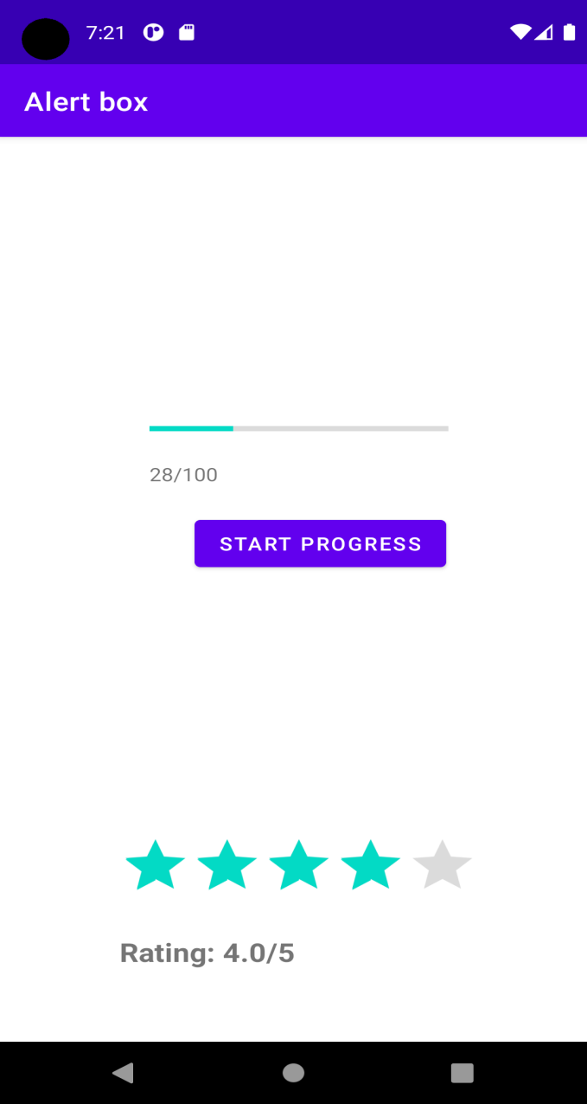

Practical27

Xml file

*<?*xml version="1.0" encoding="utf-8"*?>*<RelativeLayout xmlns:android="http://schemas.android.com/apk/res/android"  
 xmlns:app="http://schemas.android.com/apk/res-auto"  
 xmlns:tools="http://schemas.android.com/tools"  
 android:layout\_width="match\_parent"  
 android:layout\_height="match\_parent"  
 android:background="#f6f6f6">  
  
 <TextView  
 android:id="@+id/txtCrud"  
 android:layout\_width="wrap\_content"  
 android:layout\_height="wrap\_content"  
 android:layout\_marginLeft="53dp"  
 android:layout\_marginTop="30dp"  
 android:text="CRUD Operation"  
 android:textColor="#000000"  
 android:textSize="35dp" />  
  
 <EditText  
 android:id="@+id/name"  
 android:layout\_width="1.9in"  
 android:layout\_height="wrap\_content"  
 android:layout\_below="@id/txtCrud"  
 android:layout\_centerInParent="true"  
 android:layout\_marginTop="20dp"  
 android:hint="Enter Your Name"  
 android:textColor="#66afd1"  
 android:textSize="25dp" />  
  
 <EditText  
 android:id="@+id/email"  
 android:layout\_width="1.9in"  
 android:layout\_height="wrap\_content"  
 android:layout\_below="@id/name"  
 android:layout\_centerInParent="true"  
 android:layout\_marginTop="20dp"  
 android:hint="Enter Your Email"  
 android:textColor="#66afd1"  
 android:textSize="25dp" />  
  
 <EditText  
 android:id="@+id/enroll"  
 android:layout\_width="1.9in"  
 android:layout\_height="wrap\_content"  
 android:layout\_below="@id/email"  
 android:layout\_centerInParent="true"  
 android:layout\_marginTop="20dp"  
 android:hint="Enter Your Enrollment"  
 android:inputType="number"  
 android:textColor="#66afd1"  
 android:textSize="25dp" />  
  
 <Button  
 android:id="@+id/insert"  
 android:layout\_width="0.8in"  
 android:layout\_height="wrap\_content"  
 android:layout\_below="@id/enroll"  
 android:layout\_marginLeft="60dp"  
 android:layout\_marginTop="40dp"  
 android:text="Insert"  
 android:textAllCaps="false"  
 android:textColor="#f2f5fa"  
 android:textSize="25dp" />  
  
 <Button  
 android:id="@+id/read"  
 android:layout\_width="0.8in"  
 android:layout\_height="wrap\_content"  
 android:layout\_below="@id/enroll"  
 android:layout\_marginLeft="20dp"  
 android:layout\_marginTop="40dp"  
 android:layout\_toRightOf="@+id/insert"  
 android:text="Read"  
 android:textAllCaps="false"  
 android:textColor="#f2f5fa"  
 android:textSize="25dp" />  
  
 <Button  
 android:id="@+id/update"  
 android:layout\_width="0.8in"  
 android:layout\_height="wrap\_content"  
 android:layout\_below="@id/read"  
 android:layout\_marginLeft="60dp"  
 android:layout\_marginTop="20dp"  
 android:text="Update"  
 android:textAllCaps="false"  
 android:textColor="#f2f5fa"  
 android:textSize="25dp" />  
  
 <Button  
 android:id="@+id/delete"  
 android:layout\_width="0.8in"  
 android:layout\_height="wrap\_content"  
 android:layout\_below="@id/read"  
 android:layout\_marginLeft="20dp"  
 android:layout\_marginTop="20dp"  
 android:layout\_toRightOf="@+id/update"  
 android:text="Delete"  
 android:textAllCaps="false"  
 android:textColor="#f2f5fa"  
 android:textSize="25dp" />  
  
</RelativeLayout>

Java file

package com.example.database;  
  
import androidx.appcompat.app.AlertDialog;  
import androidx.appcompat.app.AppCompatActivity;  
  
import android.database.Cursor;  
import android.os.Bundle;  
import android.view.View;  
import android.widget.ArrayAdapter;  
import android.widget.Button;  
import android.widget.EditText;  
import android.widget.ListView;  
import android.widget.Toast;  
  
public class MainActivity extends AppCompatActivity {  
  
 EditText name, email, enroll;  
 Button btnInsert, btnRead, btnUpdate, btnDelete;  
 String name\_arr[],email\_arr[],enroll\_arr[];  
  
 @Override  
 protected void onCreate(Bundle savedInstanceState) {  
 super.onCreate(savedInstanceState);  
 setContentView(R.layout.*activity\_main*);  
  
 name = findViewById(R.id.*name*);  
 email = findViewById(R.id.*email*);  
 enroll = findViewById(R.id.*enroll*);  
  
 btnInsert = findViewById(R.id.*insert*);  
 btnRead = findViewById(R.id.*read*);  
 btnUpdate = findViewById(R.id.*update*);  
 btnDelete = findViewById(R.id.*delete*);  
  
 DB db = new DB(this);  
  
 btnInsert.setOnClickListener(new View.OnClickListener() {  
 @Override  
 public void onClick(View view) {  
 String st\_name = name.getText().toString();  
 String st\_email = email.getText().toString();  
 String st\_enroll = enroll.getText().toString();  
  
 if (name.getText().toString().length() == 0 || email.getText().toString().length() == 0 || st\_enroll.toString().length() == 0) {  
 Toast.*makeText*(MainActivity.this, "One or More Fields are Missing!", Toast.*LENGTH\_SHORT*).show();  
 } else {  
 Cursor read = db.duplicateData(st\_enroll);  
 if (read.getCount() != 0) {  
 Toast.*makeText*(MainActivity.this, "Data Already Exists in Database with Enroll\_No: " + st\_enroll, Toast.*LENGTH\_SHORT*).show();  
 } else {  
 Boolean checkInsertData = db.insertData(st\_name, st\_email, st\_enroll);  
 if (checkInsertData == true) {  
 Toast.*makeText*(MainActivity.this, "Data Inserted Successfully to Database", Toast.*LENGTH\_SHORT*).show();  
 } else {  
 Toast.*makeText*(MainActivity.this, "Something Went Wrong!", Toast.*LENGTH\_SHORT*).show();  
 }  
 }  
 }  
 }  
 });  
  
 btnRead.setOnClickListener(new View.OnClickListener() {  
 @Override  
 public void onClick(View view) {  
 Cursor read = db.displayData();  
 if (read.getCount() == 0) {  
 Toast.*makeText*(MainActivity.this, "There is no Data in Database!", Toast.*LENGTH\_SHORT*).show();  
 } else {  
  
 StringBuffer buffer = new StringBuffer();  
 while (read.moveToNext()) {  
  
 buffer.append("Id: " + read.getString(0) + "\n");  
 buffer.append("Name: " + read.getString(1) + "\n");  
 buffer.append("Email: " + read.getString(2) + "\n");  
 buffer.append("Enrollment: " + read.getString(3) + "\n\n");  
 }  
  
 AlertDialog.Builder builder = new AlertDialog.Builder(MainActivity.this);  
 builder.setCancelable(true);  
 builder.setTitle("Student Details");  
 builder.setPositiveButton("OK", null);  
 builder.setMessage(buffer.toString());  
 builder.show();  
 }  
 }  
 });  
  
 btnUpdate.setOnClickListener(new View.OnClickListener() {  
 @Override  
 public void onClick(View view) {  
 String st\_name = name.getText().toString();  
 String st\_email = email.getText().toString();  
 String st\_enroll = enroll.getText().toString();  
 if (name.getText().toString().length() == 0 || email.getText().toString().length() == 0 || st\_enroll.toString().length() == 0) {  
 Toast.*makeText*(MainActivity.this, "One or More Fields are Missing!", Toast.*LENGTH\_SHORT*).show();  
 } else {  
 Boolean checkUpdateData = db.updateData(st\_name, st\_email, st\_enroll);  
 if (checkUpdateData == true) {  
 Toast.*makeText*(MainActivity.this, "Data Updated Successfully for Enroll\_No: " + st\_enroll, Toast.*LENGTH\_SHORT*).show();  
 } else {  
 Toast.*makeText*(MainActivity.this, "Something Went Wrong! No Data Found for Enroll\_No: " + st\_enroll, Toast.*LENGTH\_SHORT*).show();  
 }  
 }  
 }  
 });  
  
 btnDelete.setOnClickListener(new View.OnClickListener() {  
 @Override  
 public void onClick(View view) {  
 String st\_enroll = enroll.getText().toString();  
 if (st\_enroll.toString().length() == 0) {  
 Toast.*makeText*(MainActivity.this, "Please Enter The Enrollment No!", Toast.*LENGTH\_SHORT*).show();  
 } else {  
 Boolean checkDeleteData = db.deleteData(st\_enroll);  
 if (checkDeleteData == true) {  
 Toast.*makeText*(MainActivity.this, "Data Deleted Successfully for Enroll\_No: " + st\_enroll, Toast.*LENGTH\_SHORT*).show();  
 } else {  
 Toast.*makeText*(MainActivity.this, "Something Went Wrong! No Data Found for Enroll\_No: " + st\_enroll, Toast.*LENGTH\_SHORT*).show();  
 }  
 }  
 }  
 });  
 }  
  
}

**DB.JAVA**

package com.example.database;  
  
import android.content.ContentValues;  
import android.content.Context;  
import android.database.sqlite.SQLiteDatabase;  
import android.database.Cursor;  
import android.database.sqlite.SQLiteOpenHelper;  
  
import androidx.annotation.Nullable;  
  
public class DB extends SQLiteOpenHelper {  
  
 public DB(Context context) {  
 super(context, "userInfo.db", null, 1);  
 }  
  
 @Override  
 public void onCreate(SQLiteDatabase db) {  
 db.execSQL("CREATE TABLE studentInfo(id INTEGER primary key autoincrement, name TEXT, email TEXT, enroll TEXT)");  
 }  
  
 @Override  
 public void onUpgrade(SQLiteDatabase db, int i, int i1) {  
 db.execSQL("DROP TABLE if exists studentInfo");  
 }  
  
 public boolean insertData(String name, String email, String enroll) {  
 SQLiteDatabase db = this.getWritableDatabase();  
 ContentValues contentValues = new ContentValues();  
 contentValues.put("name", name);  
 contentValues.put("email", email);  
 contentValues.put("enroll", enroll);  
  
 long result = db.insert("studentInfo", null, contentValues);  
 if (result == -1) {  
 return false;  
 } else {  
 return true;  
 }  
 }  
  
 public Cursor displayData() {  
 SQLiteDatabase db = this.getWritableDatabase();  
 Cursor cursor = db.rawQuery("SELECT \* FROM studentInfo", null);  
 return cursor;  
 }  
  
 public boolean updateData(String name, String email, String enroll) {  
 SQLiteDatabase db = this.getWritableDatabase();  
 ContentValues contentValues = new ContentValues();  
 contentValues.put("name", name);  
 contentValues.put("email", email);  
  
 Cursor cursor = db.rawQuery("SELECT name,email from studentInfo where enroll=?", new String[]{enroll});  
 if (cursor.getCount() > 0) {  
 long result = db.update("studentInfo", contentValues, "enroll=?", new String[]{enroll});  
 if (result == -1) {  
 return false;  
 } else {  
 return true;  
 }  
 } else {  
 return false;  
 }  
 }  
  
 public boolean deleteData(String enroll) {  
 SQLiteDatabase db = this.getWritableDatabase();  
 ContentValues contentValues = new ContentValues();  
 contentValues.put("enroll", enroll);  
  
 Cursor cursor = db.rawQuery("SELECT \* FROM studentInfo where enroll=?", new String[]{enroll});  
 if (cursor.getCount() > 0) {  
 long result = db.delete("studentInfo", "enroll=?", new String[]{enroll});  
 if (result == -1) {  
 return false;  
 } else {  
 return true;  
 }  
 } else {  
 return false;  
 }  
 }  
  
 public Cursor duplicateData(String enroll) {  
 SQLiteDatabase db = this.getWritableDatabase();  
 Cursor cursor = db.rawQuery("SELECT enroll FROM studentInfo ", null);  
 return cursor;  
 }  
}

